Ariba Invoicing:
- A Schwab issued Remit ID is required and issued by Schwab. Please see example below. If a supplier is unable to identify a Remit ID, please email invoicesforprocessing@schwab.com.
GEN:0000086411:NEW YORK:1:1
- Invoices can only to be submitted on network from a Purchase Order (NON PO or Contract invoicing is not transactable on the Ariba Network)
- All invoices require sales tax to be submitted even if value is $0.00.
- Discounts are not to be added to any invoice – header or line level.
Standard Invoicing Best Practice:
- Select purchase order for invoicing
  - Select tile labeled “Orders”, expand the date range to populate PO listing. If PO older than 365 days, choose exact match option POXXXXX – hit apply settings. If a purchase order is closed and needing to be reopened, please reach out to Vendormanagement@Schwab.com
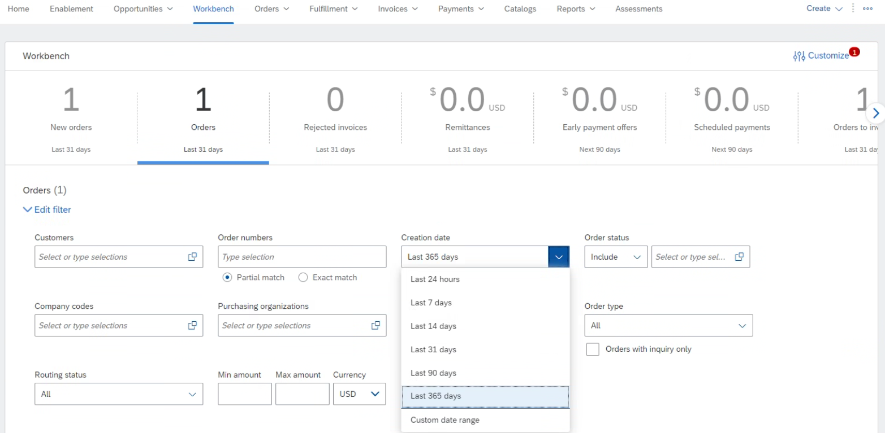
- Select purchase order - blue hyperlink
  - Create Invoice Standard Invoice
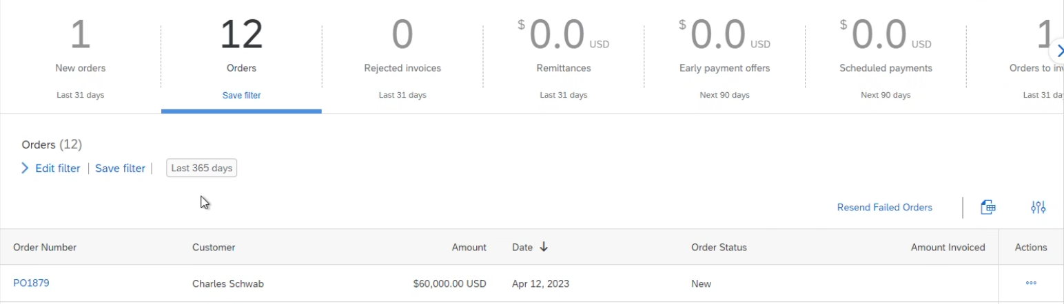
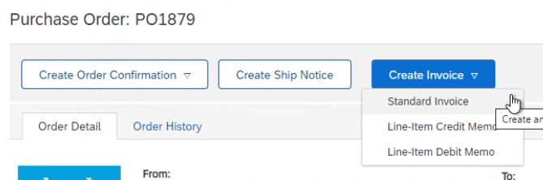
- Invoice #- Number should not contain any special characters (#, -, !) and should not be a duplicate invoice number
- Taxes must be submitted at Header Level - even when value is equal to $0.00
  - Select “Header level” and open tax box (tax box will not populate if the shipping is listed as “Line level shipping” – this icon needs to be selected at header level to populate correct options)
    - Add to Header Tax
  - From the tax box, second column – fourth table key in Tax Amount: ($0.00)
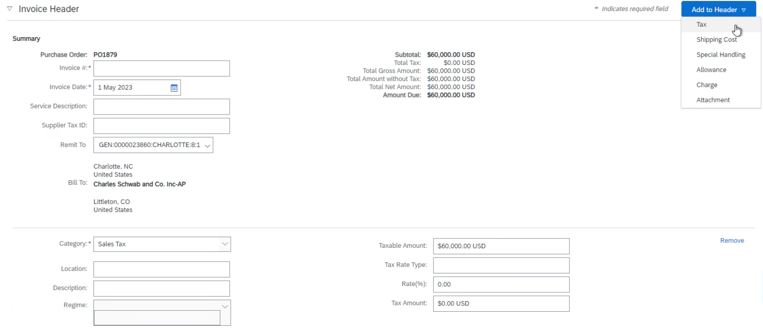
- Add attachments/support to submitted invoices
  - Select Add to Header drop down Attachment Choose File Add Attachment
- Select line(s) from PO for billing
  - If invoicing against a multi-line PO and not all lines are being billed, please do not select, and delete. Instead, click the green icon “include” so it turns off/grey
  - Adjust quantity billable if necessary
  - If submitting one invoice for two PO’s please create two separate invoices, one per purchase order.
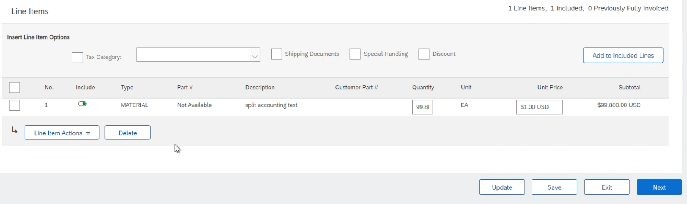
- Click “Update” –system will populate an error box preventing submission if all required criteria are not met
- Click Next verify all information is correct (invoicing amount, taxes, PO#, Remit to) Submit
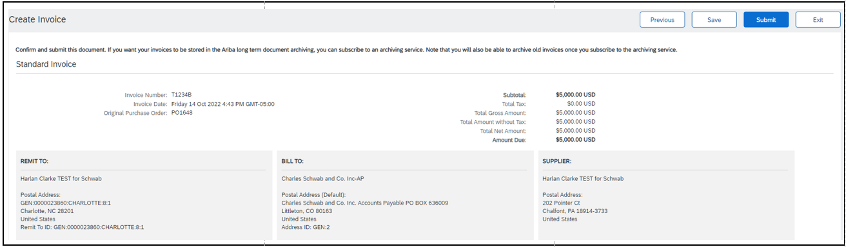
For additional support:
Vendor Management: (Assistance with creating a purchase order, changing an existing purchase order) vendormanagement@schwab.com
Supplier Enablement: (Ariba Network onboarding) supplierenablement@schwab.com
Invoices for Processing: (General questions, manual invoice submissions, status updates or where to guidance) invoicesforprocessing@schwab.com

