**P2P - Master Data Integration via Mediated Connectivity:**

**Question**

Master data integration via mediated connectivity  
  
Hi,  
  
In step 11 (page no :164) of the guide to configure the Integration Scenario Procedure, we have to choose communication component AR_Ariba_Upload. However, I don’t see this component.

Please let us know if this is a documentation defect and we have to create the communication component manually.

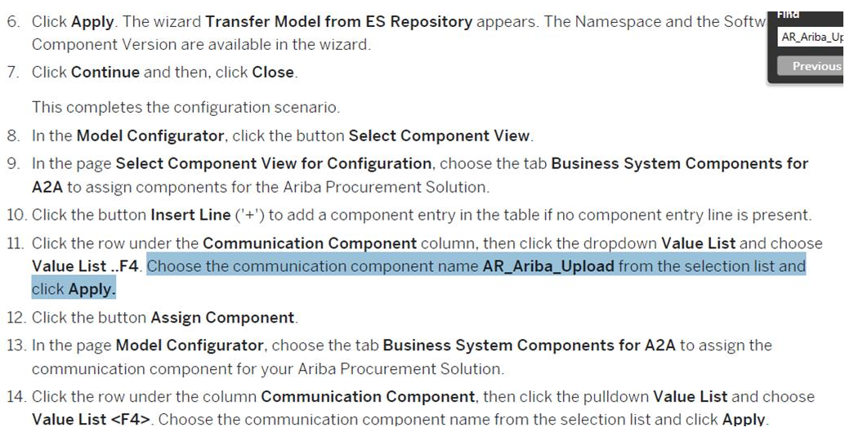

**Click the row under the Communication Component column, then click the dropdown Value List and choose Value List ..F4. Choose the communication component name AR_Ariba_Upload from the selection list and click Apply. (from guide pgno:164,step11)**

Customer is asking that there is no list of business components to select. Ariba Consulting asked Customer to create it in SLD and then you can see that in list.

So Customer's concern is that “Creation of Business Components in SLD and importing it to ID” step is missing in the guide.  
  
Attached an e-mail from customer and integration guide we are referring to.

**Answer**

We have tried creating the Configuration Scenario - AR_Ariba_Upload and able to choose the Communication Component as mentioned in the Guide.

Please refer to the screenshots attached

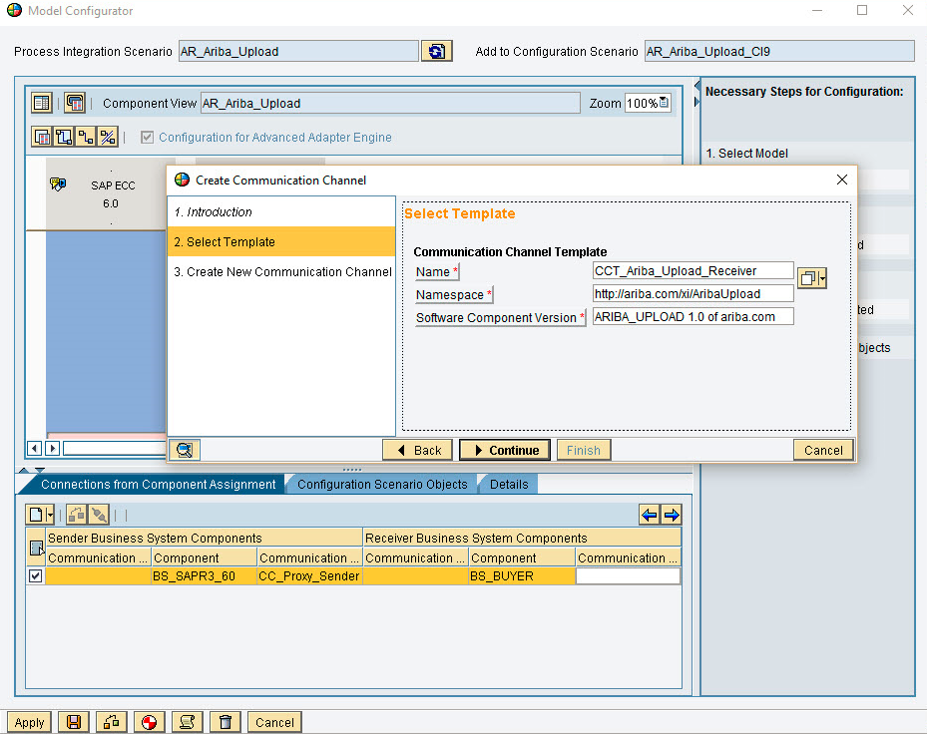

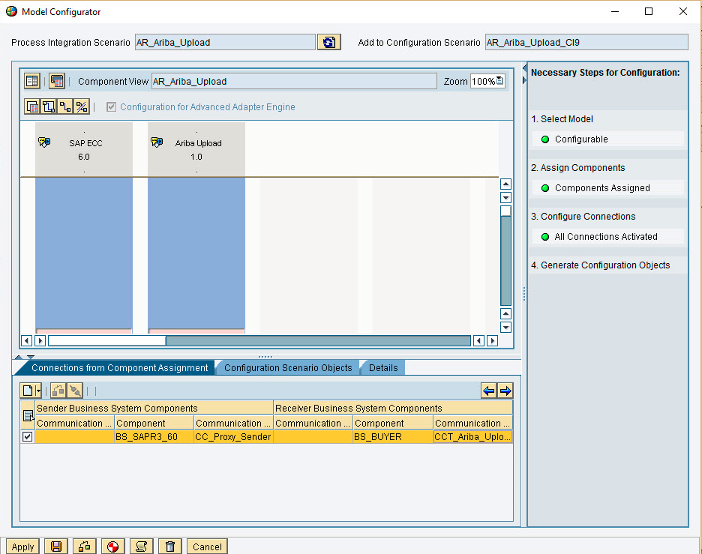

Additionally, we have informed the Customers that the issue is not about the unavailability of the Process Integration Scenario to be imported in to Integration Builder (ID) for creating Configuration Scenario – ***AR_Ariba_Upload***.

But is about choosing the Business Component (Business System) for the completing the Configuration Scenario.

This is briefly explained under the Section: ***Configuring the System Landscape Directory à How to configure the Business Landscape for the Ariba Procurement Solution***.