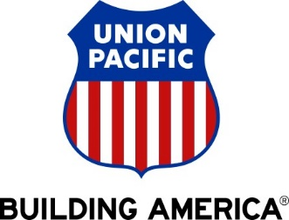

Dear Valued Union Pacific Supplier,

We are pleased to announce a new initiative to streamline our procurement and accounts payable processes. Union Pacific is partnering with **SAP**to transform and modernize our systems to increase process efficiency, enhance our data quality, and create a best-in-class customer experience for our suppliers. SAP has been transforming the global procurement landscape for businesses of all sizes. We are excited to provide you with this opportunity.

**Additional Important Information:**

* **What does this mean for you?**

We selected SAP because it brings our suppliers many benefits such as real-time PO delivery, use of online catalogs, invoice automation, and potential new business opportunities on SAP Business Network. Your transactions, all sourcing events (RFIs, RFPs), contract negotiations, and risk assessments will soon be transmitted using this platform. Conducting business on the SAP Business Network will be required.

* **When will this take effect?**

In the coming weeks, SAP will send you important communications and instructions for joining SAP Business Network. The first communication includes establishing a trading relationship with Union Pacific on the network and configuring your SAP Business Network account. The second communication is an invitation to complete a Supplier Registration Questionnaire with the subject “Invitation: Register to become a supplier with Union Pacific.” The email domain is ansmtp.ariba.com. Please note this is not spam. It has come from Union Pacific, via SAP Ariba.

We appreciate your prompt action on all communications and requests regarding this initiative (not to exceed five business days). We are targeting a cutover date from your existing AP process in Q3 of 2024.

* **How can you learn more about the Union Pacific and SAP partnership?**

You can learn more about SAP and the specific details about this initiative by registering to view an OnDemand web-based supplier Summit. Viewing the Summit is highly encouraged as it includes important information regarding the upcoming transition.

Visit the [SAP Supplier Information Portal](https://support.ariba.com/item/view/208414) to review the Union Pacific Railroad Company Supplier Summit to learn more details about this initiative and how it will impact your business.

Additional information is available on both the [UP Portal](http://www.up.com/suppliers/Ariba/index.htm) and the [SAP Supplier Information Portal](https://support.ariba.com/item/view/208414) endorsed by UP. These platforms offer convenient access to up-to-the-minute information, guaranteeing you're kept informed throughout the process.

We believe this shift will strengthen our business relationship and allow for more robust collaboration and purchasing capabilities. If you are not the correct recipient or have questions, please contact the Union Pacific Supplier Enablement Team at upse@up.com.

Thank you,

*Union Pacific Supplier Enablement Team*

upse@up.com