Browser Troubleshooting for Internet Explorer 10

Use these instructions to troubleshoot when using Windows and Internet Explorer 10 with SAP Ariba solutions.

- From an Internet Explorer Page, click on “Tools” then “Internet Options”
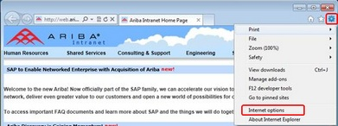
- On the General tab, under “Browsing History,” click the “Delete” button
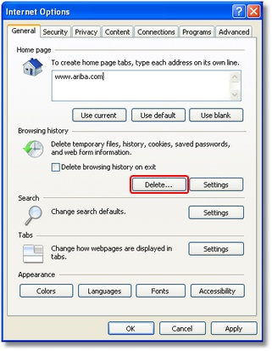

- Ensure the below highlighted options are check marked and click “Delete”
(screen below may also be accessed via commands: Ctrl + Shift + Delete)
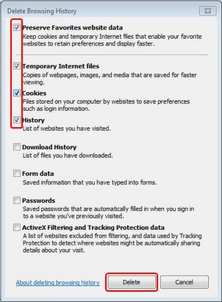
- You will now be returned to the General tab. Once again within the “Browsing History” section, click “Settings”
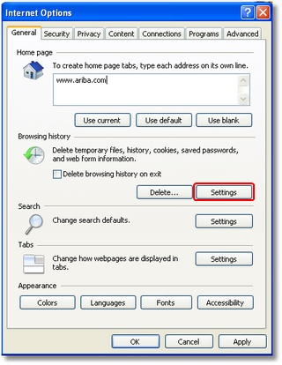
- Ensure that “Every time I visit the Webpage” is check marked then click “OK”
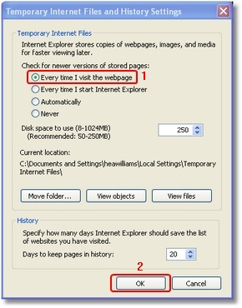
- Click on “Security” tab, Select the zone “Internet,” Click “Custom level…” button
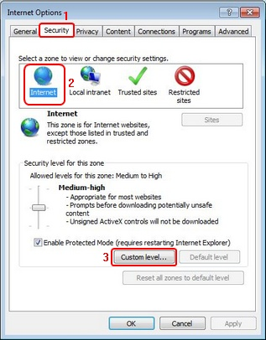
- Select the following settings under the “ActiveX Controls and Plug-ins” section
  - Enable “Allow previously unused ActiveX Controls to run without prompt
  - Enable “Allow Scriptlets”
  - Enable “Automatic Prompting for ActiveX Controls”
  - Enable “Binary and Script Behaviors”
  - Enable “Display video and animation on a webpage that does not use external media player”
  - Enable “Download Signed ActiveX Controls”
  - Prompt “Download unsigned ActiveX Controls”
  - Prompt “Initialize and Script ActiveX Controls not marked as safe for scripting”
  - Enable “Run ActiveX Controls and Plug-ins”
  - Enable “Script ActiveX Controls marked as safe for scripting”

Under Downloads section
  - Enable “File Download”
  - Enable “Font Download”

Scroll down and under Scripting section
  - Enable “Active Scripting”
  - Prompt “Allow programmatic clipboard access”
  - Disable “Allow status bar updates via script”
  - Disable “Allow websites to prompt for information using scripted windows”
  - Enable “Scripting of Java applets”

- Click “OK”
(The system will prompt for confirmation of the change of settings)
- Click “Yes”
- Now select the zone “Trusted sites,” click “Sites”
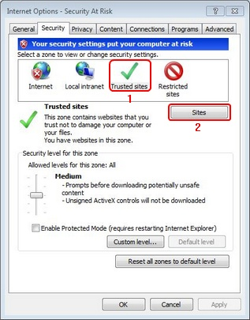
- Add the Website “*.ariba.com” and click “Add” then “Close”
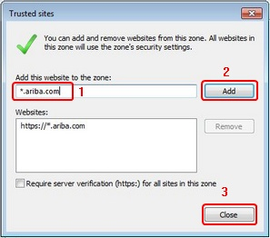
- Go to the “Privacy” tab and click on “Advanced”
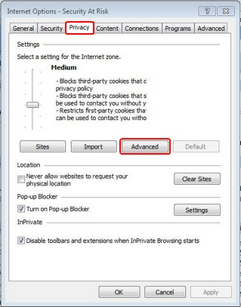
- Check mark the “Override automatic cookie handling” option
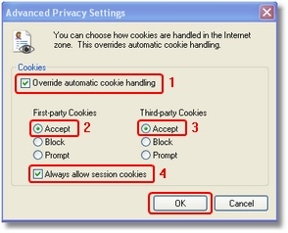
- Accept both “First-party Cookies” and “Third-party Cookies”
- Check mark “Always allow session cookies”
- Click “OK”
- Click on the “Advanced” tab
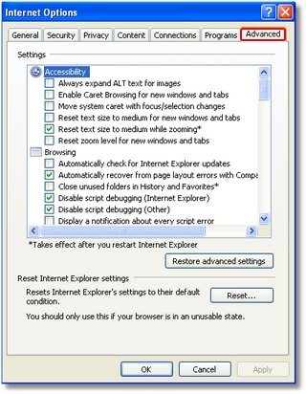
- Under “HTTP 1.1 settings,” check mark both boxes for “Use HTTP 1.1” and “Use HTTP 1.1 through proxy connections”
- Scroll down to the bottom, under “Security,”
- Make sure the box for “Do not save encrypted page to disc” is UNCHECKED.
- Click “OK” and then “OK” again.

Disclaimer:
- These are the recommended browser configurations with IE 10 and the SAP Ariba product suite.
- Your IT department should be consulted to ensure these changes will not impact another application/tool that your company might use

Configuring Your Browser to Access SAP Ariba Solutions
Before you can log in to any SAP Ariba On-Demand Solution, your web browser must be configured to allow cookies from ariba.com.
• If you are using Firefox or Safari and your browser is configured to block cookies, make sure you allow cookies from ariba.com in your exception list.
• If you are using Internet Explorer and you require a high privacy setting, make sure you allow cookies from ariba.com in a per-site configuration.
See the following procedures for specific browser configuration instructions.
- How to specify Cookie Settings for Microsoft Internet Explorer
1 In Internet Explorer, click the “Tools” menu, and then click “Internet Options.”
2 Click the “Privacy” tab and check your privacy settings:
• If your privacy setting is “Block all cookies,” you must change the privacy setting to a lower level of privacy, such as “High.”
• If your privacy setting is “High,” click “Sites,” enter “ariba.com” in the Address of website field, and click “Allow.”
• If your privacy setting is anything else, you don't have to do anything.
- How to specify Cookie Settings for Mozilla Firefox
1 In Mozilla Firefox, click the “Tools” menu, and then click “Options.”
2 Click the “Privacy tab” and check the setting in the “History” section:
• If the setting is “Remember history” or “Never remember history,” you do not have to do anything.
• If the setting is “Use custom settings for history”, and the “Accept cookies from sites” check box is selected, you do not have to do anything.
• If the setting is “Use custom settings for history,” and the “Accept cookies from sites” check box is not selected, click “Exceptions,” enter “ariba.com” in the Address of website field, and click “Allow.”
- How to specify Cookie Settings for Apple Safari
1 In Apple Safari, click the button that displays the menu of the general Safari settings, and then click “Preferences.”
2 Click the “Privacy” tab and check the “Block cookies” setting:
• If the Block cookies setting is “From third parties and advertisers” or “Never,” you don't have to do anything.
• If the Block cookies setting is “Always,” change it to either “Never” or “From third parties and advertisers.”

