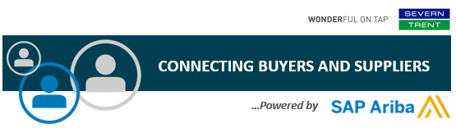

**Project Notification Letter**

Dear valued supplier,

We are committed to driving improvement through innovation, and are pleased to be connecting our Severn Trent buyers and suppliers via a robust and streamlined procurement solution powered by SAP Ariba.

* **What does this mean for you?**

**We’re phasing out the processing of paper and manually transmitted documents, and inviting our suppliers to register on the Sap Ariba Network**. Once registered, you will be able to participate in tenders, and exchange transactions such as Purchase Orders, invoices and other such related data. The SAP Ariba Network brings our suppliers many benefits including working together more efficiently with our buyers, and being able to discover new business opportunities.

* **Is there a cost associated with this initiative?**

Suppliers new to the Ariba Network generally start transacting for free, though based on the volume of transactions you do with Severn Trent, as well as with other buyers on the Network – there may eventually be fees associated with your use. These fees will be billed by and payable to Ariba. To learn more please visit [**SAP Ariba Subscriptions and Pricing.**](https://www.ariba.com/ariba-network/ariba-network-for-suppliers/subscriptions-and-pricing)

* **When will this take effect?**

We are already starting to send out onboarding invites to our suppliers asking them to register on the SAP Ariba Network, so please look out for your email (check your junk/spam box). In the coming weeks, Ariba will send you important communications and instruction for joining the Ariba Network. This includes establishing a trading relationship with Severn Trent on the Ariba Network and configuring your Ariba Network account.

* **How can you learn more about our Severn Trent and SAP Ariba partnership?**

**You can learn more about this initiative by registering for a web-based supplier summit** (details below). Attendance is highly encouraged as you will have the opportunity to participate in a live Q&A with experts from both SAP Ariba and Severn Trent.

|  |  |  |  |
| --- | --- | --- | --- |
| **Summit Title** | **Date** | **Time** | **Registration** |
| **Severn Trent Supplier Summit** | **9 November 2020** | **10:00- 11:00** | [**Register**](https://event.on24.com/wcc/r/2795616/838DEAB02E98E55750FF49A319F3FC7B) |

We believe this shift will strengthen our business relationship and allow for more effective collaboration and purchasing capabilities. If you are not the correct recipient or have any questions, please contact our Supplier Enablement Team at **SupplierEnablement@severntrent.co.uk**.

**Kind Regards,**

***The Supplier Enablement Team***

**Severn Trent**