**Invoice Submission Method.**

This document will help the customer in identifying the method by which supplier has submitted the invoice.

There a basically following ways by which a customer can come to know how an invoice was submitted.

1. Seeing in Inbox.
2. Opening the Invoice and check submission Method.
3. Looking at the PayloadID
4. Looking at submission method in cxml.

1-Seeing in Inbox.

1. Login to your account.
2. Go to Inbox.
3. Search for the specific invoice.
4. See the submission method mentioned. If Submission is :

i – cxml – the invoice was submitted by supplier cxml system.

Ii – Online – The invoice has been created in Ariba network directly.

Iii – CSV – The invoice has been uploaded as csv upload.

iv – EDI – The invoice has been submitted by supplier’s EDI system.

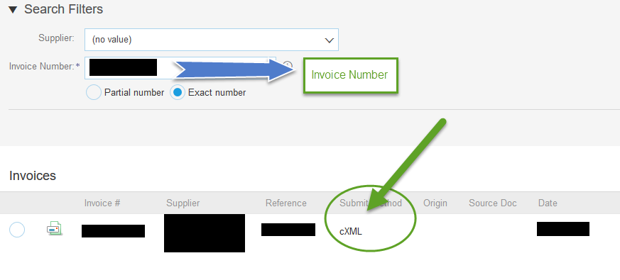

2- Opening the Invoice and check submission Method.

The Invoice submission method can be see if you open the invoice.

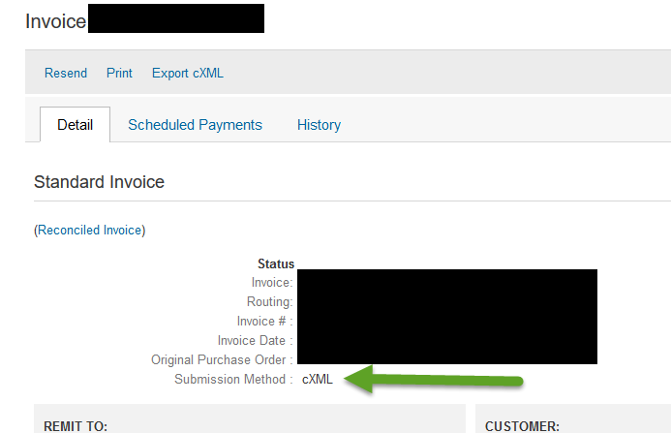

3- Looking at the PayloadID

The submission method can be checked by looking at payloadID. This will just confirm if the invoice was created in Ariba Network or by some external system of supplier.

If the payload ID as Ariba’s IP address (starting with 216.xx.xx.xx), it is created in Ariba Network. If the payload ID does not have Ariba IP, it is created in supplier’s external integrated system.

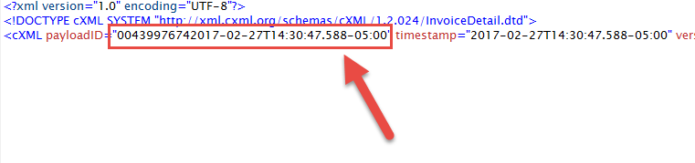

1. Looking at submission method in cxml

The invoice submission method can also be check by looking for the value of tag

<invoiceSubmissionMethod > in the exported cxml of invoice.

