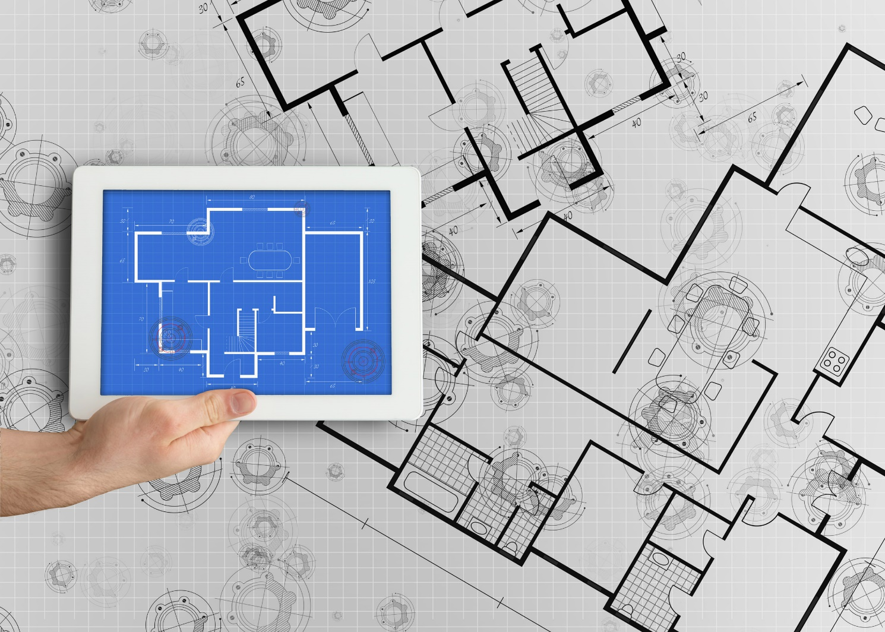z

**Integrated Seller Transaction Guideline**

Oct 2018

Table of Contents

Version History 3

Ariba Supply Chain Collaboration Implementation 4

E&J Gallo Process and Data Flow 4

E&J GALLO Mapping Specification and Requirements 6

Purchase Order Specifics 6

Order Confirmation Specifics 7

Advance Ship Notice Specifics 7

Invoice Specifics 7

Invoice Status Update Specifics 9

Ariba Network Transaction Validation Rules 9

EDI Sample 10

cXML Sample 10

GUSI Sample 10

Supplemental Documentation 10

Cloud Integration Gateway Connection Requirements 11

Ariba Network Support Information 11

# Version History

This log is updated each time this Process Document is updated. The log identifies the version number, the date the version was completed, the author of the changes, and a brief description of the changes.

|  |  |  |  |
| --- | --- | --- | --- |
| Version | Date | Author | Description |
| 1.0 | 10/11/18 | Smriti Jaiswal | Initial Version of Document |

|  |
| --- |
|  |
| SAP STATEMENT OF CONFIDENTIALITY AND EXCEPTIONS  The contents of this document shall remain the confidential property of SAP and may not be communicated to any other party without the prior written approval of SAP. This document must not be reproduced in whole or in part. It must not be used other than for evaluation purposes only, except with the prior written consent of SAP and then only on condition that SAP’s and any other copyright notices are included in such reproduction. No information as to the contents or subject matter of this proposal or any part shall be given or communicated in any manner whatsoever to any third party without the prior written consent of SAP.  The furnishing of this document is subject to contract and shall not be construed as an offer or as constituting a binding agreement on the part of SAP to enter into any relationship. SAP provides this document as guidance only to estimate costs and time-scales of the predicted delivery project. This will be subject to confirmation prior to any contractual or delivery commitment by SAP.  SAP warrants that to the best of its knowledge those who prepared this material have taken all reasonable care in preparing it and believe its contents to be true as at the date of this document. SAP cannot however warrant the truth of matters outside of its control and accordingly does not warrant the truth of all statements set out in this document to extent that such statements derive from facts and matters supplied by other persons to SAP. The statements in this document are qualified accordingly. | |

# Ariba Supply Chain Collaboration Implementation

SAP Ariba **Supply Chain Collaboration (SCC)** is an **extension of Ariba Network** that enhances the ability of suppliers to collaborate with buyers in supply-chain tasks such as ordering, invoicing, and shipping.

With SAP Ariba Supply Chain Collaboration enabled, an array of features become available to buyers and suppliers on Ariba Network. These features facilitate collaboration between buyers and suppliers, for example on transactions pertinent to direct material supply chains.

E&J Gallo will be using the Standard PO and Returns PO modules of Ariba SCC solution with Ariba enabled vendors. The standard PO at the client site will be used for procurement of ingredients and raw materials, MRO and store-room spares, Point of Sale (POS) materials and finished goods imports.

# E&J Gallo Process and Data Flow

The Ariba Network serves as the platform to connect E&J GALLO and suppliers via electronic document exchange.

The following diagrams represents the E&J GALLO business process at a high level.

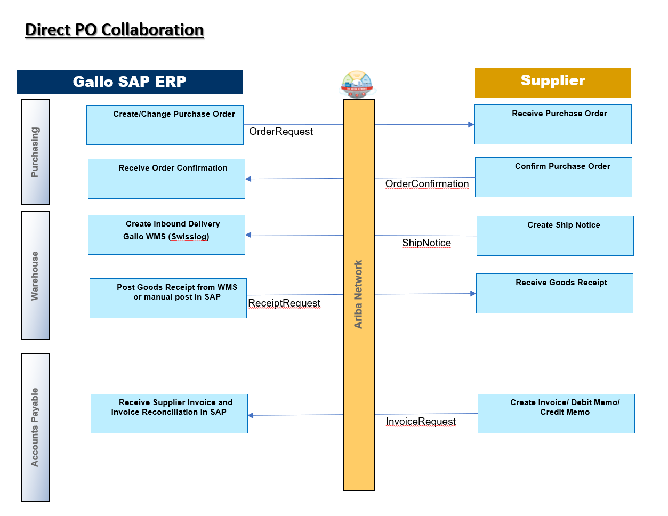

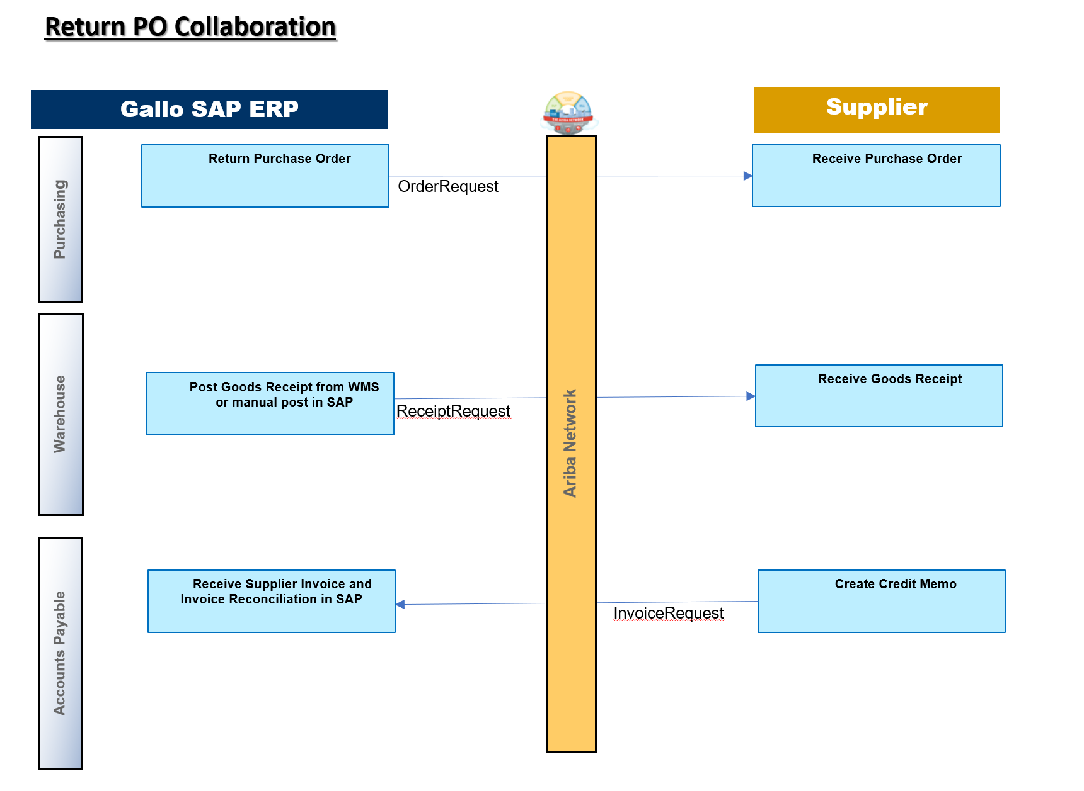

**Purchase Order:** communicates Gallo’s order, including Price, Request Date and Quantity, to the Supplier and the Supplier’s corresponding response.

**Order Confirmation:** communicates the supplier’s acknowledgement and approval of Gallo’s Purchase order and estimated shipping dates

**Shipment (ASN):** communicates the Supplier’s material shipment information to Gallo via Supplier Shipments.

**Receipt:** communicates the Customer’s material goods receipt information to the Supplier via Customer Receipts.

**Invoice:** communicates the Supplier’s financial settlement information to the Customer via Supplier and the corresponding Payment Notification back to the Supplier.

**Remittance:** communicates the details of the payment made by Gallo against the invoice submitted by the vendor – including payment method, actual amount and related details.

# E&J GALLO Mapping Specification and Requirements

E&J GALLO Prod ANID: AN01094186902

E&J GALLO Test ANID: AN01094186902-T

Required Transactions

* + **Purchase Order**

cXML OrderRequest

EDI 850 (New/Return PO)

EDI 860 (Change PO)

* + **Order Confirmation**

cXML ConfirmationRequest

EDI 855

* + **Advance Shipment Notification**

cXML ShipNoticeRequest

EDI 856

* + **Goods Receipt**

cXML ReceiptRequest

EDI 861

* + **Invoice**

cXML InvoiceDetailRequest

EDI 810

**Optional Transactions**

* + Acknowledgement Message
  + Acceptance / Rejection Notice
  + Document Status Update

**Ariba supports the below methods for inbound / outbound documents**.

* + cXML
  + EDI
  + GUSI
  + Online (Ariba Portal)

## 

## Purchase Order Specifics

|  |  |
| --- | --- |
| **Purchase Order Types in Scope** | **Purchase Order Types Not in Scope** |
| New POs | Blanket POs (BPO’s) |
| Change/Cancel | Service POs |
| POs with attachments | SubContract POs |
| Return POs | Consignment POs |
|  |  |

Table 1 - Purchase Order Types Supported/Not Supported

* PO will have **ShipTo Address** at **header level**
* PO may or may not contain **ShipTo Address IDs**
* **Payment terms** will be sent on all POs
* Partially Shipped Orders or Fully Shipped Orders can be changed
* Fully Shipped Orders cannot be cancelled but open quantities can be cancelled

## Order Confirmation Specifics

* Order Confirmations need to be sent prior to the ASN
* Order Confirmations may contain attachment, but it will be left online on Ariba portal and not transferred to buyer end
* Suppliers can send Order Confirmations at the line-item level
* Suppliers can reject entire Order but rejection at line level is not supported
* Suppliers cannot change line item description on Order Confirmations.
* Suppliers cannot change the Supplier Part ID and Auxiliary Part ID fields on Order Confirmations at the line-item level.
* Suppliers cannot change quantity, price unit, unit conversion, currency and pricing description for a line item on Order Confirmations.
* Suppliers **must send Delivery date and Estimated Shipping date** on Order Confirmations.
* Suppliers **must send comments in Order Confirmation** in case of rejection

## Advance Ship Notice Specifics

* ASN may contain attachment, but it will be left online on Ariba portal and not transferred to buyer end

**Header Level**

* Suppliers cannot increase item quantities or pricing details on ship notices.
* Packing Slip IDs is optional, but it doesn’t have to be unique
* Suppliers must send Delivery date and Estimated Shipping date in ASN

**Shipment Level**

* Tracking details can be provided but it is not mandatory.

## Invoice Specifics

|  |  |
| --- | --- |
| **Invoice Types in Scope** | **Invoice Types Not in Scope** |
| Individual Detail Invoice: applies against single PO referencing line items; line items may be material items | Invoice against Blanket PO |
| Partial invoice: Invoice against a portion of the items on a PO. | Invoice against PCard |
| Invoice against material PO | Information Only Invoice |
| lineLevelCreditMemo | Non-PO invoice against contract or master agreement |
| lineLevelDebitMemo | Invoice against service PO |
| Header Credit Memo | Header Invoice: single invoice applying to single PO without item details |
| Cancel Invoice |  |
|  |  |

Table 2 - Invoice Types Supported/Not Supported

**Special Charges**

* Special charges to be sent as part of line item. Below is the list of Gallo approved charges

• Insurance (new condition type)

• Die Charges

• Handling charges

• Hazmat charges

• Energy Surcharge

• Fuel Surcharge

• Pallet charges

**Required Address Information**

* Bill To and Remit To address information is required on the invoice

**NOTE:** Strict address validation is enforced. When this rule is enabled, the system will check if the following EDI elements are present and if it has a value:

1. Name

2. PostalAddress.Street

3. PostalAddress.City

4. PostalAddress.State

5. PostalAddress.PostalCode

6. PostalAddress.Country isoCountryCode attribute

**Other Invoice Requirements**

* Invoice number can be reused from rejected or failed invoices, canceled
* Invoice number can be reused from past calendar years
* Invoice number cannot be reused from modified or accepted invoices
* Invoices cannot be backdated more than **60 days**
* Payment terms are mandatory
* Suppliers cannot change price unit quantity, price unit, unit conversion, currency and pricing description for a line item on Invoices
* Suppliers cannot change the Supplier Part ID and Auxiliary Part ID fields on Invoices at the line-item level
* Suppliers can add allowances and charges to invoices
* Invoice with net amounts to exceed subtotals is allowed
* Suppliers can send line-item credit/debit memo. Suppliers can use these memos to make adjustment to taxes, shipping, and special handling charges
* Supplier must provide reason for credit memo

## Invoice Status Update Specifics

After an invoice, has been received and processed by the SAP ERP system, status updates will be sent to Ariba Network.

The below are the status updated in AN based on the SAP ERP invoice status:

|  |  |
| --- | --- |
| **Action in SAP ERP** | **Invoice Status on Ariba Network** |
| The invoice is deleted (deletion of invoice with errors) or discarded in Forward Error Handling. | rejected |
| The invoice is not posted (e.g. because it has errors or is parked).  The invoice is not released for payment | processing |
| The invoice is posted. | Approved |
| The invoice is partially paid. | paying |
| The invoice is paid. | paid |
| The invoice is reversed or cancelled by a cancellation invoice. | cancelled |

## Ariba Network Transaction Validation Rules

* The custom validation rules have been set on the Ariba Network which apply specifically to POs, Order Confirmations, ASN and PO based Invoices. Review these settings from your supplier account on the Ariba Network.

**E&J GALLO DOCUMENTS SAMPLES**

The following excel workbooks you will find cXML samples and EDI transaction guidelines accepted by the Ariba Network with the additional requirements**.**

## EDI Sample

**

*Please download / view latest EDI guidelines from ClG portal.*

## cXML Sample



*<Please note: The cXML documents are validated against the dtd, the latest version(s) available at* [*www.cXML.org*](http://www.cXML.org) *> cXML documents can be sent to the URL via https post based on the authentication preferred*

## GUSI Sample

*Not Applicable*

# Supplemental Documentation

This document contains E&J GALLO specific information regarding transaction requirements. Information in this document does **NOT** cover the complete technical aspects of integrating with the Ariba Network. Below are two sections for supplemental documentation to be used with this document for EDI or cXML transaction formats. Only refer to the section that pertains to the format your organization with be sending/receiving from the Ariba Network (EDI or cXML).

**cXML Section for Supplemental Documentation**

New cXML supplier to Ariba Network must:

1. Support a DTD (document type definition) validation tool internally and download the document type definitions (DTD’s) for all supported transactions.
2. Support HTTPS protocol. Ariba supports HTTPS (not HTTP) only for cXML transactions.
3. Review the cXML Solutions Guide and cXML User Guides.

**cXML Document Type Définitions (DTD’s):**

* [http://cxml.org](http://cxml.org/) Download [InvoiceDetail.zip](http://xml.cxml.org/current/InvoiceDetail.zip) for the InvoiceDetailRequest.dtd.
* <http://cxml.org> Download cXML.DTD for the OrderRequest
* <http://cxml.org> Download Fulfill.dtd for ConfirmationRequest/ShipNoticeRequest

**Recommended Resources:** The [Ariba cXML Solutions Guide](https://uex.ariba.com/sites/default/files/imported_files/en_363e020ce3ddfb77cdf083f16b3ca4fe9f477511_412ba108d0a31014a748ee1cf3fe6955.pdf) (URL to post documents to Ariba). May also be downloaded via login to your supplier account (<https://supplier.ariba.com>) on the Ariba Network:

1. Click the ‘Help’ link in the upper righthand section of the page.
2. Select ‘Help Center’ from the dropdown menu.
3. Enter Search… key words or full document name.
4. Click on the pdf document name to open and download.

## Cloud Integration Gateway Connection Requirements

Suppliers will use the Cloud Integration Gateway to connect to Ariba Network.

The required connection Specifications are embedded (in the mapping specification section above) and is also available under the ‘Resources’ section in the Cloud Integration Gateway upon supplier login.

To establish AS2 connectivity with Cloud Integration Gateway, please complete the information in attached file.



# 

To establish VAN connectivity with Cloud Integration Gateway, please complete the information in attached file.



To establish HTTPS connectivity with Cloud Integration Gateway, please complete the information in attached file.



# Ariba Network Support Information

Supplier Integration (SI) support is available to E&J GALLO suppliers. SI support is available during the test phase and two weeks post-go live with E&J GALLO or until the first production transactions are exchanged. After that period, suppliers must leverage Ariba Technical Support for any production issues. To contact SI support, send an email to askaribatech@ariba.com. Be sure to list E&J GALLO in the subject line of the email.

Depending on your transaction volume across all Buyers on the Ariba Network you will be automatically subscribed to a Supplier Membership Program Subscription.  These subscriptions provide your organization access to many premium features and services that are exclusively available to members at these levels.  The Premier, Enterprise, and Enterprise Plus levels provide ongoing technical electronic document support.  To find out more go to:   
  
<http://www.ariba.com/assets/uploads/documents/Datasheets/SMP_Subscription_Datasheet.pdf>.

To find out your Program Subscription, log on to <https://supplier.ariba.com>, click the Property Navigator toolbar on the upper right corner of the page and select **Service Subscriptions** in the drop down box.

**Until subscribed to one of Ariba’s support programs**, limited assistance regarding account registration, access and configuration is available from Ariba:

**By Telephone:**

Europe, Middle East and Africa: +44 (0) 20 7187 4185

US/Canada toll free: 1-866-218-2155

North/South America +1-412-222-6170

Asia Pacific: +65 6311 4585

**By Web:**

|  |  |
| --- | --- |
| **If you can log into your Ariba Network Account** | **If you cannot log into your account** |
| * Login at [http://supplier.ariba.com](http://supplier.ariba.com/) * Once logged in, click on the *‘Help*’ link located on the upper right hand side of the page and choose *Help Center.* * Select Support located in the top right hand side of the page. * Options in the bottom right hand side of the page are Live Chat or By Phone. * An Online Service Request can also be submitted by selecting the “Start” button in the top center of the page. | * Go to [http://supplier.ariba.com](http://supplier.ariba.com/) * For login issues select the *“Forgot Username”* or *“Forgot Password”* links near the top of the page. * Fill out the web form and select the *Submit* button. |