**Issue**

When send a QuoteRequest from ECC to Ariba using PI 7.5 single stack, we have the following error: An unrecoverable error occurs wh  
en performing outbound transaction: [CC_QuoteRequest_cXML_Receiver] [Request Name/Type] QuoteRequest/QuoteRequest [Request URL] http  
s://service.ariba.com/service/transaction/cxml.asp [TimeStamp/PayloadID] null/null [Response Status Code] 406 [Response Status Text]  
Not Acceptable [Response Status Desc] Invalid Document:Element type "QuoteHeaderInfo" must be declared. at line 3, column 1280] cau  
ses a XIAdapterException and can be retried.  
We have the latest version of CI9 SP2, with new specs described in "Guide to SAP Ariba cloud integration 9.0 SP2 features to support upc  
oming Ariba Network or Ariba Application features", with <http://ariba.com/xi/ASN/QuoteRequest> scenario objects.

**Cause**

Customer was using 1.2.030 cxml version in the communication channel for Quote Request , but the cxml version should be 1.2.034 or higher for CI9 SP2 , documented in the integration guide

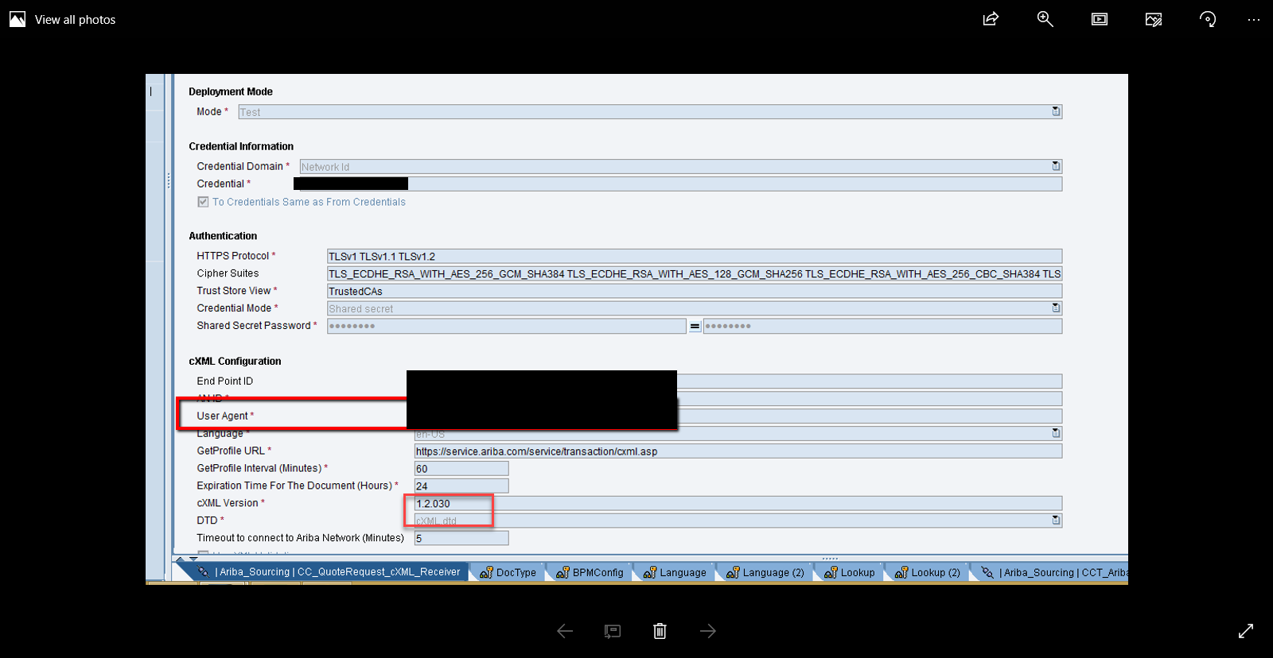

**Solution**

1. For CI9 SP2 , the adapter cxml version should be 1.2.34 or higher as per documentation :  
     
   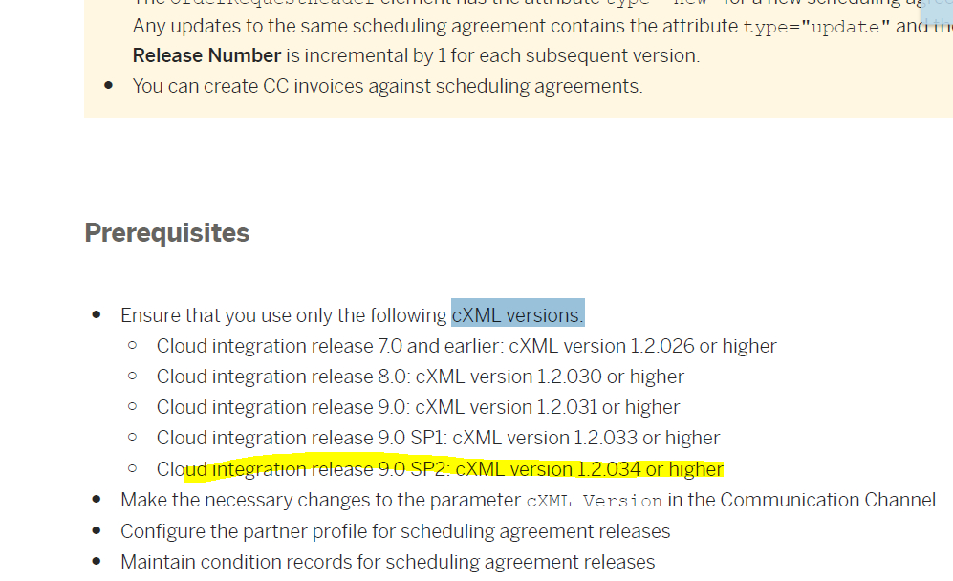

Example below:  
  
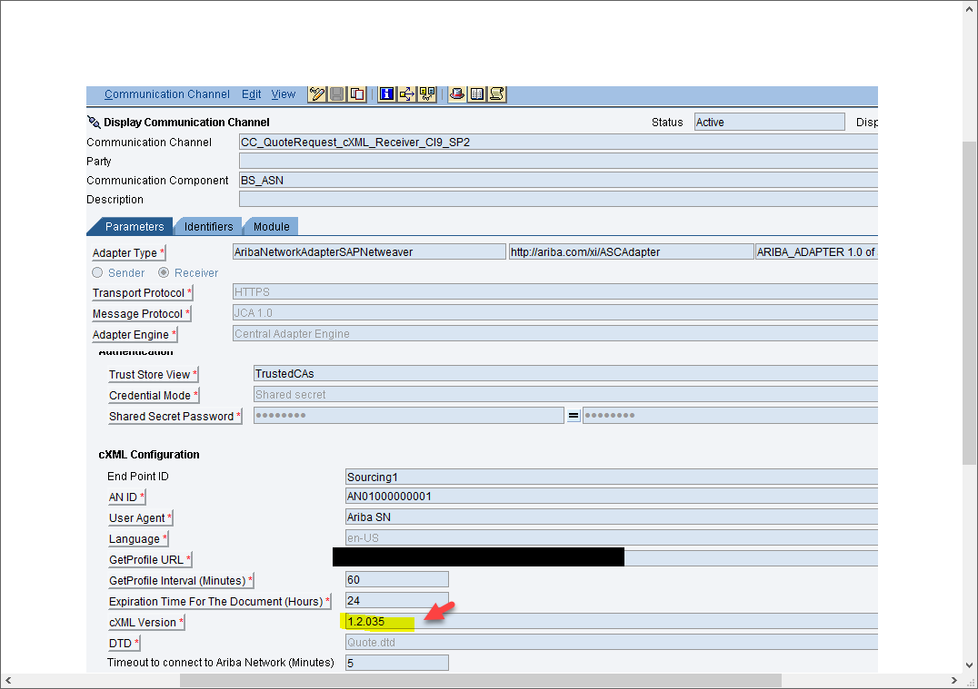

2. Please test by changing the cxml version as above in the communication channel and let us know the results, your screen shot indicates you maintained 1.2.030 .

**Additional Information**

Customer confirmed issue is resolved after the change of cxml version to 1.2.035 , cache refresh in PI to reflect the changes done , restart of the channel and test end to end