**GR sent for Movement Type not configured fails in SAP PI:**

**Issue**

Goods Receipt (GRN) sent for the Movement Types 104, 105 and 106 are failing and producing Errors in SAP PI.

***"Split Mapping created no messages"***

***"Splitting to 0 messages is not allowed"***

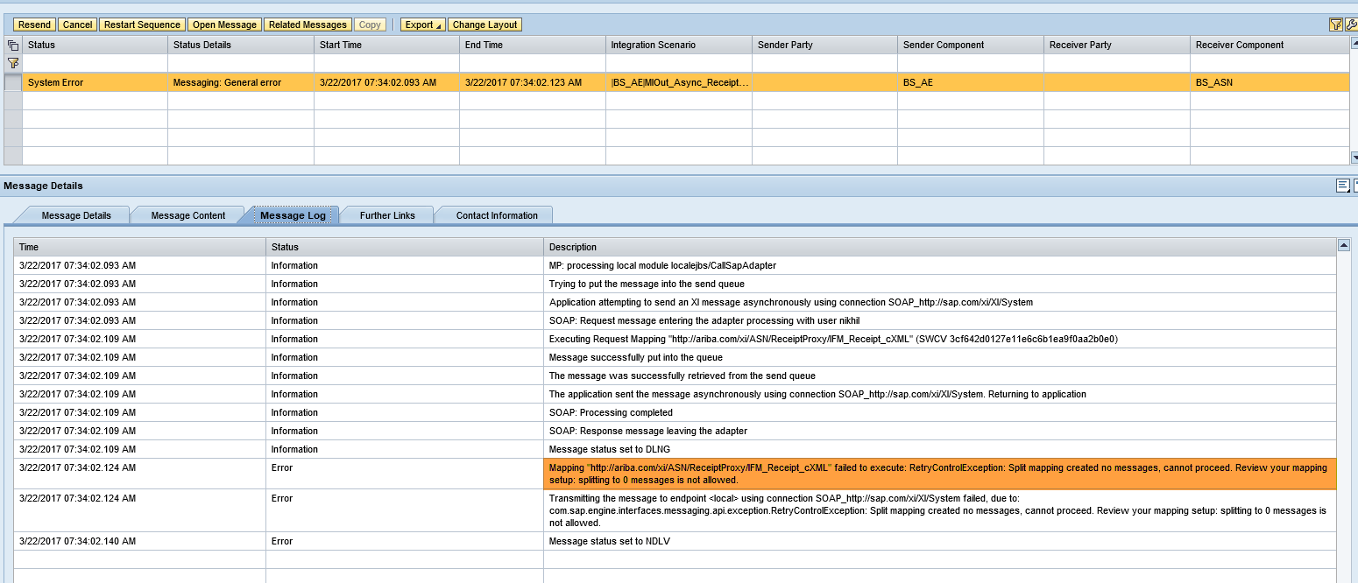

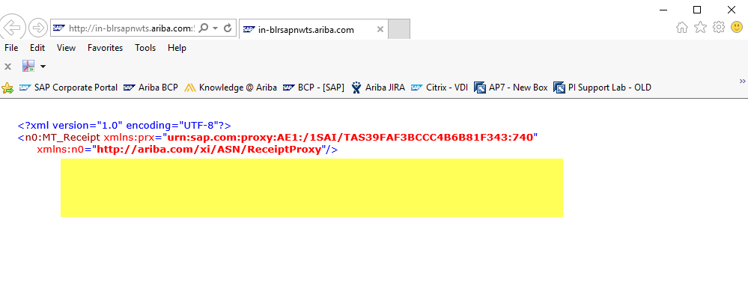

**Cause**

The reason is Customers have not maintained the necessary Parameters / Configurations in SAP ECC for the Movement Types 104, 105 and 106.

Because of this an Empty Goods Receipt Message is sent to PI and PI fails to process the message to Ariba Network.

**Solution**

We have suggested the Customers to maintain the below Parameters in ECC Table - /ARBA/PARAM_TAB using the T-Code SM30.

ECC Table - /ARBA/PARAM_TAB

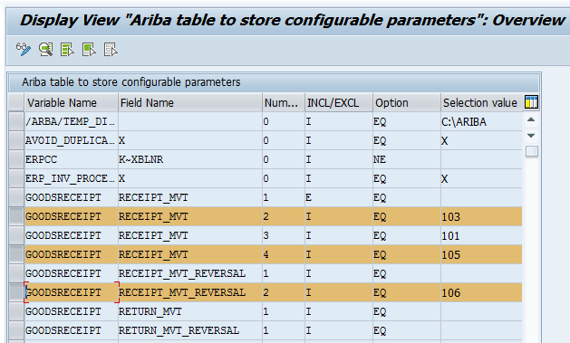

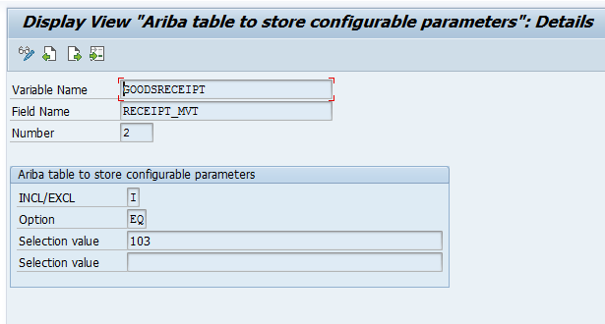

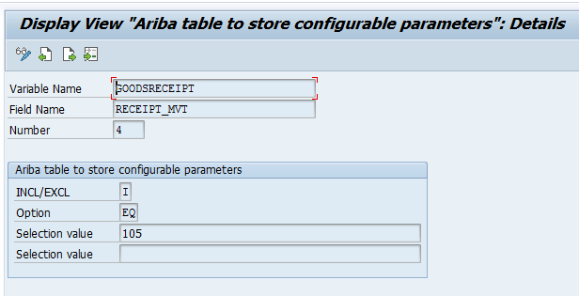

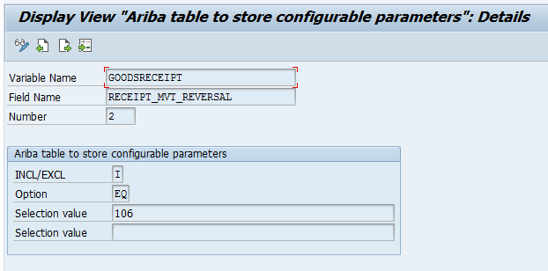

Created GR’s with Movement Types in the order 103, 105 and 106 and sent to Ariba.

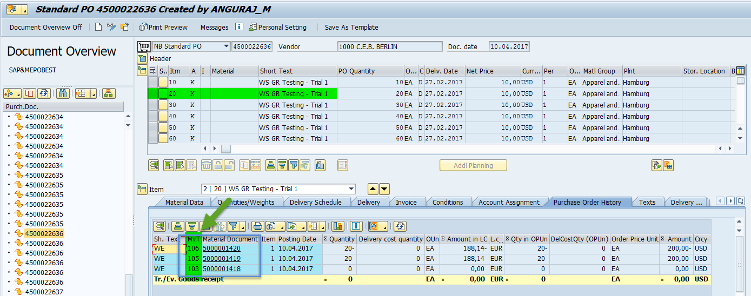

GR’s with Movement Types 103, 105 and 106 reached Ariba successfully:

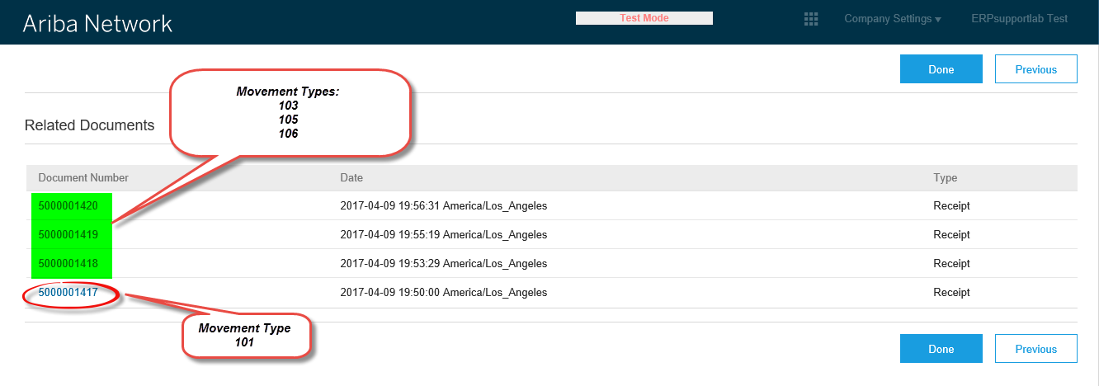

**Movement Type: 103**

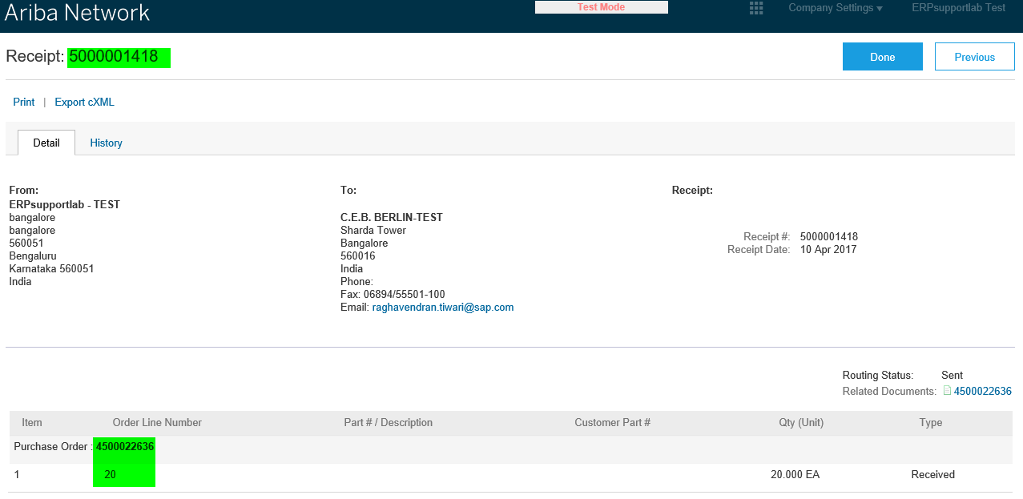

**Movement Type: 105**

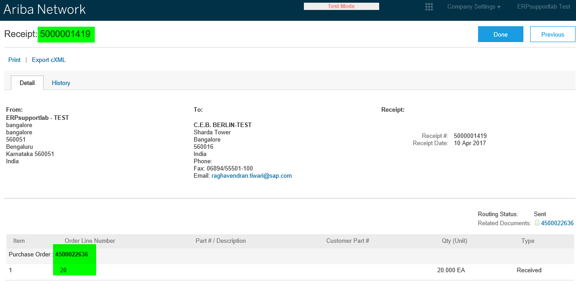

**Movement Type: 106**

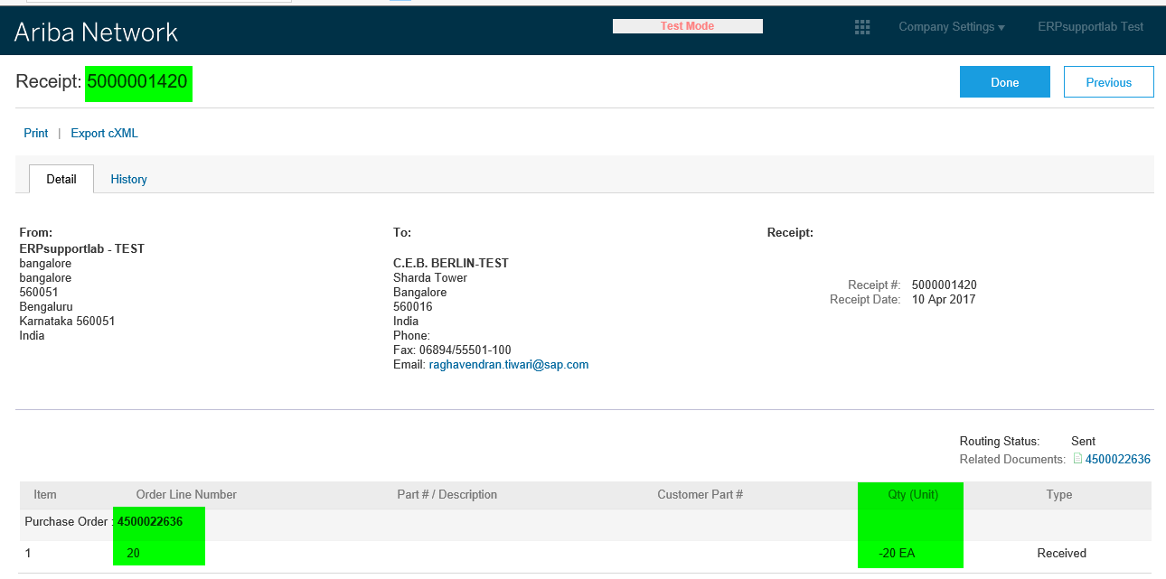

After maintaining the Parameters, Customers were able to send GR successfully to AN and the issue is resolved.