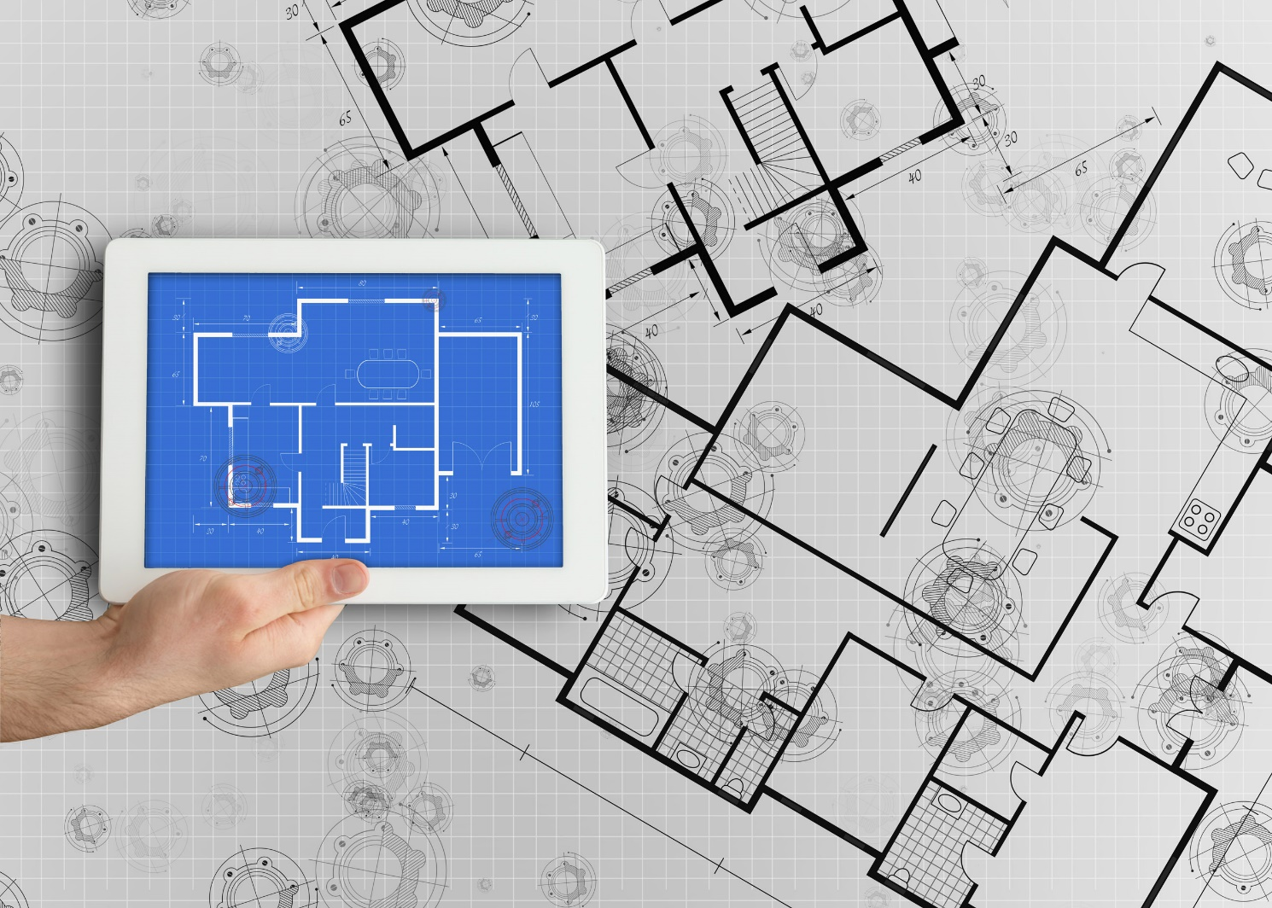

Integrated Seller Transaction Guideline
July 2022
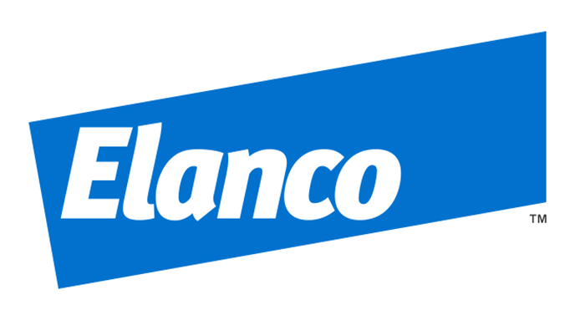

Table of Contents
Version History 2
ELANCO Mapping Requirements and Deltas 4
Where to Find Buyer Transaction Rules 5
ELANCO Detailed Specifications and Requirements 6
Scope 6
Purchase Order Details 6
Order Confirmation Details 7
Ship Notice Details 7
Invoice Details 7
Supplemental Documentation 9
SAP Ariba customer Support for Suppliers 10

Version History
This log is updated each time this Process Document is updated. The log identifies the version number, the date the version was completed, the author of the changes, and a brief description of the changes.

Version | Date | Author | Description
1.0 | 07/2022 | Katerina Markoska, SAP | Initial Version of Document for EMEA

SAP STATEMENT OF CONFIDENTIALITY AND EXCEPTIONS
The contents of this document shall remain the confidential property of SAP and may not be communicated to any other party without the prior written approval of SAP. This document must not be reproduced in whole or in part. It must not be used other than for evaluation purposes only, except with the prior written consent of SAP and then only on condition that SAP’s and any other copyright notices are included in such reproduction. No information as to the contents or subject matter of this proposal or any part shall be given or communicated in any manner whatsoever to any third party without the prior written consent of SAP.
The furnishing of this document is subject to contract and shall not be construed as an offer or as constituting a binding agreement on the part of SAP to enter into any relationship. SAP provides this document as guidance only to estimate costs and time-scales of the predicted delivery project. This will be subject to confirmation prior to any contractual or delivery commitment by SAP.
SAP warrants that to the best of its knowledge those who prepared this material have taken all reasonable care in preparing it and believe its contents to be true as at the date of this document. SAP cannot however warrant the truth of matters outside of its control and accordingly does not warrant the truth of all statements set out in this document to extent that such statements derive from facts and matters supplied by other persons to SAP. The statements in this document are qualified accordingly.

ELANCO Mapping Requirements and Deltas

Deltas
In the following excel workbooks you will find baseline cXML and EDI transactions accepted by the Ariba Network with the additional requirements for ELANCO noted below.

cXML Delta: D96A Delta:
The following is a summary of the requirements that are unique to ELANCO’s procurement environment, as detailed in the Excel Delta’s document.

Purchase Order Specifics (Tab 1)
- PO numbers will be 10 digits (ex. 4XXXXXXXXX)
Doc Type | Description | Used to Purchase | Number Range | Trigger | Comments
ZNB | Elanco std/subcn/Int | Direct Material | 450… | S/4 purchase requisition | Goods Receipt expected
ZIND | Elanco ARIBA Standard PO | Indirect Material | 480… | S/4 purchase requisition | Goods Receipt expected
ZIND | Elanco ARIBA Limit Service PO (BPO) | Indirect Material | 480… | S/4 purchase requisition | No Goods Receipt
- Ship To address will be sent at the header level. Deliver To fields may/may not be included.
- Control Keys will be sent to allow or disallow OC and ASN
- POs can contain attachment

Invoice Specifics (Tab 2)
- Required addresses and IDs: Ship From, Ship To/Ship To ID, Bill To/Bill To ID, Sold To
- Sold To Name and Country must match PO Bill To Name and Country.
- Payment terms are not required on the invoice but must match from PO if sent.
- Tax is supported only at the line level.
  - Multiple taxes per invoice are allowed – not more than one tax to refer per line
- Shipping and special handling charges are supported at the summary level.
- Invoice numbers may be reused for canceled, rejected, or failed orders.
- Invoices may be backdated up to 7 days.
- Future dated invoices are not accepted.
- Non-PO invoices are not supported.
- Attachment is optional, not required.

Order Confirmation Specifics (Tab 3)
- Order Confirmations are optional, not required.
- Delivery dates are required for Order Confirmation.
- An estimated shipping date is required for Order Confirmation.
- A reason is required when an order is rejected.
- A comment is required at the line-item level when there are any changes.
- Line-item descriptions may not be changed.

Ship Notice Specifics (Tab 4)
- Ship Notices are optional, not required.
- Delivery dates are required for Ship Notice.
- An actual or estimated shipping date is required for Ship Notice.
  - Ship Notice type (actual or planned) is required.
- Delivery and transport information may be added.
Line Level Credit Memo (Tab 5)
- Credit memos are supported for quantity and price adjustment.
- Negative invoices are not supported.
- Line level credit memos should reference an invoice.
- A reason is required to be sent on the credit.

Header Level Credit Memo (Tab 6)
Extrinsics (Tab 7)

Where to Find Buyer Transaction Rules

Rules configured by ELANCO that define how transactions will be validated on the Ariba Network from a technical and business process perspective. These rules define the technical requirements presented in the Ariba Integration Guide and are unique to each Buyer.

To view a Buyer’s transaction rules:

- Login at supplier.ariba.com
- Select Company Settings in the blue menu at the top of the page
- Select Customer Relationships
- Select the Customer to view their unique rules

ELANCO Detailed Specifications and Requirements

Scope

ELANCO Prod ANID: AN01431105481
ELANCO Test ANID: AN01431105481-T

Required Transactions
  - Purchase Order
  - Invoice

Optional/Strongly Preferred Transactions
  - Order Confirmation
  - Advanced Ship Notice

Purchase Order Details

Purchase Order Types Supported | Purchase Order Types Not Supported
POs (Direct/Indirect) | Blanket POs (BPO’s) for Material
Material POs | Service POs with Service Structure
Service POs with Material structure (as BPO)
Catalog POs
Non-catalog POs
Change/cancel POs
POs with attachments

Table 1 - Purchase Order Types Supported/Not Supported

Ship To Address

  - ELANCO PO will send Ship To address and AdHoc address at header level
  - ELANCO PO will contain Ship To address IDs

Order Confirmation Details

ELANCO does not require Order Confirmation. Supported methods of providing them are:
  - cXML
  - EDI
  - Online
  - Email to requestor outside of Ariba Network

Ship Notice Details

ELANCO does not require Advanced Ship Notices. Supported methods of providing them are:
  - cXML
  - EDI
  - Online
  - Email to requestor outside of Ariba Network

Invoice Details

Invoice Types Supported | Invoice Types Not Supported
Individual Detail Invoice: applies against a single PO referencing line items; line items may be material items or service items. | Invoice against service PO
Partial invoice: Invoice against a portion of the items on a PO. | Non-PO Invoice: invoice against PO not transacted via the Ariba Network
Invoice against material PO | Non-PO invoice against contract or master agreement
Invoice against material Blanket PO sent as service | Invoice against Blanket PO
lineLevelCreditMemo (cXML 1.2.018 and higher) invoice purpose set to “lineLevelCreditMemo” | Line level credit supported by negative quantity at item level and positive unit price
Header Credit Memo | Cancel Invoice
Duplicate Invoice: invoice numbers may be reuse in case of reject/fail/cancel of original invoice | Invoice against PCard
 | Header Invoice: single invoice applying to single PO without item details
 | Debit Memo
Table 2 - Invoice Types Supported/Not Supported

Tax Requirements
- Tax is required at the Line level

VAT
- Tax amount is supported at the Line level.
- A summary tax amount is required on all invoices even if that amount is zero.
- VAT ID of buyer and supplier are required.
- In case of VAT is 0%, a reason must be provided.
- Tax point date (the date when the VAT becomes due) is required for all VAT entries.

Remit To Address Information
- Remit To address information is not required on the invoice

NOTE: Strict address validation is enforced. When this rule is enabled, the system will check if the following cXML elements are present and if it has a value:

- Name
- PostalAddress.Street
- PostalAddress.City
- PostalAddress.State
- PostalAddress.PostalCode
- PostalAddress.Country isoCountryCode attribute

Shipping and Special Handling Fees

  - Shipping and special handling charges are supported at the summary level.

Line Level Validation
- The following line level data cannot be changed from PO to Invoice.
  - Currency for Unit Price
  - Unit of Measure
  - Part Number

Supplemental Documentation

This document contains ELANCO specific information regarding transaction requirements. Information in this document does not cover the complete technical aspects of integrating with the Ariba Network.

Below are three sections for supplemental documentation to be used with this document for cXML, EDI x12 or PIDX transaction formats. Only refer to the section that pertains to the format your organization will be sending or receiving.

cXML Supplemental Documentation
New cXML supplier to Ariba Network must:
- Support a DTD (document type definition) validation tool internally and download the document type definitions (DTD’s) for all supported transactions.
- Support HTTPS protocol. Ariba supports HTTPS (not HTTP) only for cXML transactions.
- Review the cXML Solutions Guide and cXML User Guides.

cXML Document Type Definitions (DTD’s)
- http://cxml.org Download InvoiceDetail.zip for the InvoiceDetailRequest.dtd
- http://cxml.org Download cXML.DTD for the OrderRequest
- http://cxml.org Download Fulfill.dtd for ConfirmationRequest/ShipNoticeRequest

SAP Ariba Cloud Integration Gateway (CIG)
Information in this document does not cover the complete technical aspects of integrating with the SAP Ariba Cloud Integration Gateway (CIG).

Below is a list of supplemental documentation to be used with this document for CIG connectivity, CIG EDI x12 and PIDX transaction file formats. These documents can be viewed or downloaded from the CIG Resource Portal. How to login to SAP Cloud Integration Gateway.

New Cloud Integration Gateway Supplier
- Cloud Integration Portal Guide (aka. CIG “How to Guide”)

EDI x12 Supplemental Documentation via SAP Ariba Cloud Integration Gateway
- SAP Ariba PO850 4010 Purchase Order
- SAP Ariba PC860 4010 Purchase Order Change
- SAP Ariba PR855 4010 PO Acknowledgment (Order Confirmation)
- SAP Ariba IN810 4010 Invoice
- SAP Ariba SH856 4010 Ship Notice
- SAP Ariba RA820 4010 Remittance Advice
- SAP Ariba AG824 4010 Application Advice (inbound)
- SAP Ariba AG824 4010 Application Advice (outbound)
- SAP Ariba FA997 4010 Functional Acknowledgment (inbound)
- SAP Ariba FA997 4010 Functional Acknowledgment (outbound)

PIDX Supplemental Documentation via SAP Ariba Cloud Integration Gateway
- SAP Ariba PIDX OrderCreate OrderChange 1.61 Outbound
- SAP Ariba PIDX OrderResponse 1.61 Inbound
- SAP Ariba PIDX Invoice 1.61 Inbound
- SAP Ariba PIDX InvoiceResponse
- SAP Ariba PIDX Receipt Outbound

If you do not yet have user access to CIG, the SAP Ariba Supplier Integration Specialist will forward these documents. Once user access is obtained, the current CIG documentation may be viewed in or downloaded from the CIG Resources section.

SAP Ariba customer Support for Suppliers

How to utilize Help Center and access Customer Support
At SAP Ariba, our goal is to empower Suppliers with the information and tools they need to seamlessly navigate through Ariba Solutions. You can find the answers you need about Ariba products in the SAP Ariba Help Center. You can also contact SAP Ariba Support directly through the Help Center, when necessary.

Access the Help Center After Supplier Account Login
Login to your account (supplier.ariba.com), look to the top right-hand side of your screen and click on the
icon to view the Help Center panel.

Using the Help Center
The Help Center is the first place to start if you have questions about any Ariba Solution. You can search for answers to functional and navigational questions from the search bar or view Documentation.
The following tutorials are helpful when you’re getting started:
  - Supplier Basics
  - Invoices

Still need more help? Contact Customer Support
If you don’t find your answer after searching, you can request direct support via the Help Center webform.

To Request Support:
  - Click the icon in the bottom-right corner of the expanded Help Center. After clicking, you will see a new window titled Help Center Home.
  - Select Contact Us on the menu bar.
  - Search for your issue in the I need help with search bar.
Based on your search, FAQ and Support Help articles will appear for review. If the guided content does not resolve the issue, click on Something else then Contact Us at the bottom of the screen.

SAP Ariba Customer Support Help Form
- Send a written online request to SAP Ariba Customer Support via a short webform.
- Provide a Short Description, Details, and Attachment to ensure a fast and accurate response

