**Ariba initiated Non PO Invoices on CI9 ariba network adapter:**

**Issue**

When Customers create Non-PO Invoice in AN, the Invoice goes to P2P/InvoicePro for Reconciliation and when the Reconciled Invoice is sent from AN to SAP via SAP PI, the Invoice IDoc fails to get posted in SAP ECC with the below Error:

***A company code cannot be determined for LS XXXXX***

**Steps To Reproduce:**

* + Non-PO Invoice created in AN.
  + Invoice goes to P2P/Invoice Pro for Reconciliation.
  + Upon Reconciliation, Invoice is sent back to AN and from AN Invoice is picked by PI.
  + In SAP ECC, the Invoice IDoc fails with the Error : ***A company code cannot be determined for LS XXXXX***

**Cause**

Customers were not filling / selecting the appropriate Bill-To in Accounting Section while approving Invoice Reconciliation. This populated the Bill-To Information in E1EDKA1 RE Segment in ECC Invoice IDoc.

**Solution**

We have suggested Customers to check the below Configurations:

1) OBCA

2) OBCD

3) OBCE

4) SPRO Program Parameters

5) To fill or select correct Bill-To in Accounting Section while approving IR in InvoicePro / P2P

6) This populates the E1EDKA1 RE Segment with necessary Bill-To Details and "Company Code Determination Error" is not observed.

Before Approving the IR please go to the Accounting section and select the Correct bill to address and submit the same for approval.

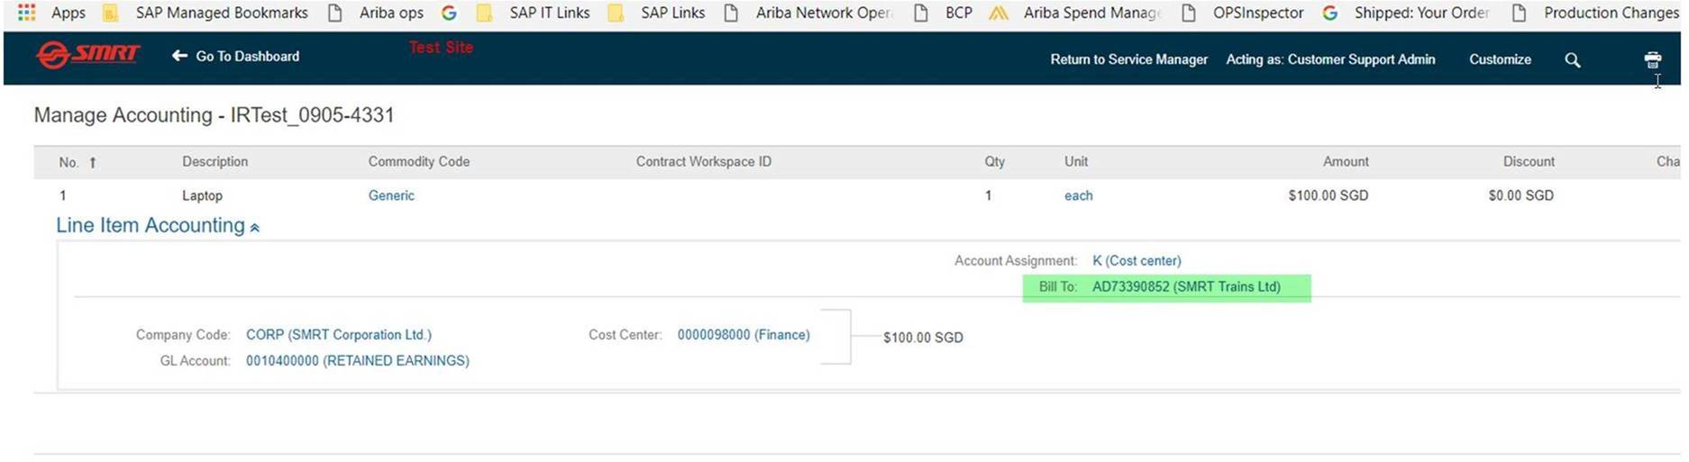

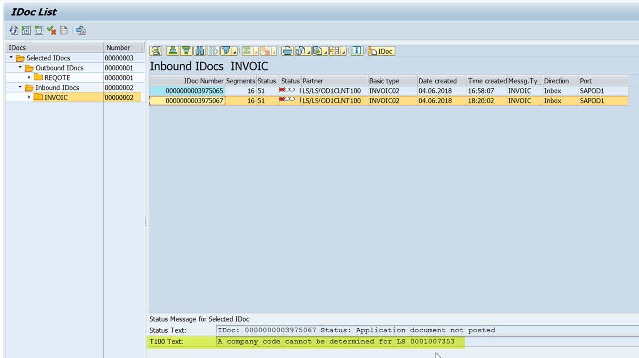

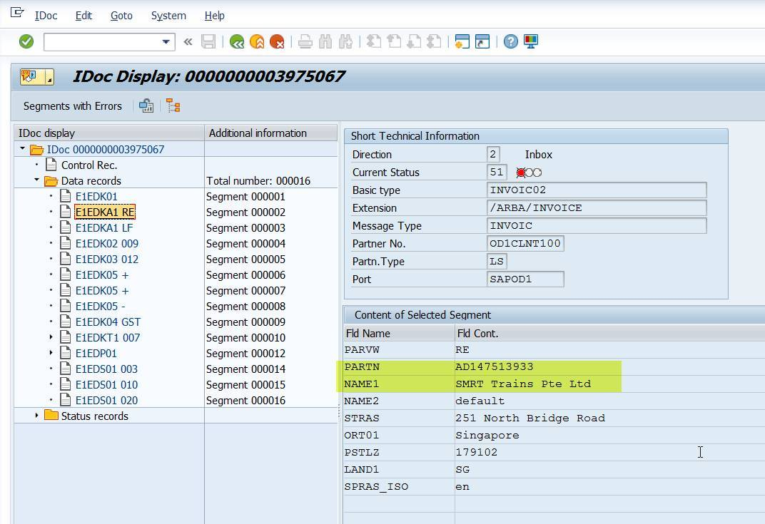

To verify this, we tried re-pushing the IDoc by changing E1EDKA1 RE Segment Values and we are able to resolve the ***Company Code Determination Error***. However a new error related ***Assigning Tax Key*** is thrown which shows incorrect ECC Tax Configurations / incorrect Tax Values being entered while creating the Invoice.

Please refer to the below screenshots.

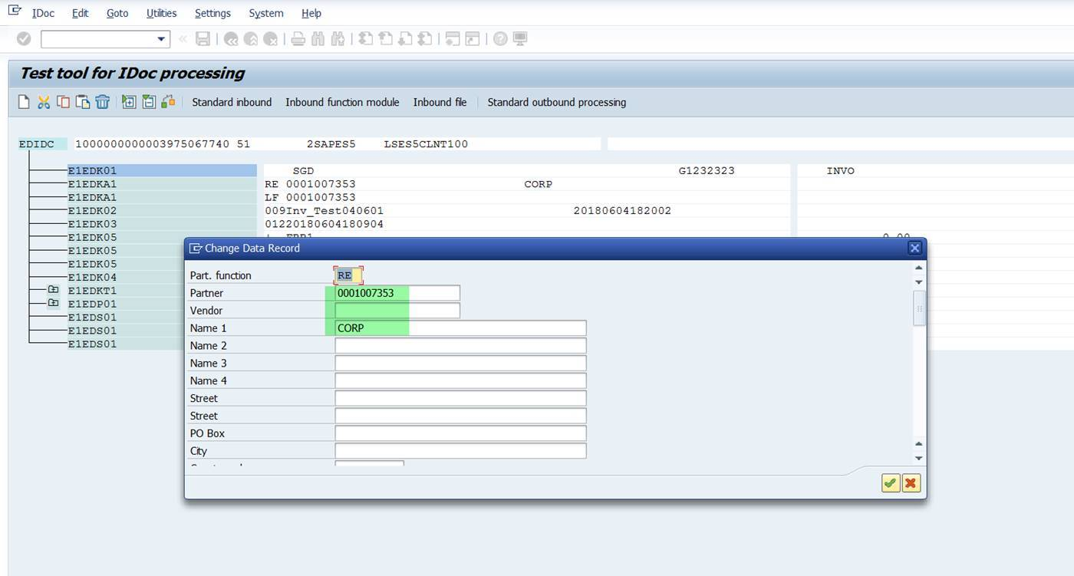

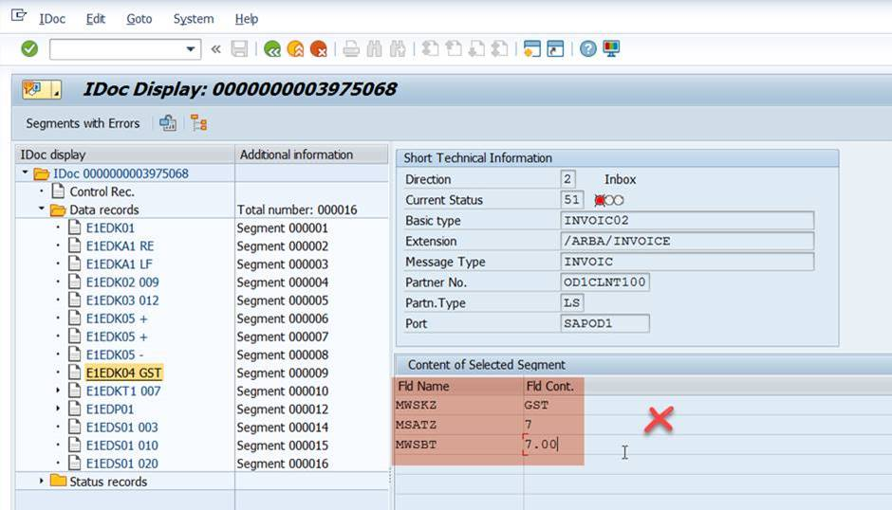               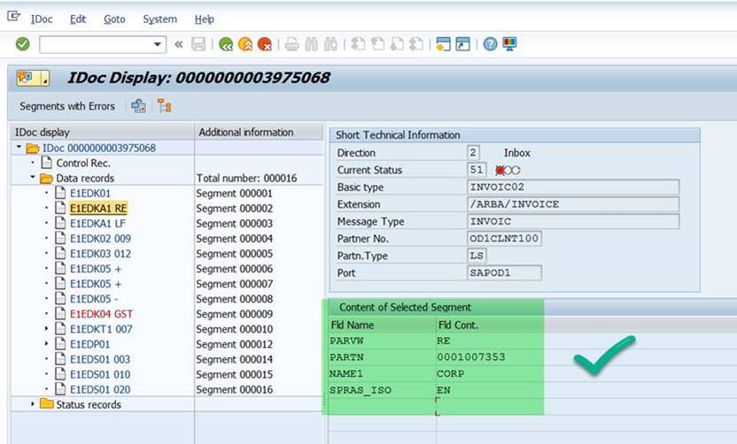

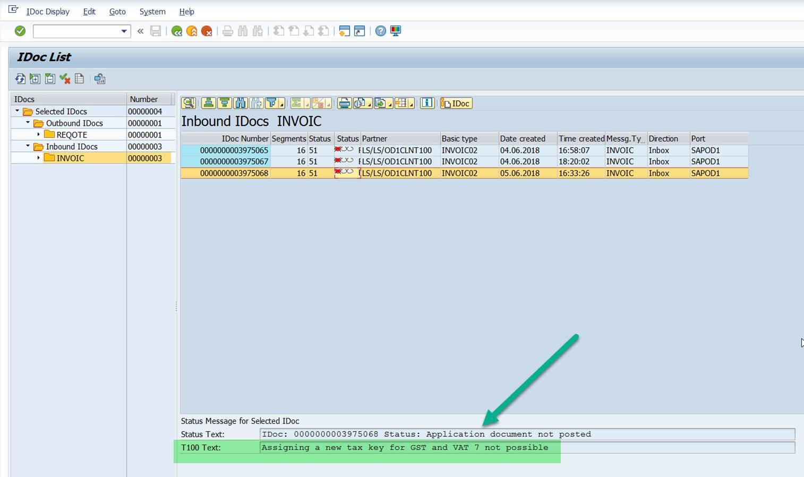

As always please clear the approval flow and approve the IR to post the Reconciled document to AN.

Please do the above steps and let us know the results.