# Supplier Registration Questionnaire in Ariba Network

## Overview

To create an account and do business with SIPCHEM, suppliers must register their company on Ariba Network.

Registration on Ariba Network takes only a few minutes—all that’s needed is basic company information such as the company name, address, and a business contact.

In the previous step (Supplier Request creation) once supplier request is submitted and approved, SRM Representative will send the registration invite to supplier contact. The email message contains a link for starting the registration process.

Below are the processes covered:

* 4.1 - Supplier account creation in Ariba Network
* 4.2 - Supplier responding to Supplier registration questionnaire
* 4.3 - Supplier responding to additional information requested from SIPCHEM
* 4.4 – Supplier responding to complete Modular Questionnaire – Certificates (Saudi Based Supplier)

**Prerequisites**

* N/A

**Helpful Hints**

* Keep all your documents handy like ISO certificate, Code of Conduct, Financial Statement, Company profile, Bank Letterhead.
* If you are already registered with Ariba Network, please contact your Ariba Network Administrator, and request them to create a user account for yourself. This means multiple users getting registered under same supplier’s Ariba Network account.

### 4.1 - Supplier account creation in Ariba Network

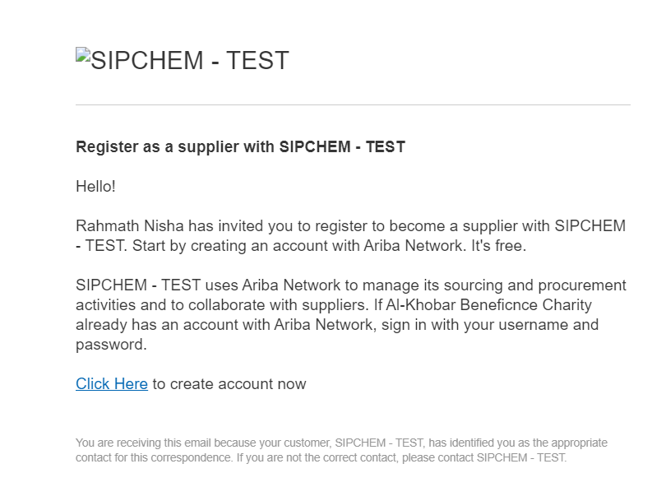

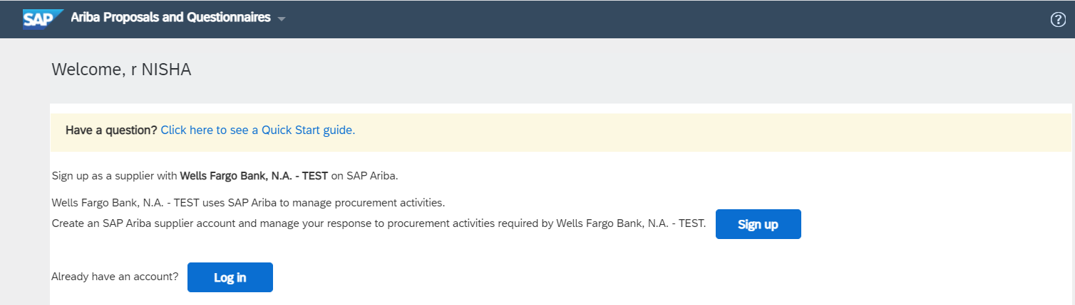

1. You can use one of the following methods to register a new or existing seller account on Ariba Network:

If you received an email invitation from SIPCHEM, click the link in the email message. When Ariba Network shows the welcome page, do one of the following:

* If you already have an account, click **Log in.**
* For New Registration click **Sign up** and then continue with below process**.**

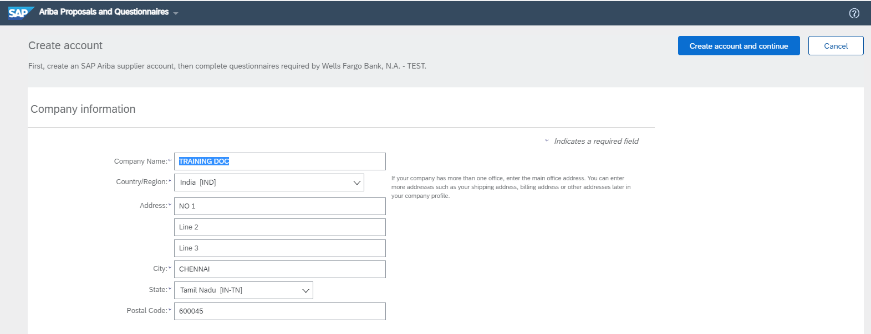

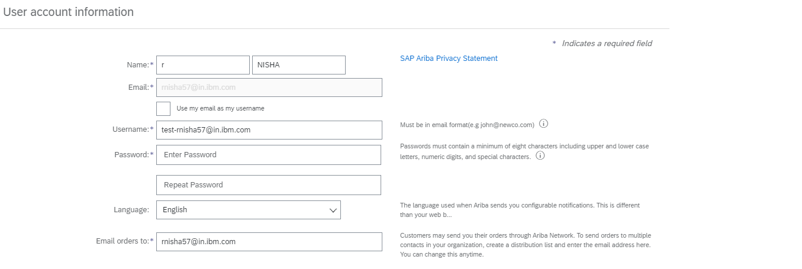

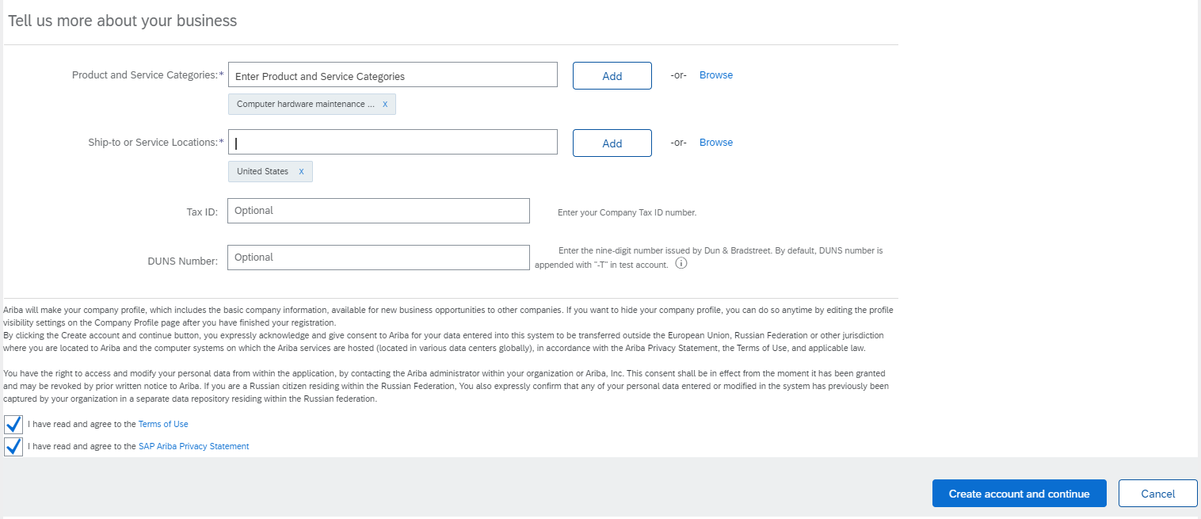

1. Follow the steps in the registration wizard.

* Ariba Network asks for basic information about your business, such as your company name, address, and email address. You also create a username and password.
* The wizard performs automatic address validation to detect and correct any wrong or misspelled portion of a mailing address. A pop-up window shows a recommendation, which you can accept or reject.
* There is an ISO-based country- or region-specific drop-down list for state/province in the address section of the supplier profile. Select from the drop-down list (where available) instead of entering free text.
* Read the terms of use and choose the check box if you agree to the terms.
* Click **Create account and continue.**

Note: Supplier would see fields (Name, Address) auto populated in this page because of the mapping configured between Supplier Request form and Registration form. Supplier can edit these values.

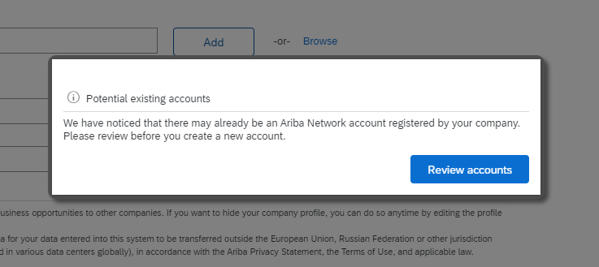

1. Click on **Review accounts** to see the list of potential duplicates.

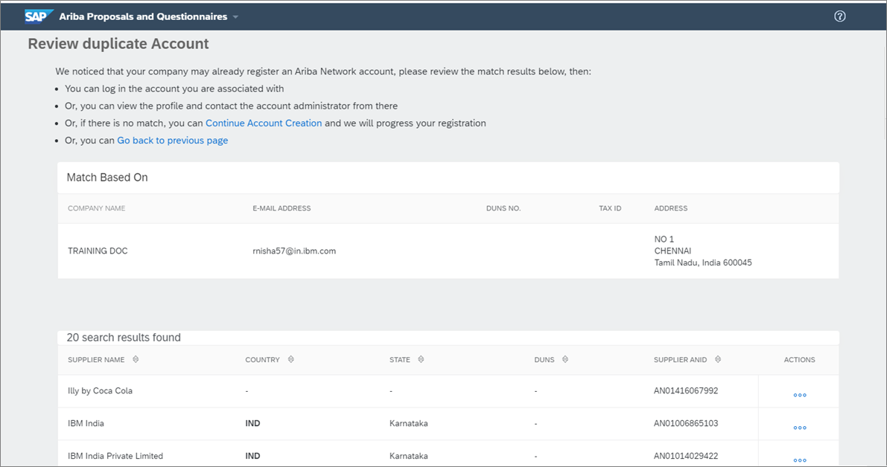

1. Click on **Continue Account creation** if the account is not duplicate; if not **Go back to previous page** and contact your Ariba Network Administrator to create your user id under the same account.

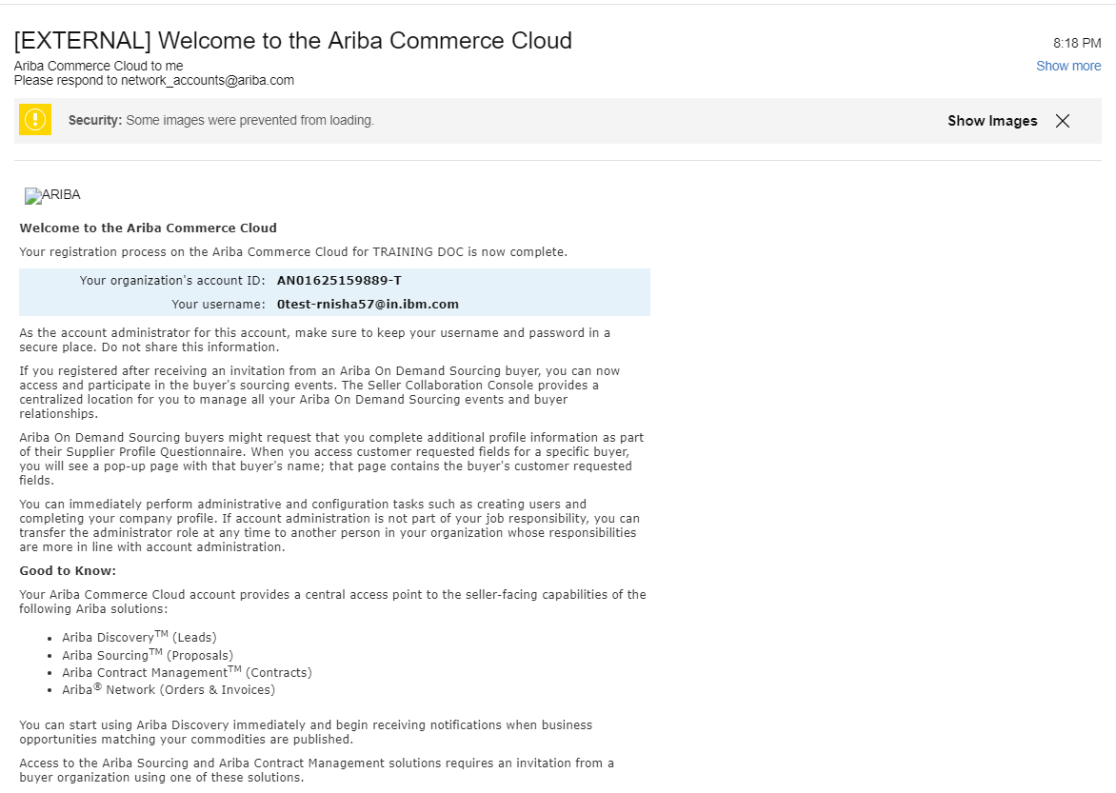

1. Clicking on **Continue Account creation** would direct you to Supplier Registration Questionnaire and supplier would also receive an email confirming the account creation. This means that the Supplier account is successfully created, and the supplier would be able to now respond to the questionnaire via Ariba Network.

*Congratulations! You have created account in Ariba Network successfully*

### 4.2 - Supplier responding to SIPCHEM’s Supplier Registration Questionnaire

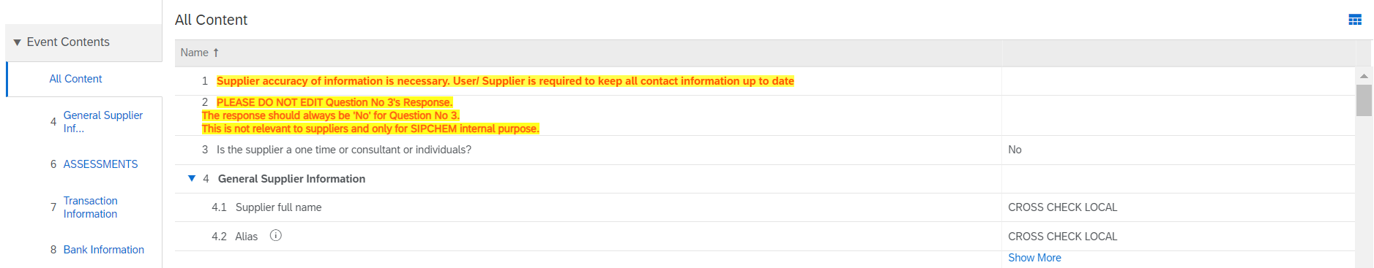

1. Once supplier account is created successfully, you will be directed to SIPCHEM’s *Supplier Registration Questionnaire*.

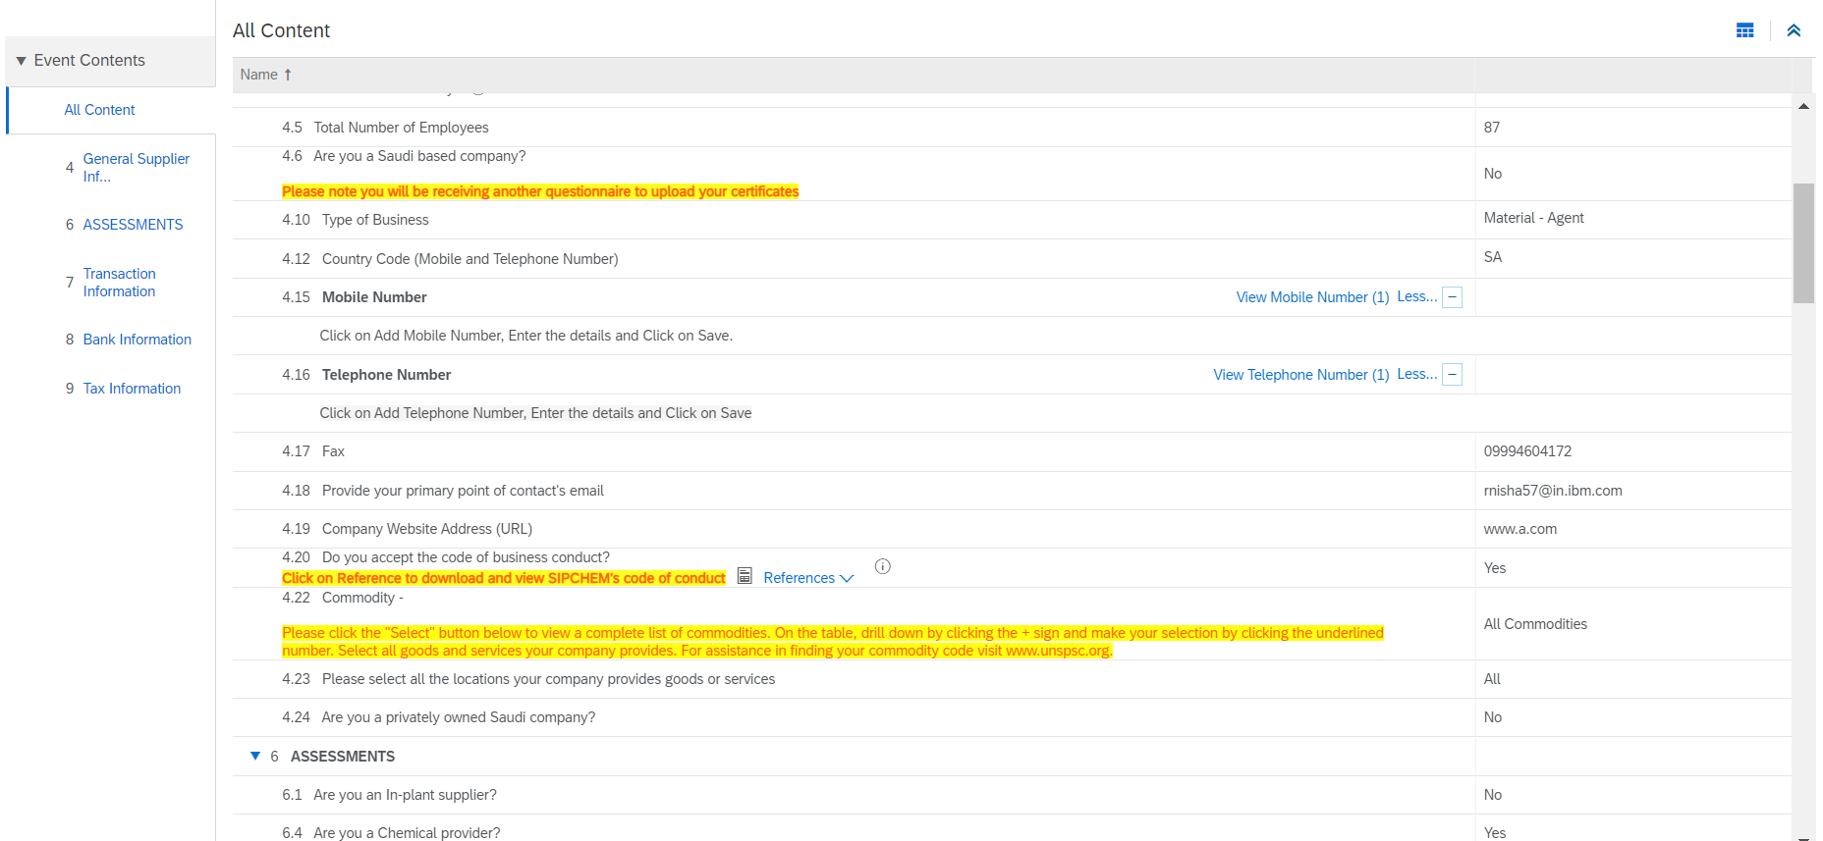

1. Fill in all the mandatory/ desired fields and click on **Submit Entire Response** and click **OK**.

* *Please do not change the response to Question. It should always be No. This is for SIPCHEM’s internal purpose.*
* *Code of conduct has a reference document – SIPCHEM’s code of conduct. You can click on that Reference link to download a copy of the same.*
* *Read all the instructions highlighted in yellow carefully before answering the questions.*
* *If you are a Saudi Based supplier, please choose yes to question “4.6 – Are you a Saudi based company”. please note that you will be receiving another “Certificate questionnaire” to upload your Zakat and Commercial Registration Certificate. Unless you submit “Certificate questionnaire” your registration process is not complete with SIPCHEM.*
* *If you are an Inplant supplier, you need to answer additional questions.*
* *If you are a chemical or motor carrier, you need to answer additional questions.*
* *If you have any questions, you can use the option “Compose Message” to communicate back to SIPCHEM’s point of contact.*
* *You can save your answers by clicking on Save Draft and submit the responses later.*
* *Also, please make sure that you complete the Supplier Registration process within 7 days of receiving the invitation. If not, the questionnaire would be closed.*
* *Additionally, If you a Saudi Based supplier, you must complete the certificate questionnaire complete the same within 3 days of receiving the invitation. If not, the questionnaire would be closed.*

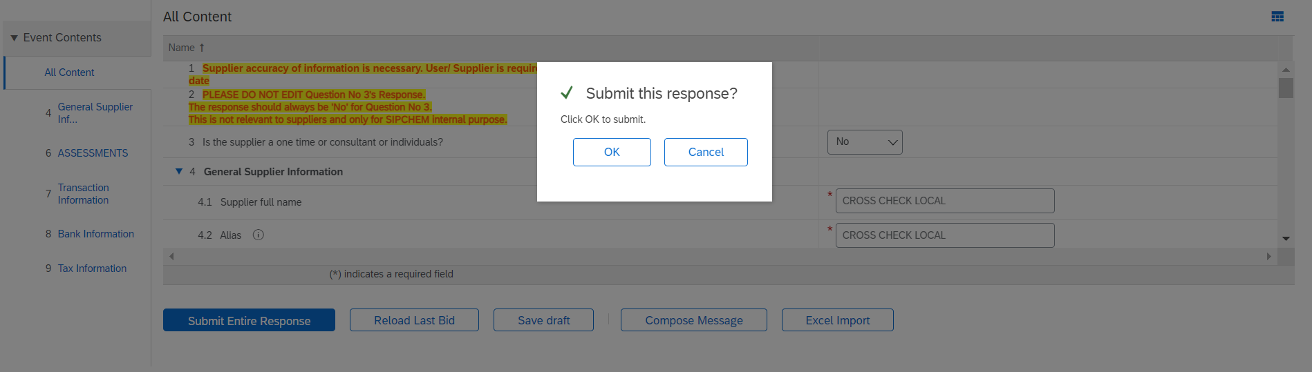

1. Click **OK**.

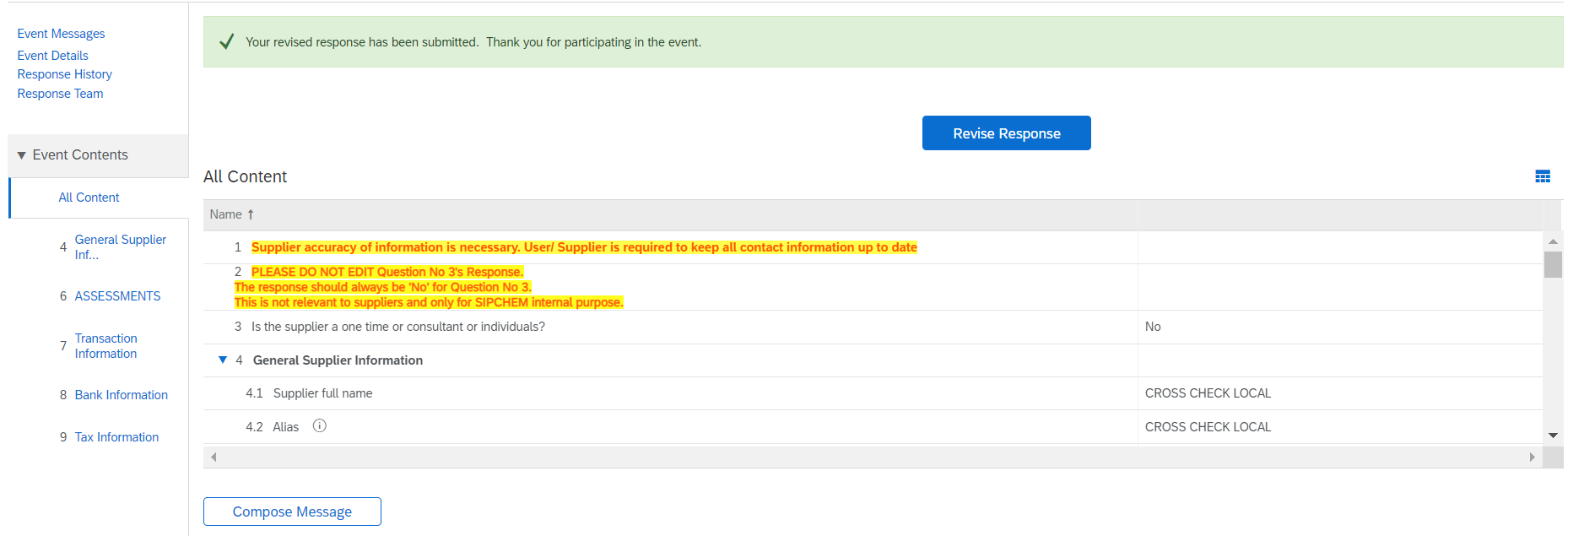

1. The response to Supplier Registration questionnaire has been submitted by the supplier. Next step would be the approval process by SIPCHEM team.

### 4.3 - Supplier responding to additional information requested from SIPCHEM

Once SIPCHEM has requested for additional information, the supplier receives an email indicating what information has been requested. Select **Click here** to login with their credentials.

* *In this example, the request is to update the latest email address.*

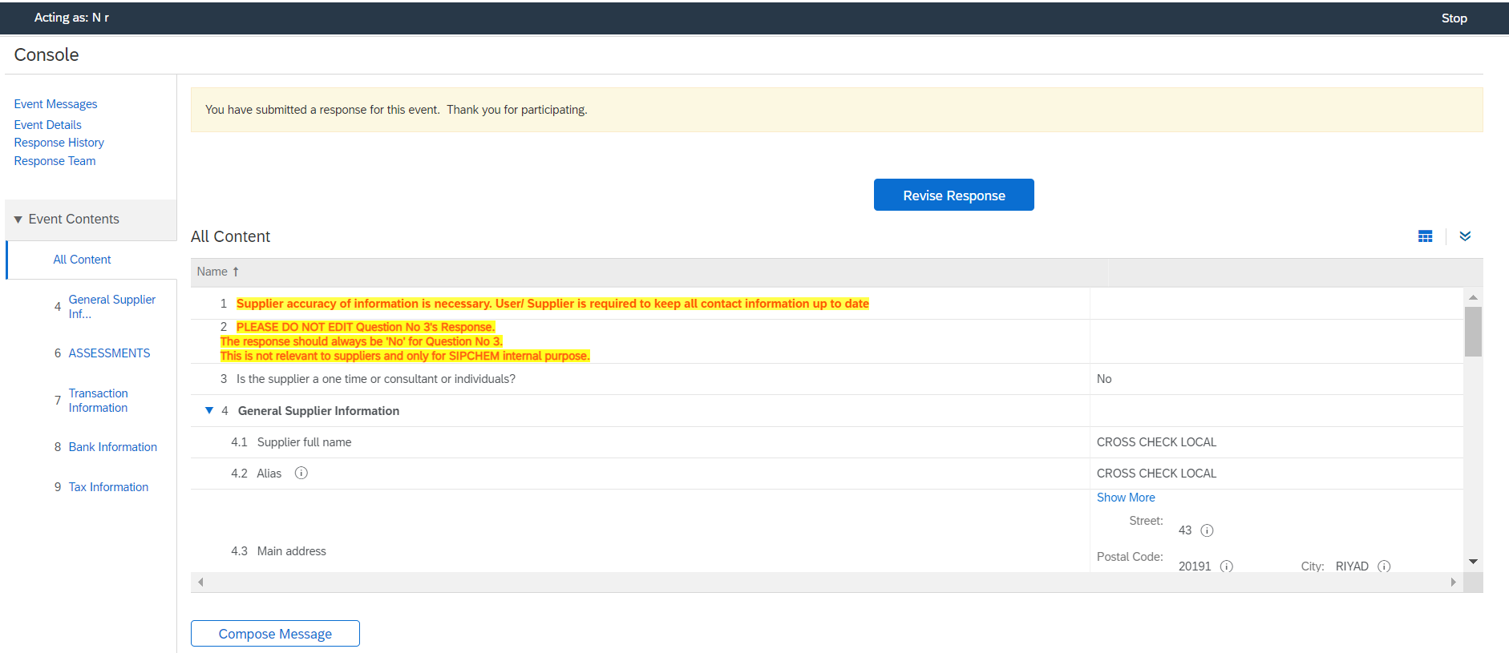

1. From the previous step, you would be landed in Supplier registration questionnaire. Click on **Revise Response** to provide the requested information from SIPCHEM.

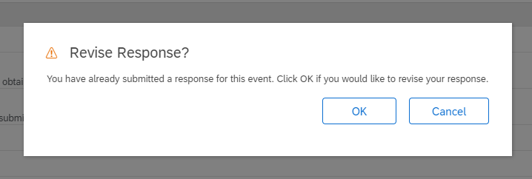

1. Click **OK** to revise your response. This would reopen the questionnaire to edit the responses.

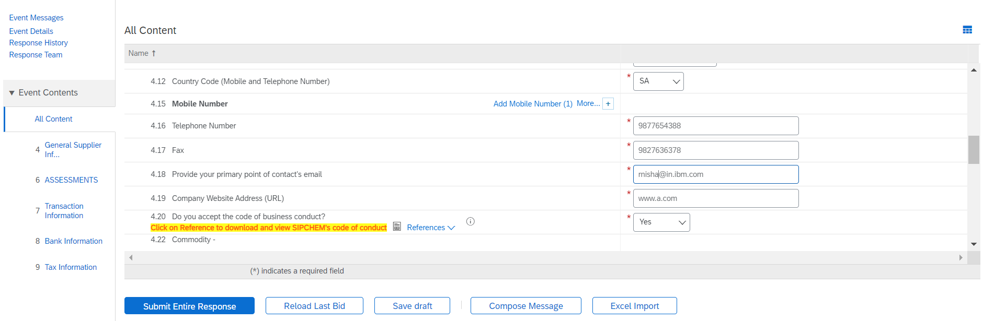

1. Fill in the requested information/updates and click on **Submit Entire Response**.

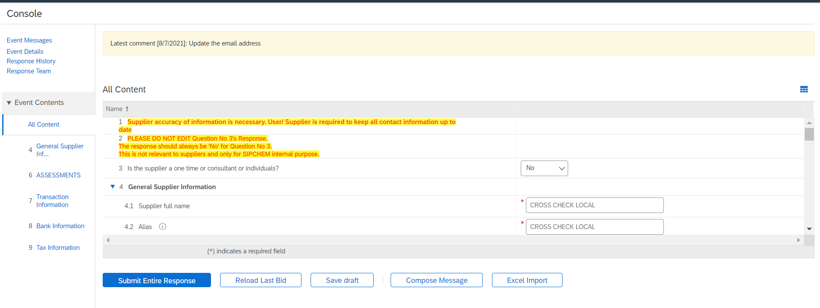

* You can view the requested information from SIPCHEM in the comments section at the top.*

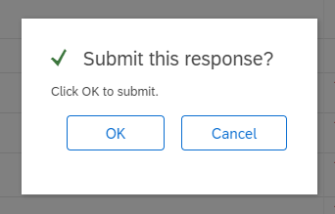

1. Click **OK** to submit the response.

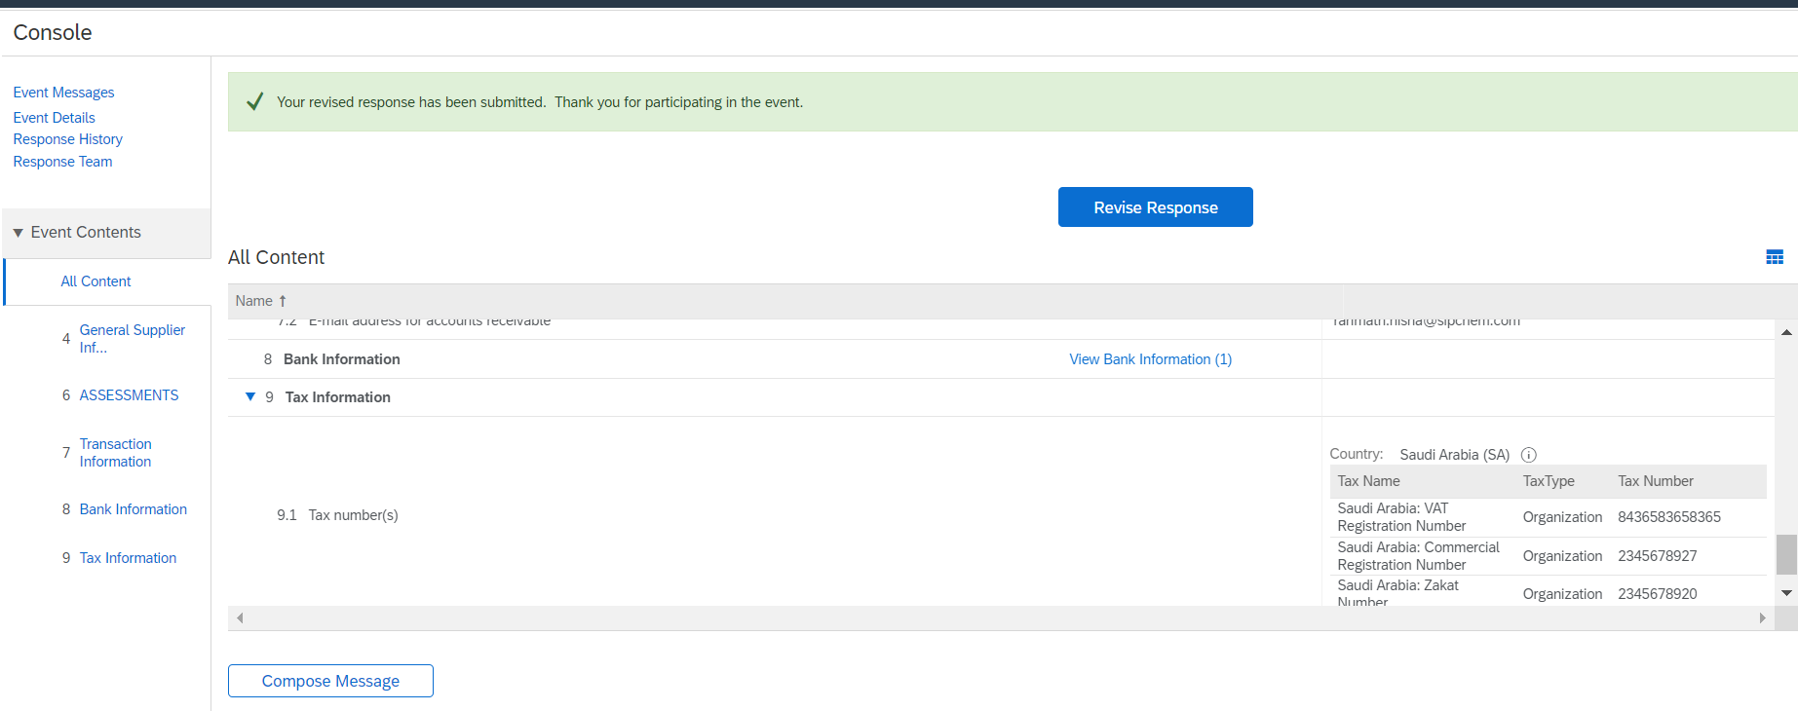

1. Requested information has been revised and submitted for SIPCHEM’s approval.

*The supplier can also use* ***Compose Message*** *option to send any messages/comments to SIPCHEM.*



*Congratulations! You have updated the supplier registration questionnaire.*

### 4.4 – Supplier responding to complete Modular Questionnaire – Certificates (Saudi Based Supplier)

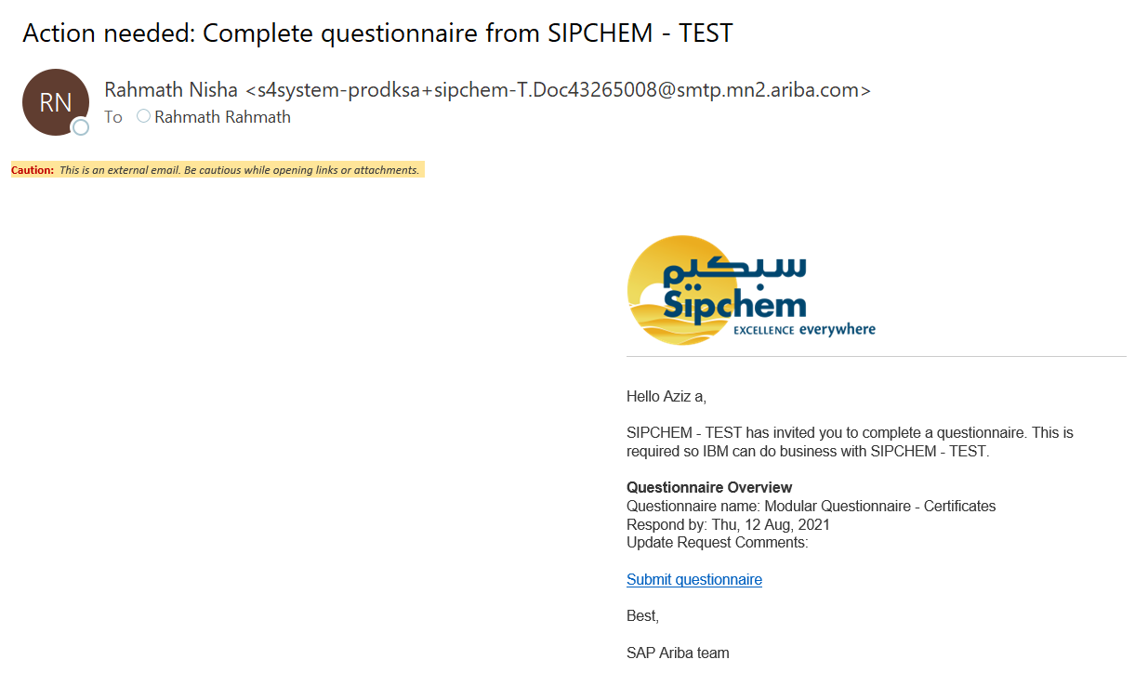

1. If you are Saudi Based company, you would be receiving the above email to upload your certificates such as Zakat and Commercial Registration certificate. You can click on the hyperlink **“Submit questionnaire”** and then login to Ariba Network with your ID and password.

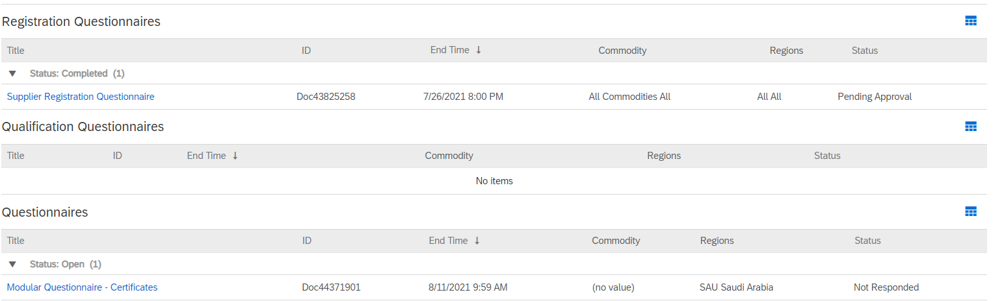

1. Once logged in, click on the “**Modular Questionnaire – Certificates”** to complete the questionnaire.

* *Please note that you will have only 3 days to complete the questionnaire from the day you have received the email notification. Post 3 days, questionnaire will be closed.*

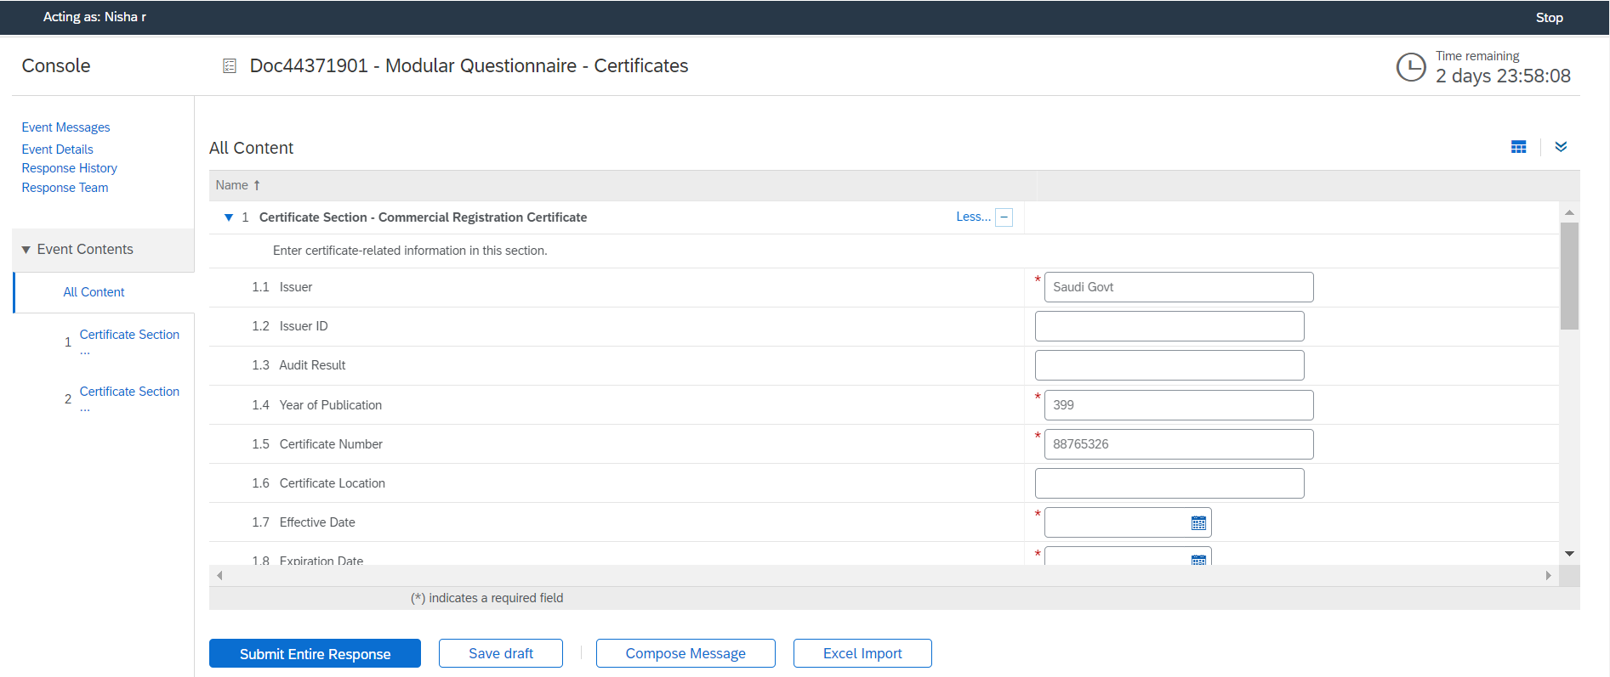

1. Fill in all the desired fields.

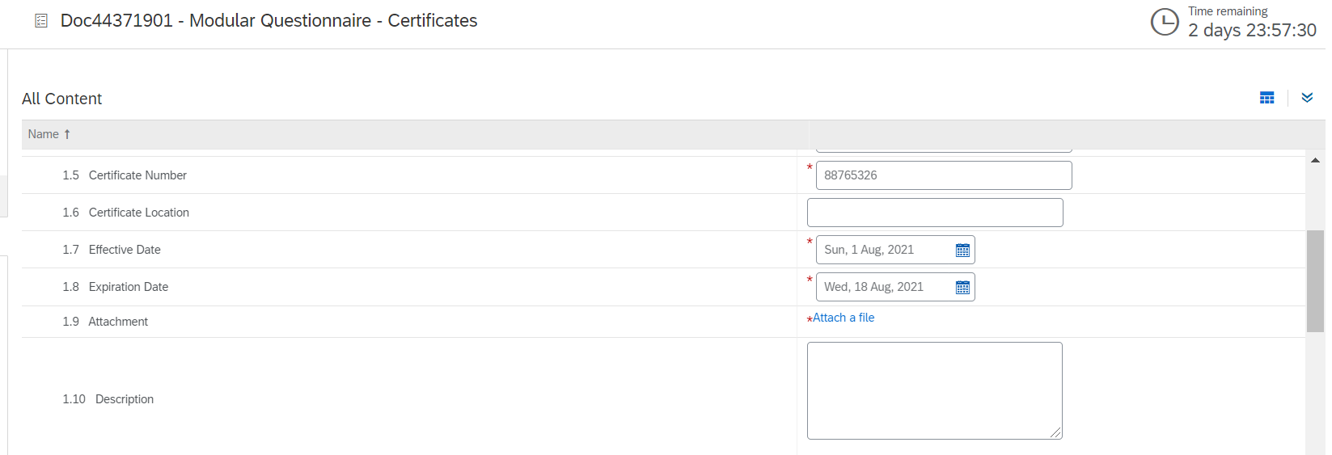

1. You must upload to certificate copy by clicking on the hyper link **“Attach a file”.**

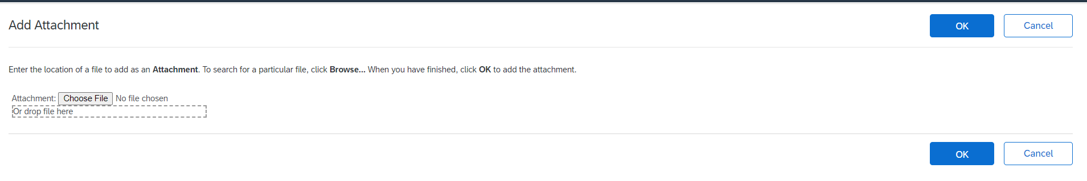

1. Upload the certificate by clicking on “**Choose File”** and locate the file from your computer and upload it. Once done click on **OK**.



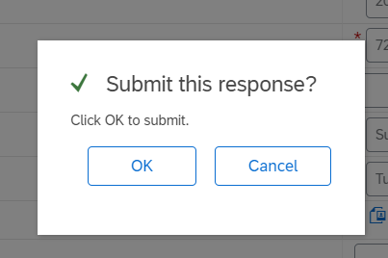

1. Once you have filled all the questions click on Submit Response and then click on OK. This would submit your questionnaire to SIPCHEM’s approval.

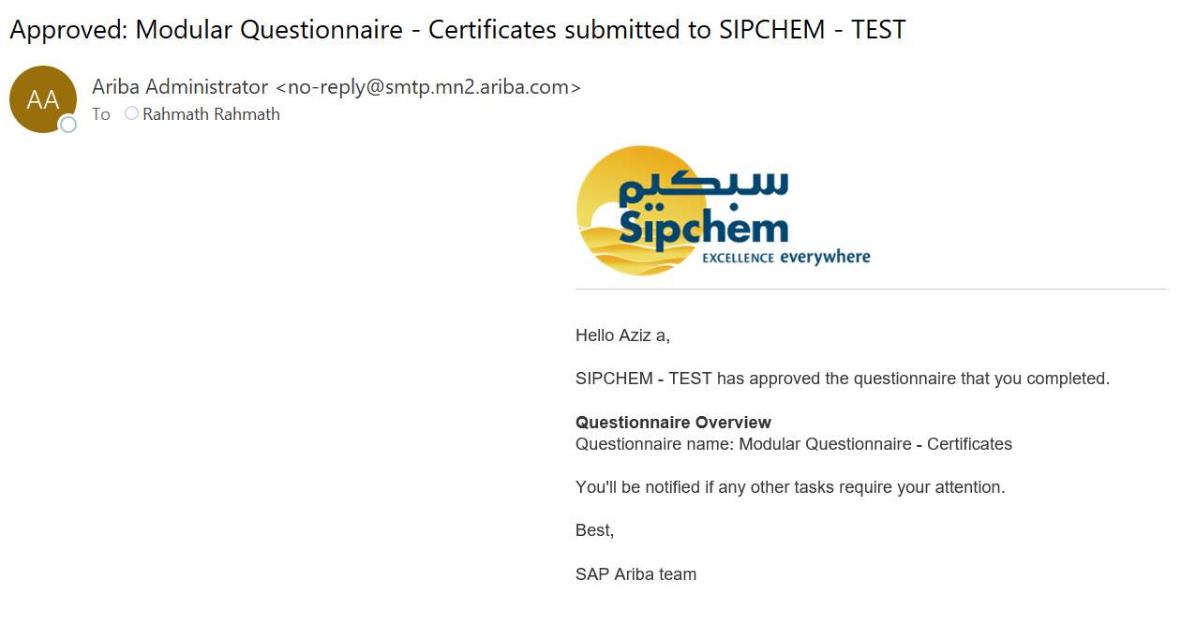

1. Once SIPCHEM has approved your questionnaire, you would be receiving the above email. If SIPCHEM is requesting additional information from you, you would be notified via email. You can access the link and login to Ariba Network. Click on “Revise Response” to update the requested information from SIPCHEM. You can see in the comments what information SIPCHEM needs from you.

* *Certificate maintenance - SAP Ariba will send you multiple reminder notification if your certificates are going to be expired. Please make sure to upload the latest certificate in the questionnaire by clicking on Revise Response on the Modular Questionnaire – Certificates. Attach the latest certificate and update the dates accordingly in the Expiration date. Once done, you can submit the questionnaire to SIPCHEM. SIPCHEM would be reviewing the same and will provide the approval decision.*

*Congratulations! You have submitted the certificate details.*