**Advance Ship Notice (DESADV.DELVRY06) material number mapping causing errors when processing IDOC:**

**Question**

CI-9(HF8), Advance Ship Notice (DESADV.DELVRY06) material number mapping causing errors when processing IDOC  
  
Customer had installed CI9 HF8. During initial unit tests there was discovered that when processing inbound Advance Ship Notice translated IDOC will fail in SAP due to the below error

"the material number is longer than the length set"

The field in question is /DELVRY06/IDOC/E1EDL20/E1EDL24/KDMAT.  
  
Value is being populated via RFC call to SAP hence not based on mapping from incoming cxml.  
  
Please advice the next steps.

**Answer**

Upon checking this issue, we are able to understand that Ariba doesn't map this Field (KDMAT / Customer Material Number) in Standard PI Maps.

The Field ***KDMAT***is not sent when PO's are posted and the Customer Material Number is also not filled from Ariba Network during Ship Notice Creation.

Basically, the ***KDMAT***Field information is pulled from the Table ***KNMT***maintained in SAP ECC.

We have tried replicating this issue with a PO having Material Number and Customer Material Number and able to find that ***KDMAT***is picked from ECC Table - KNMT and got populated in ***DESADV***IDoc.

**KNMT Table:**

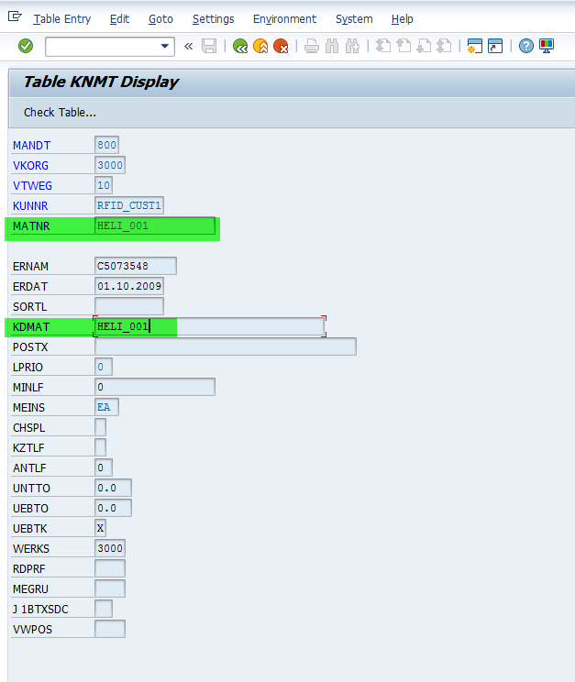

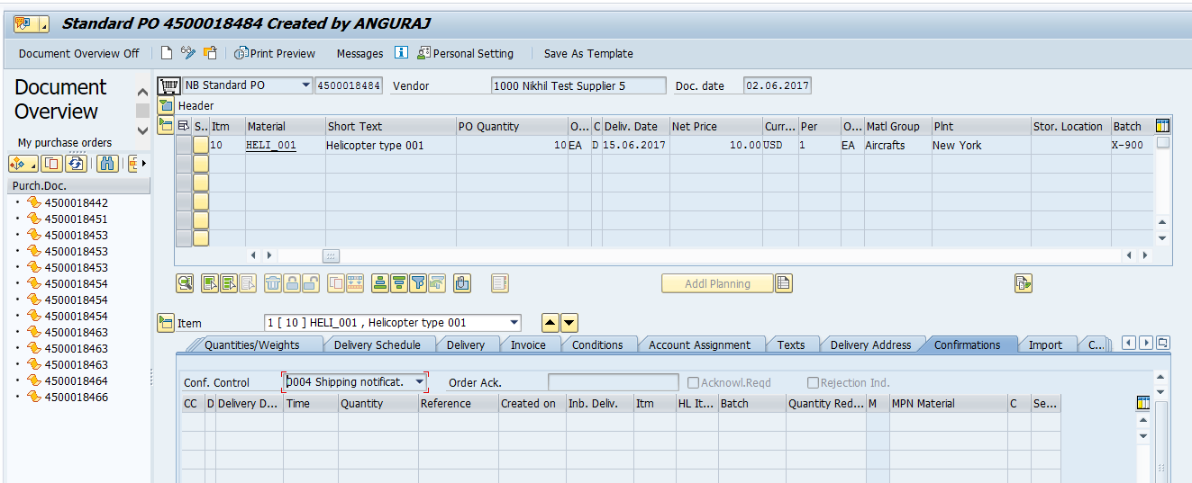

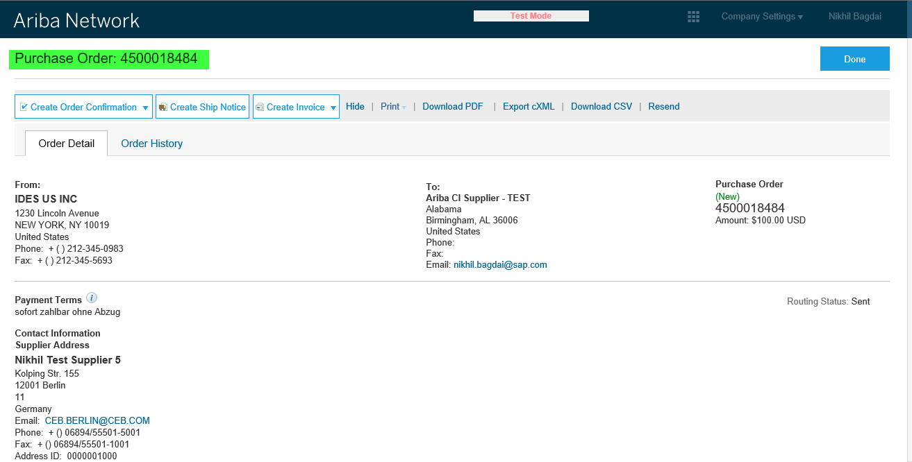

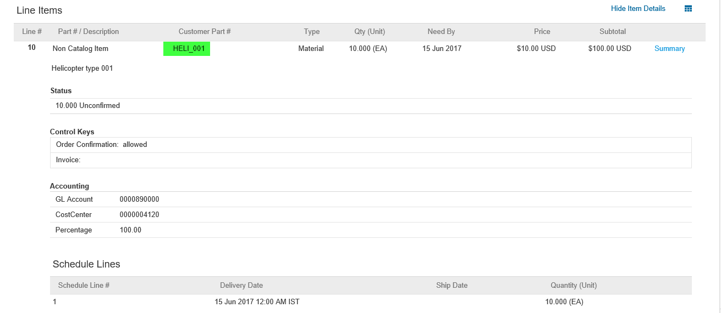

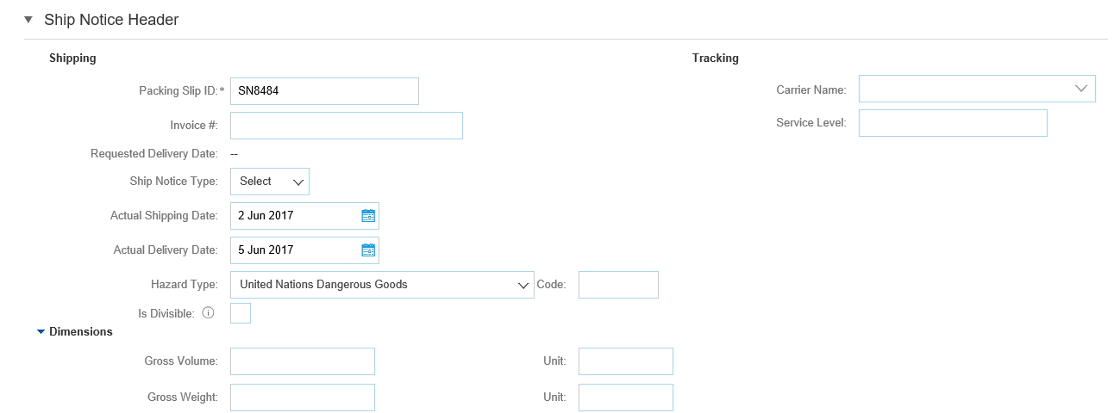

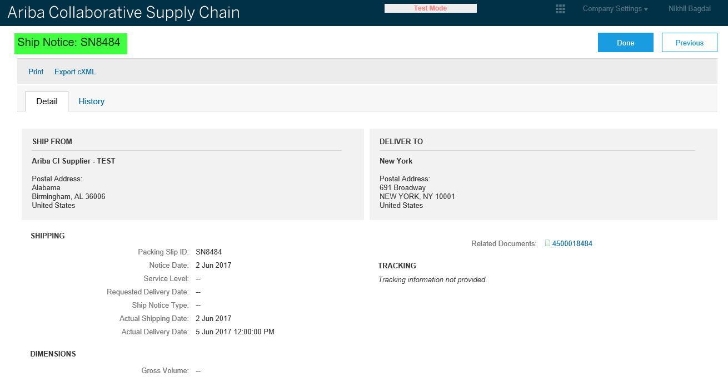

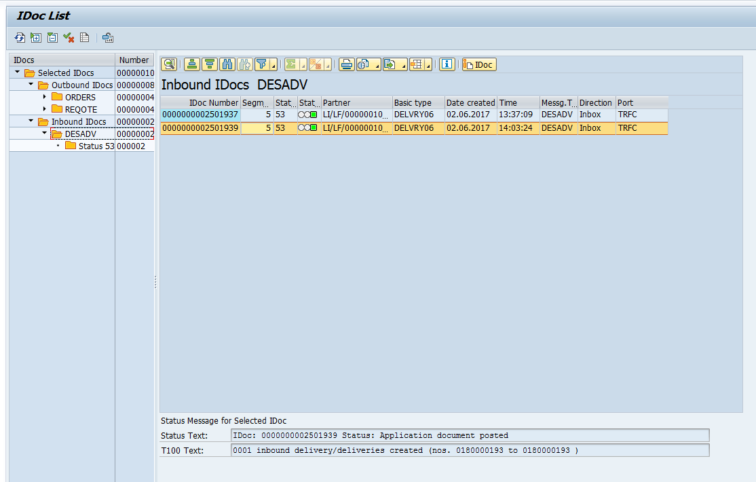

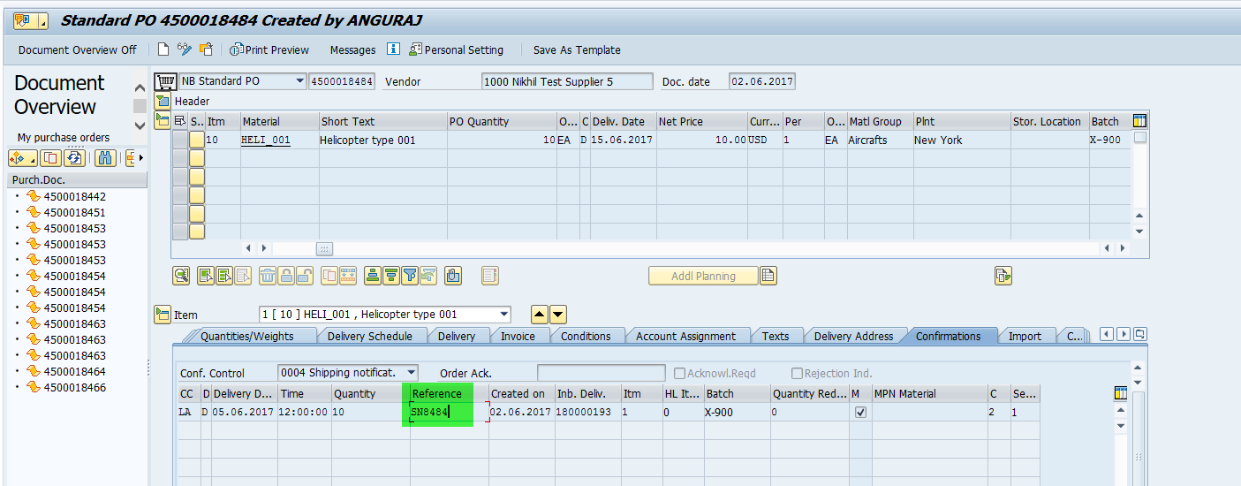

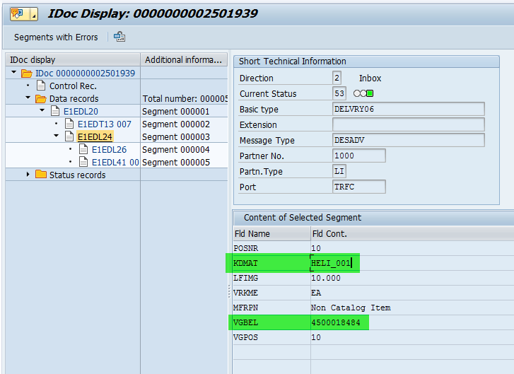

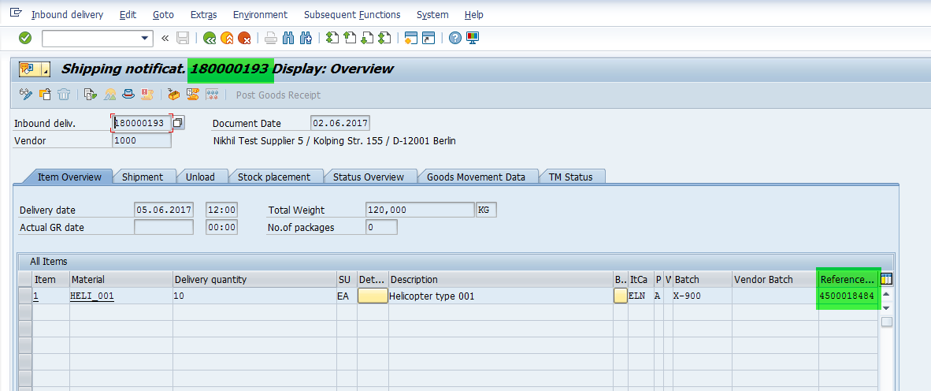

Regarding the Length Constraints, we suggested the Customers to maintain ***KDMAT***based on ECC Limitations and to have this issue checked from ECC Side.