**Ariba Invoicing:**

* A Schwab issued Remit ID is required and issued by Schwab. Please see example below. If a supplier is unable to identify a Remit ID, please email [WFA@schwab.com](mailto:WFA@schwab.com).

**GEN:0000086411:NEW YORK:1:1**

* Invoices can only be submitted on network from a Purchase Order (NON PO or Contract invoicing is not transactable on the Ariba Network)
* All invoices require header level sales tax to be submitted even if value is $0.00.
* Discounts are not to be added to any invoice – header or line level.
* Turn off automatic invoice notifications unless an invoice has been entered and is 30 days past due

**Standard Invoicing Best Practice (**[**Video**](https://cdnapisec.kaltura.com/html5/html5lib/v2.86/mwEmbedFrame.php/p/1921661/uiconf_id/31736811?wid=_1921661&iframeembed=true&playerId=kaltura_player_1507216725&flashvars%5bstreamerType%5d=auto&flashvars%5bplaylistAPI.kpl0Id%5d=1_nnz4ij93)**):**

1. Select purchase order for invoicing
   1. Select tile labeled “Orders”, expand the date range to populate PO listing. If PO older than 365 days, choose exact match option POXXXXX – hit apply settings. If a purchase order is closed and needing to be reopened, please reach out to [VendorManagement@Schwab.com](mailto:VendorManagement@Schwab.com)

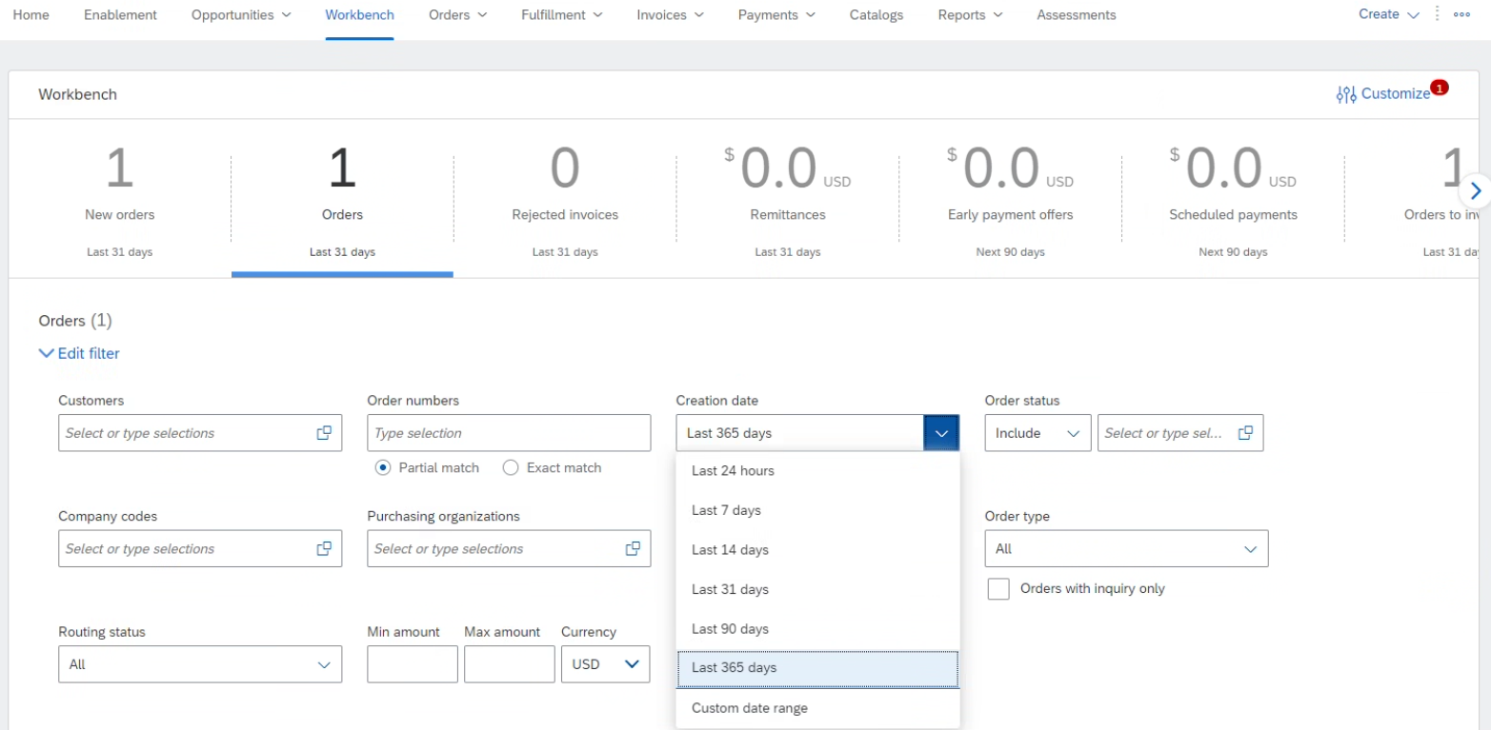

1. Select purchase order - blue hyperlink
   1. Create Invoice 🡪 Standard Invoice

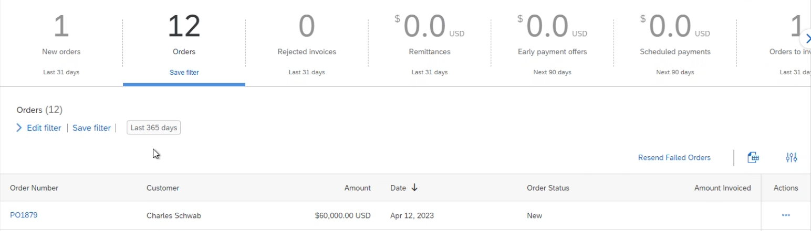

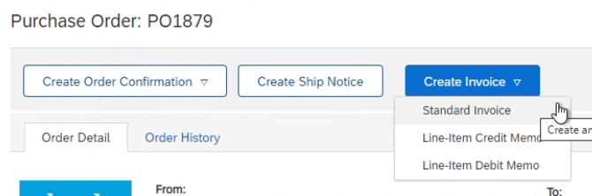

1. Invoice # - Number should not contain lower case letters or special characters (#, -, !) and should not be a duplicate #
2. **Taxes must be submitted at Header Level (only 1 tax line allowed)** - even when value is equal to $0.00
   1. Select “Header level” and open tax box (tax box will not populate if the shipping is listed as “Line level shipping” – this icon needs to be selected at header level to populate correct options)
      1. Add to Header 🡪 Tax
   2. From the tax box, second column
      1. 3rd box Rate(%): enter tax rate (0 if no tax)
      2. 4th box Tax Amount: enter tax amount (0 if no tax) 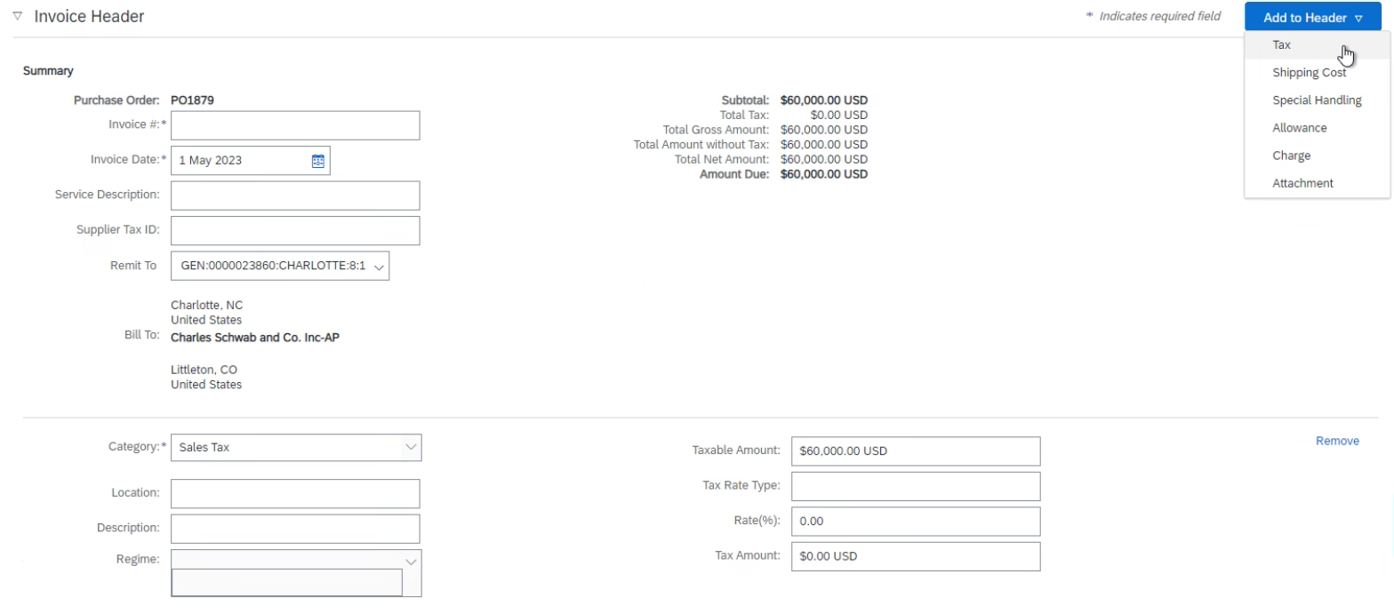
   3. Remove extra tax boxes if needed. “Sales tax” is the only valid category for our invoicing.
3. Add attachments/support to submitted invoices (highly encouraged)
   1. Select Add to Header drop down 🡪 Attachment 🡪 Choose File 🡪 Add Attachment
4. Select line(s) from PO for billing
   1. If invoicing against a multi-line PO and not all lines are being billed, please do not delete unused lines. Instead, click the green icon “include” so it turns off/grey
   2. Adjust quantity billable if necessary
   3. If submitting one invoice for two PO’s, please create two separate invoices, one per purchase order.

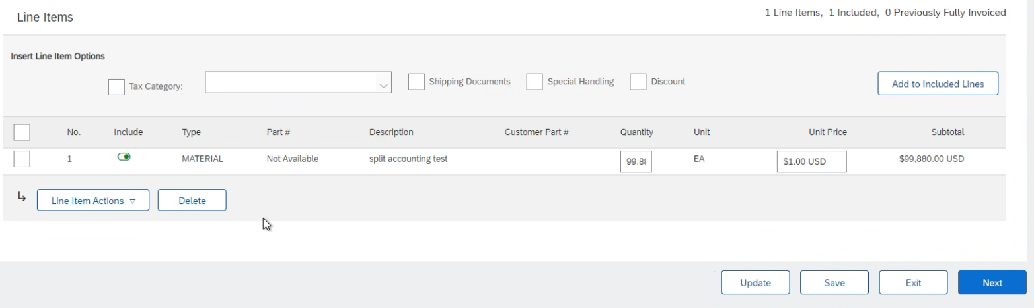

1. Click “Update” –system will populate an error box preventing submission if all *required* criteria are not met
2. Click Next 🡪 verify all information is correct (invoicing amount, taxes, PO#, Remit to) 🡪 Submit

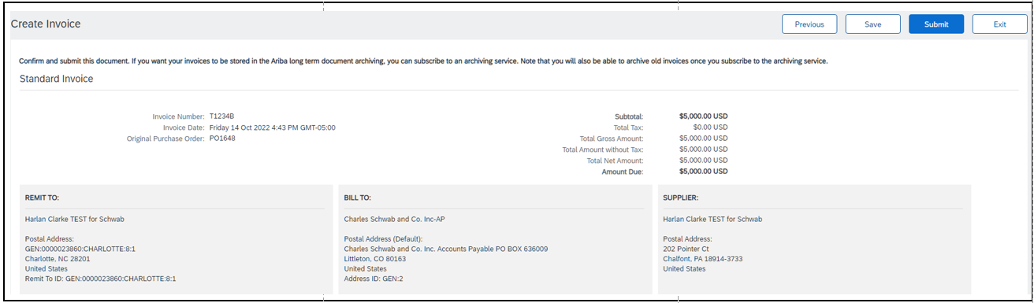

**Line Item Credit Best Practice (**[**Video**](https://cdnapisec.kaltura.com/html5/html5lib/v2.86/mwEmbedFrame.php/p/1921661/uiconf_id/31736811?wid=_1921661&iframeembed=true&playerId=kaltura_player_1507216725&flashvars%5bstreamerType%5d=auto&flashvars%5bplaylistAPI.kpl0Id%5d=1_nnz4ij93)**):**

1. Click the Invoices tab.
2. Select your previously created invoice.
3. Click the Create Line-Item Credit Memo button on the Invoice screen.
4. Complete information in the form (the amount and taxes will automatically be negative). Make sure that all required fields marked with asterisks (*) are filled in.
5. Click Next > Review Credit Memo > Submit.

**Checking Status (**[**Video**](https://cdnapisec.kaltura.com/html5/html5lib/v2.86/mwEmbedFrame.php/p/1921661/uiconf_id/31736811?wid=_1921661&iframeembed=true&playerId=kaltura_player_1507216725&flashvars%5bstreamerType%5d=auto&flashvars%5bplaylistAPI.kpl0Id%5d=1_nnz4ij93)**):**

* Routing status reflects the transmission of the invoice to Charles Schwab
  + Obsoleted: You canceled the invoice.
  + Failed: Invoice failed your Buyer's invoicing rules. Your Buyer will not receive this invoice.
  + Queued: Ariba Network received the invoice but has not processed it.
  + Sent: Ariba Network sent the invoice to a queue. The invoice is awaiting pickup by the customer.
  + Acknowledged: Your Buyer invoicing application has acknowledged the receipt of the invoice.
* Invoice Status reflects the status of Charles Schwab’s action on the Invoice
  + Sent: the invoice is sent to your Buyer but they have not yet verified the invoice against POs and receipts.
  + Cancelled: your buyer approved the invoice cancellation.
  + Paid: your buyer paid the invoice/is in the process of issuing payment.
  + Approved: your buyer has verified the invoice against POs or contracts and receipts and approved payment.
  + Rejected: your Buyer has rejected the invoice or the invoice failed validation by Ariba Network.
  + Failed: Ariba Network experienced a problem routing the invoice. Verify invoicing requirement and resubmit.
* Invoice History / Comments / Scheduled Payments

1. Click on the History tab to view status details and invoice history.
2. History and status comments for the invoice are displayed.
3. Transaction history can be used in problem determination for failed or rejected transactions.
4. When you are done reviewing the history, click Done. Steps are similar for Payments.

For additional support:

**Vendor Management:** (Assistance with creating a purchase order, changing an existing purchase order) [VendorManagement@schwab.com](mailto:VendorManagement@schwab.com)

**Supplier Enablement:** (Ariba Network onboarding) [SupplierEnablement@schwab.com](mailto:SupplierEnablement@schwab.com)

**Invoices for Processing:** (General questions, manual invoice submissions, status updates or where to guidance) [WFA@schwab.com](mailto:WFA@schwab.com)

**Charles Schwab Supplier Information Portal:** <https://support.ariba.com/item/view/192831>

**Video Tutorials (downgrade to Standard Account, forgot username/password, etc) :** [Kaltura Embed Player iFrame](https://cdnapisec.kaltura.com/html5/html5lib/v2.86/mwEmbedFrame.php/p/1921661/uiconf_id/31736811?wid=_1921661&iframeembed=true&playerId=kaltura_player_1507216725&flashvars%5bstreamerType%5d=auto&flashvars%5bplaylistAPI.kpl0Id%5d=1_nnz4ij93)

**SAP Business Network Supplier Learning Site (not specific to Charles Schwab):** [Learning Site](https://support.ariba.com/Adapt/SAP_Business_Network_Supplier_Training/#/)

Helpful tips:

* You should only have 1 ANID with Schwab per Tax ID – add users to the account if needed (each user should not have a different ANID)
* Company name changes and/or buyouts may require a new ANID and creating new POs
* You can’t use future invoice dates – Please adjust the date to the current date or submit later
* Be sure to use the actual invoice date so invoices pay on time
* If your remit ID needs to be updated, contact [WFA@schwab.com](mailto:WFA@schwab.com) for the remit string and set the update by:
  + Selecting the circle widget to the upper right hand corner with your initials
  + Select Setting -> Remittances -> edit
  + Enter the remit ID string into “Remit Id” box for Charles Schwab
  + Save
* Combine multiple taxes (state, city, county, etc) into one tax line
* You can’t overbill a PO line – Please contact your Schwab business partner for updated billing instructions
* If Ariba says there is an error but doesn’t identify on the entry page, header tax is probably missing
* Review error/reject notices from Ariba and Schwab by navigating to the invoice and viewing the notes in the blue reject comments box