CI-7 Feature CI-509 – Transfer RFQ Line Item Attachments:

Business Problem
Current integration does not support transfer of RFQ attachments on the line item level.
This needs to be supported as customers want to make documents available for Suppliers that contain detailed product specifications, i.e. Drawings.
Currently it is possible to send attachments on the header level only.
Solution Overview
- Using existing SAP DMS (Document Management System) functionality will allow user to add attachments on the line level. These attachments will now be sent to AN
- No limitation will be set on the SAP side for size or file types. If SAP allows for it in standard RFQ creation/change, then this will be supported in AN as well.
- Limitation: AN can support a maximum attachment size: 100 MB

Screenshots
Prerequisite for sending Line Level Attachments in RFQ:
Go to T-Code: /n
Navigate to Central Functions --> Document Management System --> Document --> Create
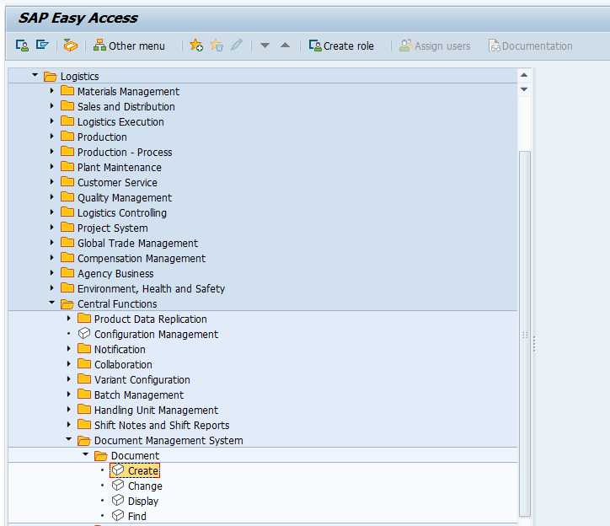

Enter the following details.
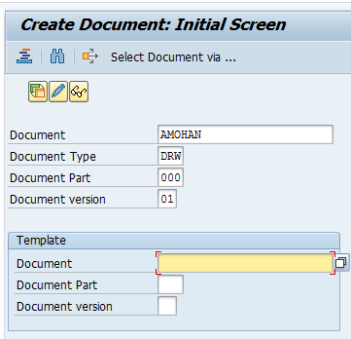
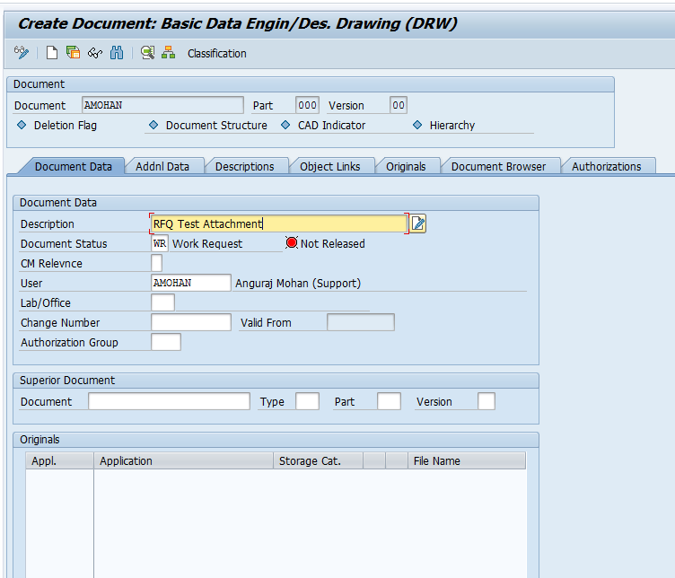

Click on Create and choose the Attachment file.
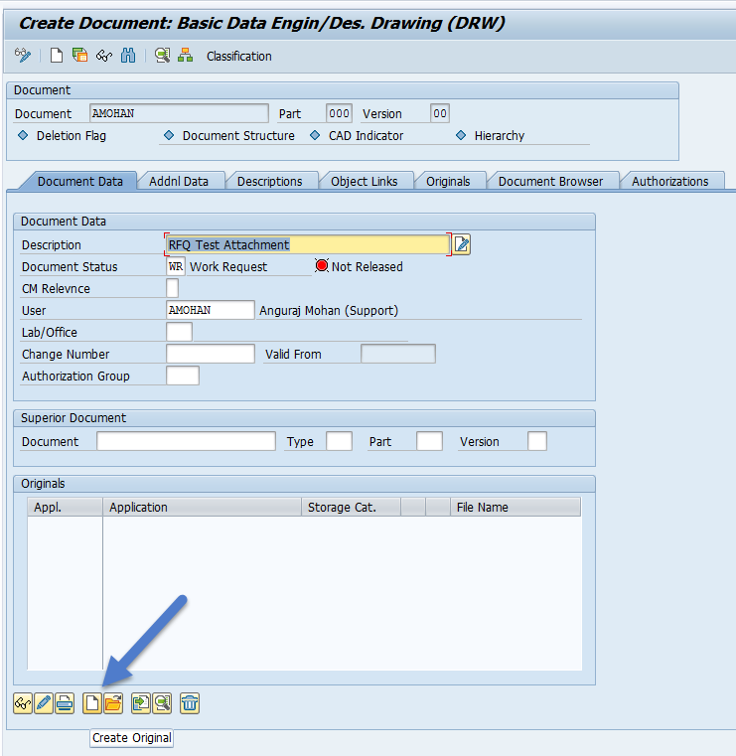
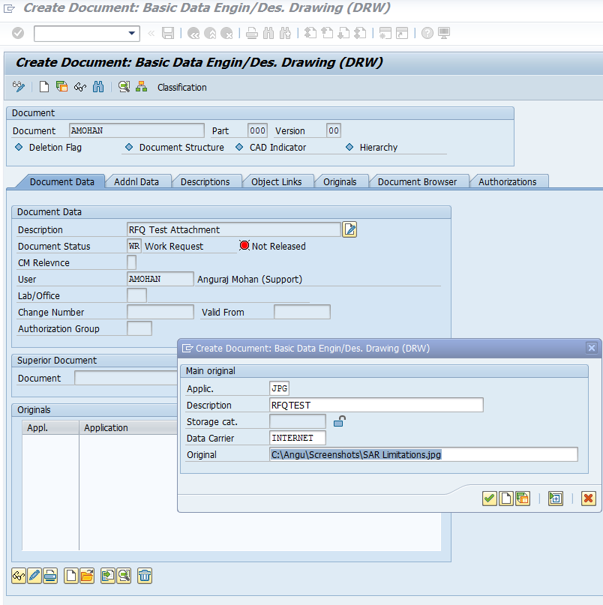

After choosing the attachment, right click on the attachment and choose Check In As… à DMS_C1_ST – Default Storage DMS (main files)
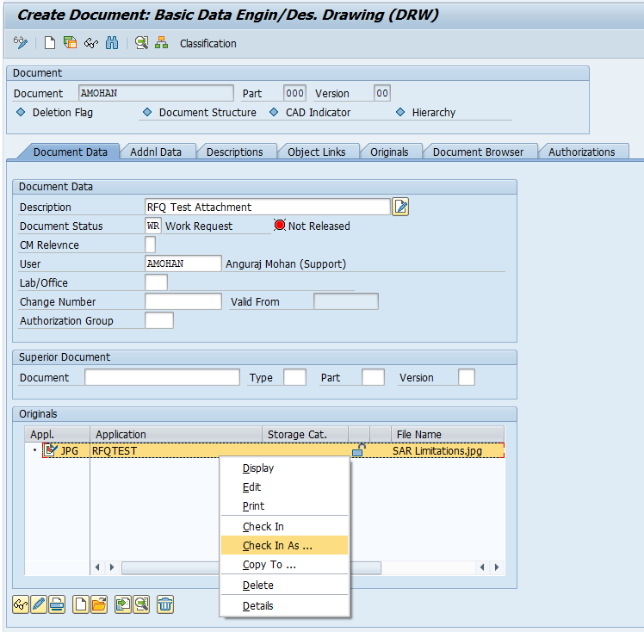
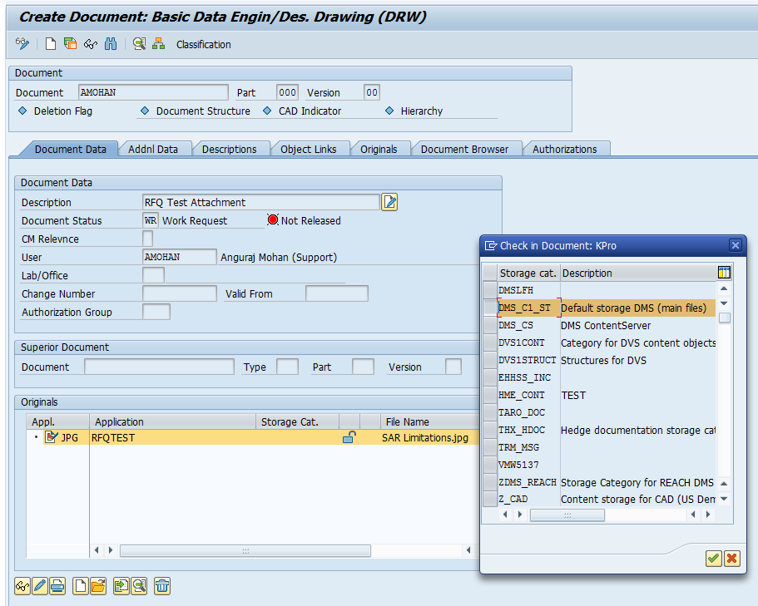

Click on Save.
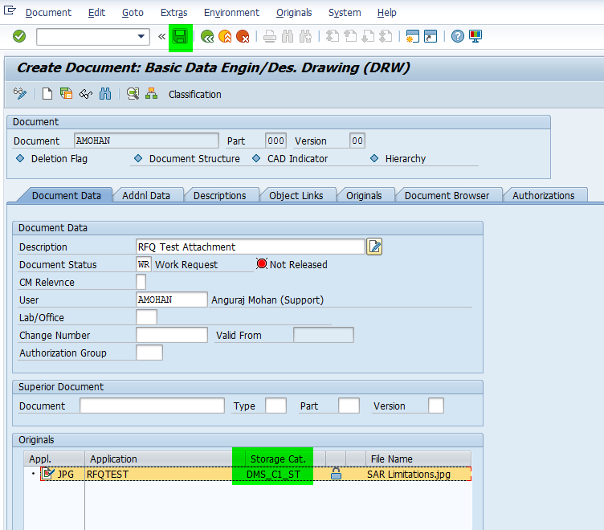

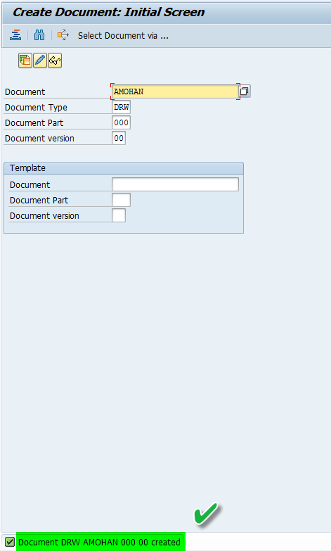

Sending RFQ with Line Item Level Attachments:
Go to T-Code: ME41
Enter the following details.
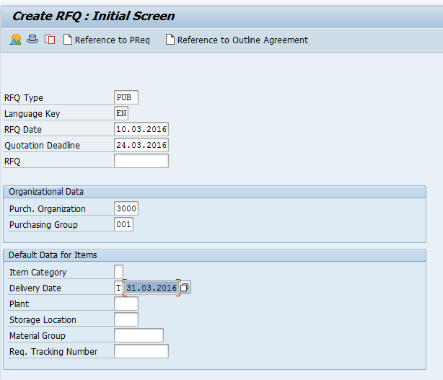
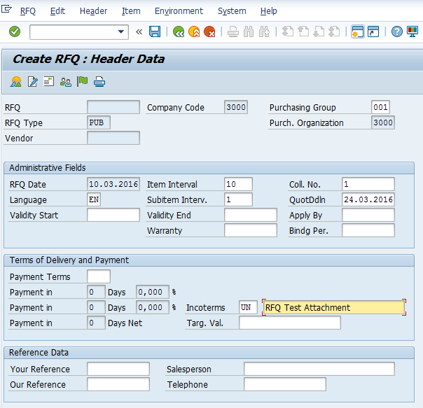
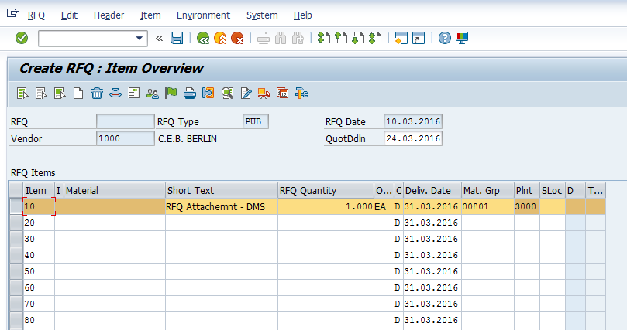

Go to Menu Path: Item -> More Functions -> Documents
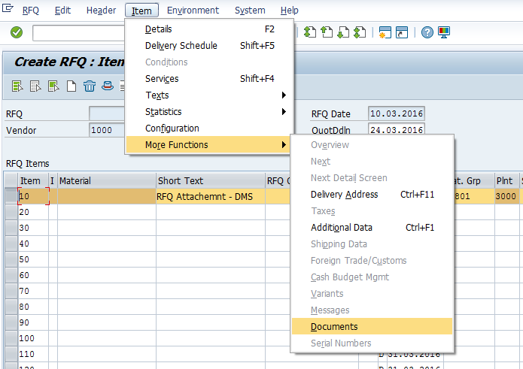

Choose the Document that you have created in the Document Management System.
Enter Type: DRW and Search for the Document as shown below.
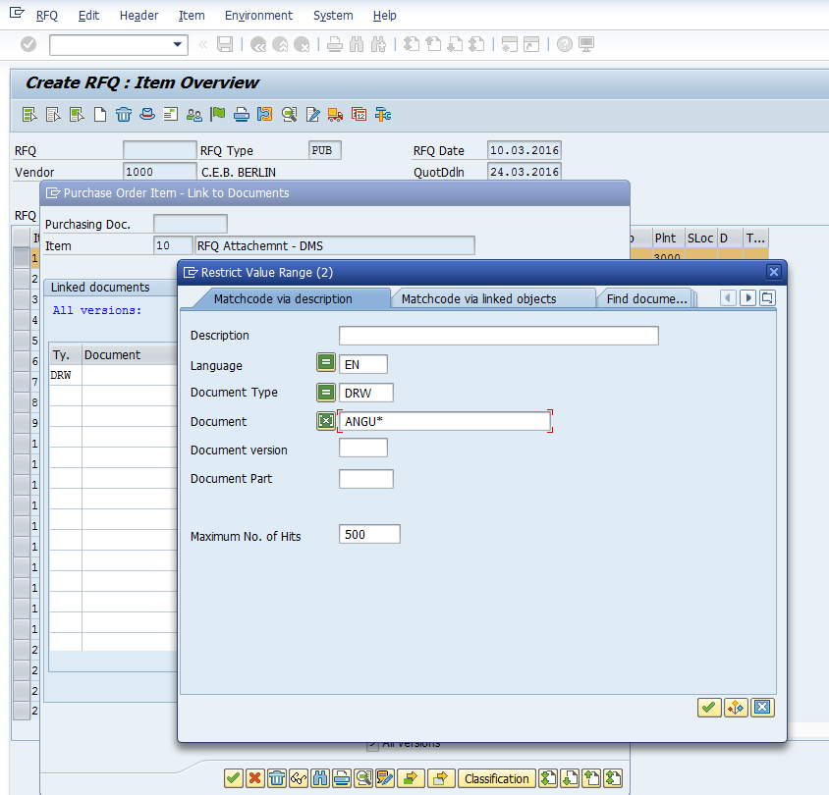
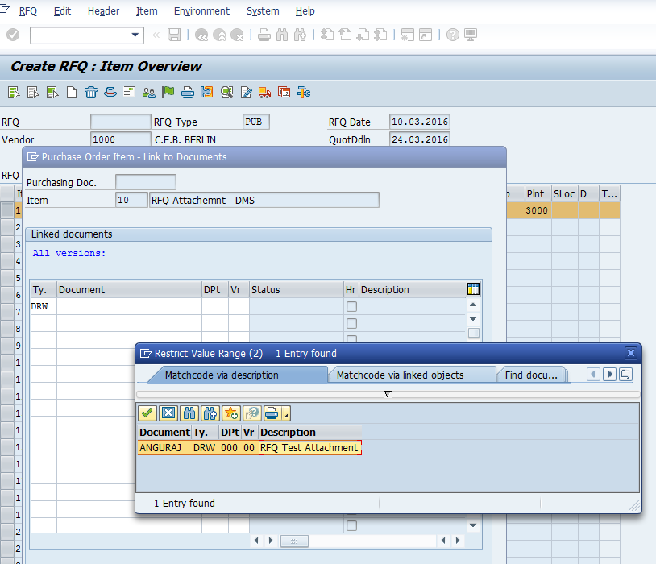
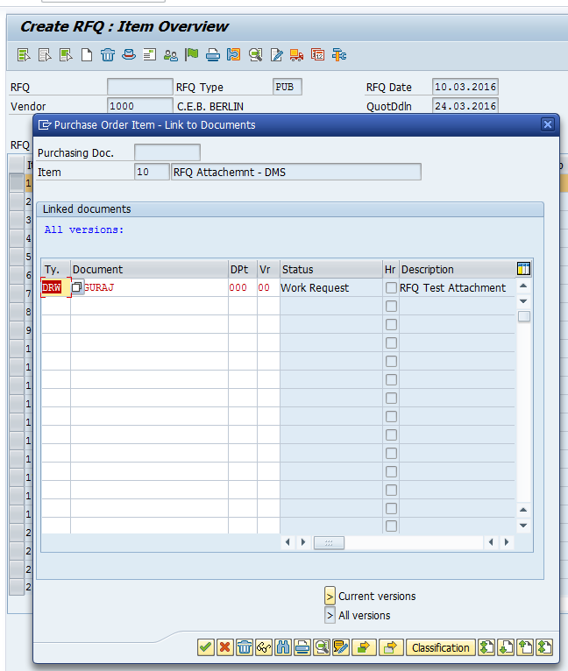

After selecting the document, click on Save. This will create an RFQ with Line Level Attachment.
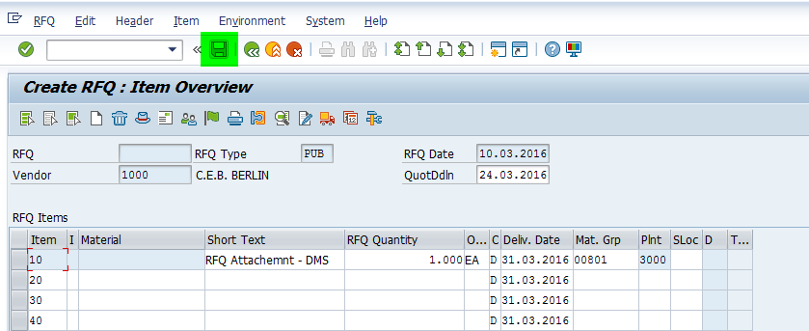

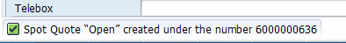

Checking the RFQ in ECC, Ariba Network and Sourcing:
Go to T-Code: ME43. Enter the RFQ#. Click on Messages.
Check the Processing Log.
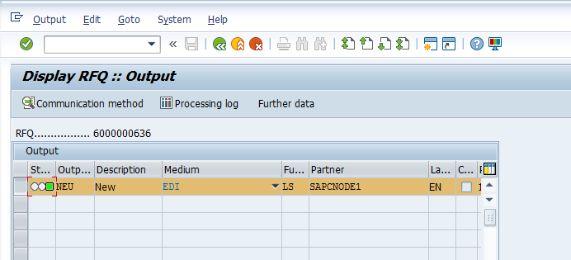
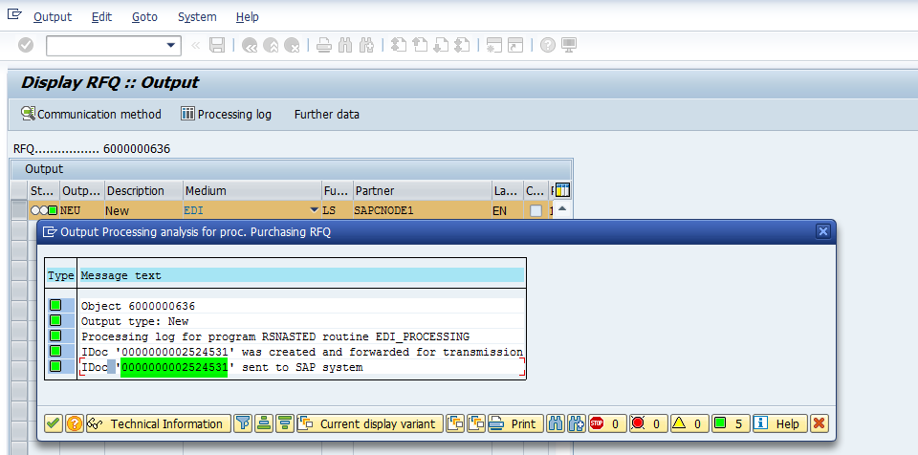

Go to T-Code: WE02 and check for REQOTE IDoc Types.
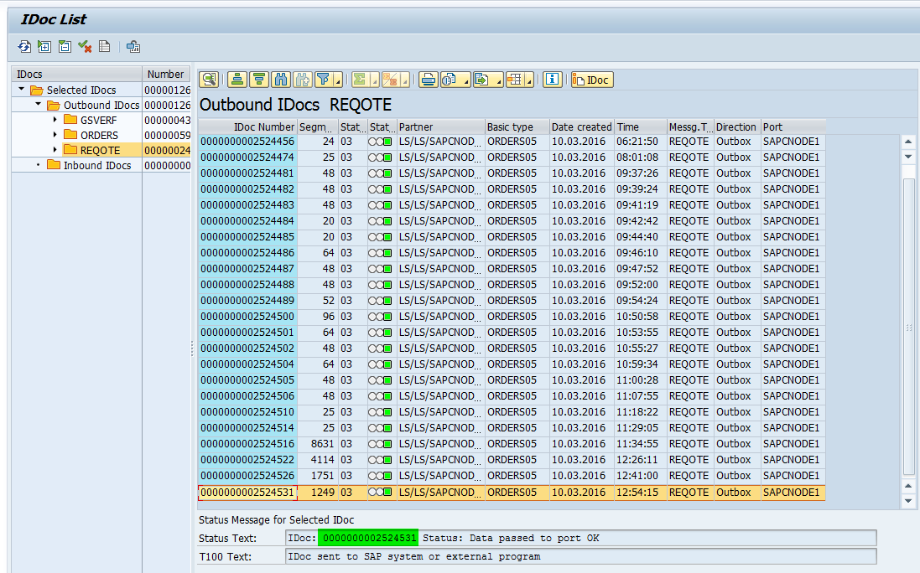

If integration type is CI9 (Cloud Integration) or similar, check the attachment in the IDoc under E1EDP01 /ARBA /DOCUMENT_ITEM.
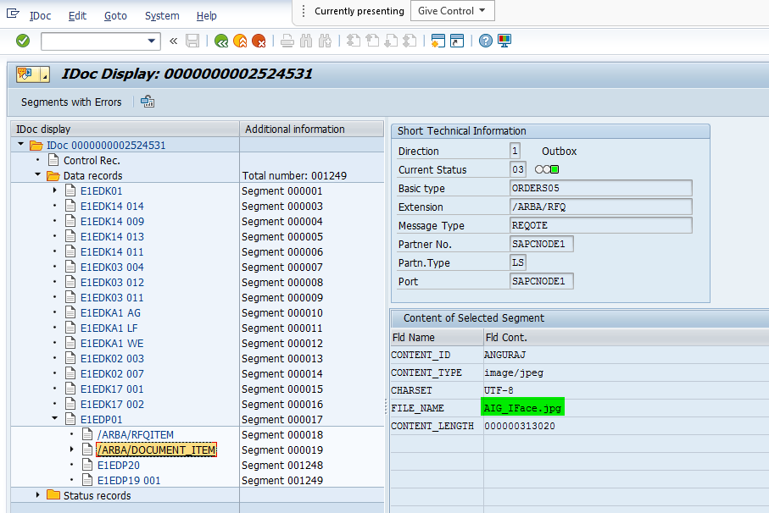

If integration type is CIG (Managed Gateway for Spend&Network), check the attachment in the IDoc under E1EDK01/ E1ARBCIG_ATTACH_HDR_DET. In this segment, when the field LINENUMBER is mentioned, it would signify line level attachments. And when the field LINENUMBER is not mentioned, it would signify header level attachments.

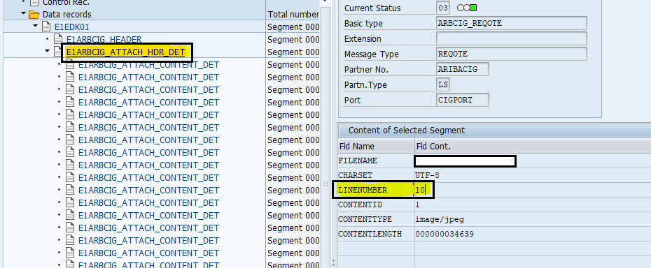

Check in Ariba Network.
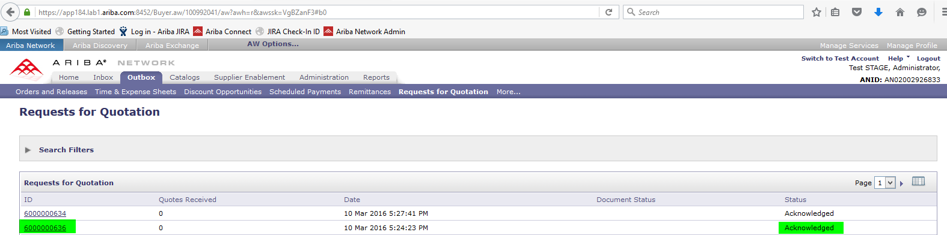
Go to Ariba Sourcing and search for the RFQ#
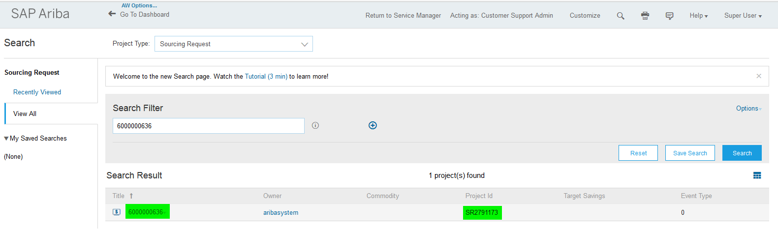

In Sourcing, Go to Documents -> View Details. Navigate to Content Tab and Scroll Down to view the attachment.
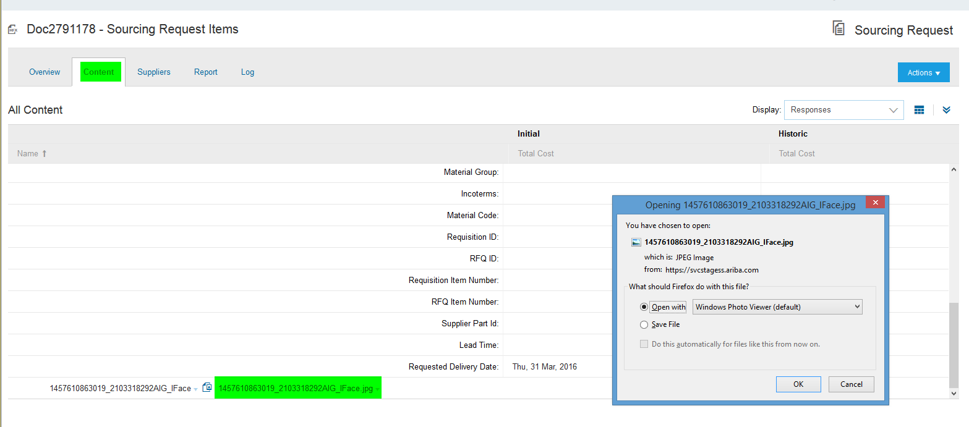

Additional Information
While adding attachments in ECC, there should not be a space in the Attachment Filename. If there is a space, then RFQ would fail in AN Buyer side.
This is a genuine defect in this Feature and it has been reported to ERP Engineering Team.

