Ariba Invoicing:
- A Schwab issued Remit ID is required and issued by Schwab. Please see example below. If a supplier is unable to identify a Remit ID, please email WFA@schwab.com.
GEN:0000086411:NEW YORK:1:1
- Invoices can only be submitted on network from a Purchase Order (NON PO or Contract invoicing is not transactable on the Ariba Network)
- All invoices require header level sales tax to be submitted even if value is $0.00.
- Discounts are not to be added to any invoice – header or line level.
- Turn off automatic invoice notifications unless an invoice has been entered and is 30 days past due
Standard Invoicing Best Practice (Video):
- Select purchase order for invoicing
  - Select tile labeled “Orders”, expand the date range to populate PO listing. If PO older than 365 days, choose exact match option POXXXXX – hit apply settings. If a purchase order is closed and needing to be reopened, please reach out to VendorManagement@Schwab.com
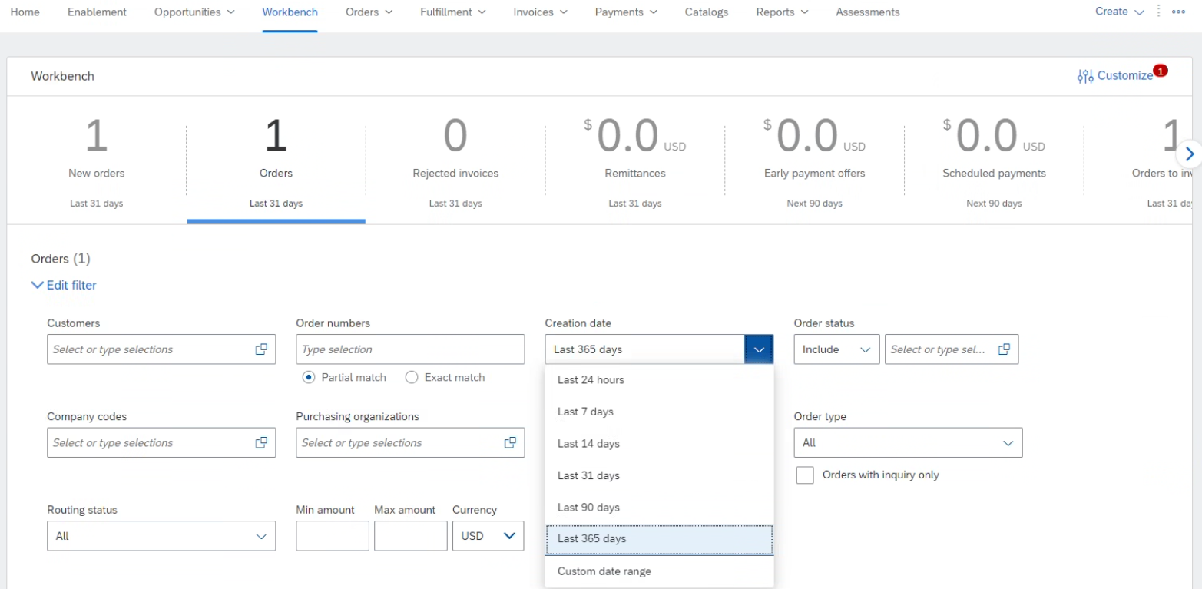
- Select purchase order - blue hyperlink
  - Create Invoice Standard Invoice
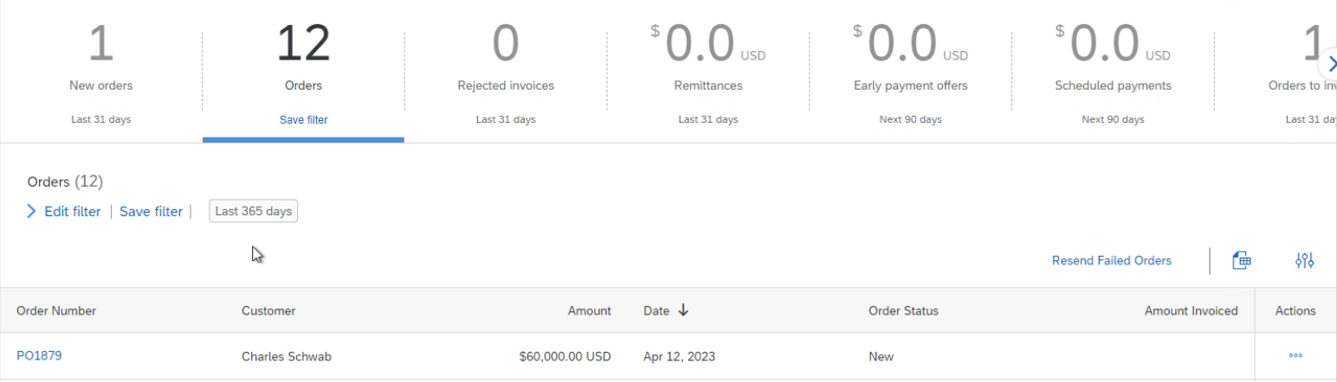
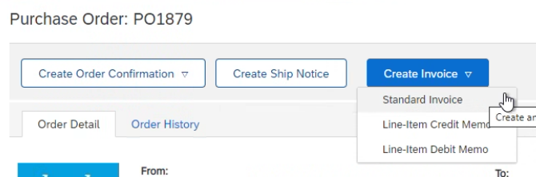
- Invoice # - Number should not contain lower case letters or special characters (#, -, !) and should not be a duplicate #
- Taxes must be submitted at Header Level (only 1 tax line allowed) - even when value is equal to $0.00
  - Select “Header level” and open tax box (tax box will not populate if the shipping is listed as “Line level shipping” – this icon needs to be selected at header level to populate correct options)
    - Add to Header Tax
  - From the tax box, second column
    - 3rd box Rate(%): enter tax rate (0 if no tax)
    - 4th box Tax Amount: enter tax amount (0 if no tax) 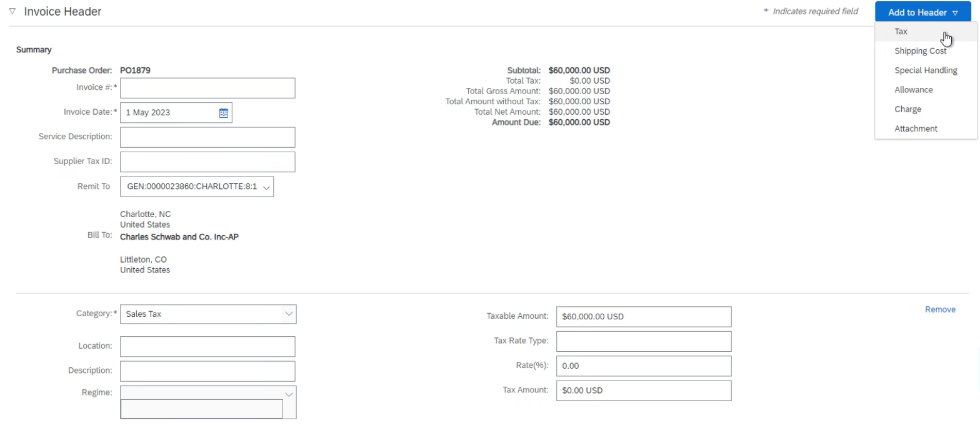
  - Remove extra tax boxes if needed. “Sales tax” is the only valid category for our invoicing.
- Add attachments/support to submitted invoices (highly encouraged)
  - Select Add to Header drop down Attachment Choose File Add Attachment
- Select line(s) from PO for billing
  - If invoicing against a multi-line PO and not all lines are being billed, please do not delete unused lines. Instead, click the green icon “include” so it turns off/grey
  - Adjust quantity billable if necessary
  - If submitting one invoice for two PO’s, please create two separate invoices, one per purchase order.
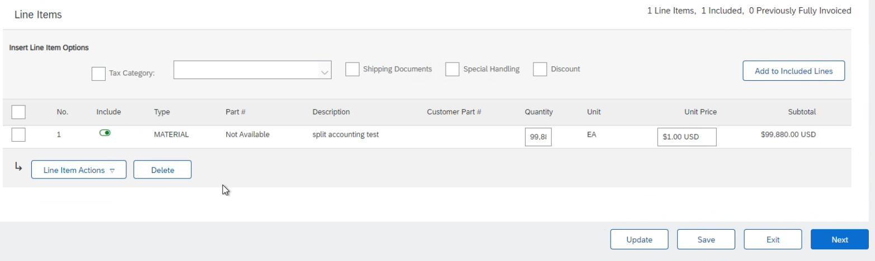
- Click “Update” –system will populate an error box preventing submission if all required criteria are not met
- Click Next verify all information is correct (invoicing amount, taxes, PO#, Remit to) Submit
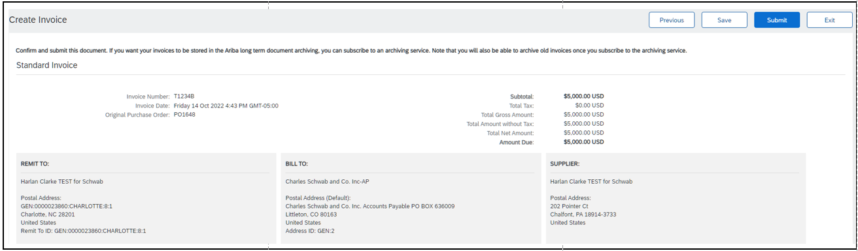
Line Item Credit Best Practice (Video):
- Click the Invoices tab.
- Select your previously created invoice.
- Click the Create Line-Item Credit Memo button on the Invoice screen.
- Complete information in the form (the amount and taxes will automatically be negative). Make sure that all required fields marked with asterisks (*) are filled in.
- Click Next > Review Credit Memo > Submit.

Checking Status (Video):
- Routing status reflects the transmission of the invoice to Charles Schwab
  - Obsoleted: You canceled the invoice.
  - Failed: Invoice failed your Buyer's invoicing rules. Your Buyer will not receive this invoice.
  - Queued: Ariba Network received the invoice but has not processed it.
  - Sent: Ariba Network sent the invoice to a queue. The invoice is awaiting pickup by the customer.
  - Acknowledged: Your Buyer invoicing application has acknowledged the receipt of the invoice.
- Invoice Status reflects the status of Charles Schwab’s action on the Invoice
  - Sent: the invoice is sent to your Buyer but they have not yet verified the invoice against POs and receipts.
  - Cancelled: your buyer approved the invoice cancellation.
  - Paid: your buyer paid the invoice/is in the process of issuing payment.
  - Approved: your buyer has verified the invoice against POs or contracts and receipts and approved payment.
  - Rejected: your Buyer has rejected the invoice or the invoice failed validation by Ariba Network.
  - Failed: Ariba Network experienced a problem routing the invoice. Verify invoicing requirement and resubmit.
- Invoice History / Comments / Scheduled Payments
- Click on the History tab to view status details and invoice history.
- History and status comments for the invoice are displayed.
- Transaction history can be used in problem determination for failed or rejected transactions.
- When you are done reviewing the history, click Done. Steps are similar for Payments.

For additional support:
Vendor Management: (Assistance with creating a purchase order, changing an existing purchase order) VendorManagement@schwab.com
Supplier Enablement: (Ariba Network onboarding) SupplierEnablement@schwab.com
Invoices for Processing: (General questions, manual invoice submissions, status updates or where to guidance) WFA@schwab.com
Charles Schwab Supplier Information Portal: https://support.ariba.com/item/view/192831
Video Tutorials (downgrade to Standard Account, forgot username/password, etc) : Kaltura Embed Player iFrame
SAP Business Network Supplier Learning Site (not specific to Charles Schwab): Learning Site

Helpful tips:
- You should only have 1 ANID with Schwab per Tax ID – add users to the account if needed (each user should not have a different ANID)
- Company name changes and/or buyouts may require a new ANID and creating new POs
- You can’t use future invoice dates – Please adjust the date to the current date or submit later
- Be sure to use the actual invoice date so invoices pay on time
- If your remit ID needs to be updated, contact WFA@schwab.com for the remit string and set the update by:
  - Selecting the circle widget to the upper right hand corner with your initials
  - Select Setting -> Remittances -> edit
  - Enter the remit ID string into “Remit Id” box for Charles Schwab
  - Save
- Combine multiple taxes (state, city, county, etc) into one tax line
- You can’t overbill a PO line – Please contact your Schwab business partner for updated billing instructions
- If Ariba says there is an error but doesn’t identify on the entry page, header tax is probably missing
- Review error/reject notices from Ariba and Schwab by navigating to the invoice and viewing the notes in the blue reject comments box

