

SAP Ariba Supplier Solution Blueprint
July 2020



Table of Contents
Version History 4
SAP STATEMENT OF CONFIDENTIALITY AND EXCEPTIONS 4
PROJECT DYNAMICS 5
TIME LINES AND SCHEDULES 6
SAP Ariba Integration Methodology Time Line 6
Project Schedule 7
Contingency Plan 7
ASSUMPTIONS & CONSTRAINTS 8
Assumptions 8
Constraints 8
PROJECT SCOPE 9
Document Details and Supplier Transmission 9
10
Cutover Documents 10
DOCUMENT REQUIREMENTS 11
Orders 11
12
Order Confirmation 12
Advanced Shipping Notification (ASN) 13
Invoice 14
Supporting Documentation 18
Where to Find Buyer Transaction Rules 18
CONNECTIVITY AND INFRASTRUCTURE 19
Buyer Profile 19
Supplier Profile 20
Supplier ERP Connection 20
SUPPLIER ERROR HANDLING & BUSINESS PROCESS 21
Order Validation 21
Invoice Processing 21
Error Handling 21
Business Processes 22
POST GO LIVE SUPPORT 24
SUPPLEMENTAL DOCUMENTATION 25
cXML Section for Supplemental Documentation 25
EDI x12 Supplemental Documentation via SAP Ariba Cloud Integration Gateway 25
PIDX Supplemental Documentation via SAP Ariba Cloud Integration Gateway 25
SAP ARIBA CUSTOMER SUPPORT FOR SUPPLIERS 26
APPENDIX A 27
Precision Rounding on Invoice 27
APPENDIX B 28
Advanced Pricing / Price Basis Quantity (PBQ) 28

Version History
This log is updated each time an update is made to this guide. The log identifies the version number, the date the version was completed, the author of the changes, and a brief description of the changes.

Version | Date | Author | Description
1.0. | June 2020 | Matthew Dallas | Initial BluePrint Guideline

SAP STATEMENT OF CONFIDENTIALITY AND EXCEPTIONS

The contents of this document shall remain the confidential property of SAP and may not be communicated to any other party without the prior written approval of SAP. This document must not be reproduced in whole or in part. It must not be used other than for evaluation purposes only, except with the prior written consent of SAP and then only on condition that SAP’s and any other copyright notices are included in such reproduction. No information as to the contents or subject matter of this proposal or any part shall be given or communicated in any manner whatsoever to any third party without the prior written consent of SAP.
The furnishing of this document is subject to contract and shall not be construed as an offer or as constituting a binding agreement on the part of SAP to enter into any relationship. SAP provides this document as guidance only to estimate costs and time-scales of the predicted delivery project. This will be subject to confirmation prior to any contractual or delivery commitment by SAP.
SAP warrants that to the best of its knowledge those who prepared this material have taken all reasonable care in preparing it and believe its contents to be true as at the date of this document. SAP cannot however warrant the truth of matters outside of its control and accordingly does not warrant the truth of all statements set out in this document to extent that such statements derive from facts and matters supplied by other persons to SAP. The statements in this document are qualified accordingly.

PROJECT DYNAMICS

Company | Contact | Role | Email | Phone
SAP Ariba |  | Seller Integrator
SAP Ariba | John Peng | Customer Engagement Executive | John.peng@sap.com
SAP Ariba |  | Supplier Enablement Lead
SAP Ariba | Mike Menegazzi | Catalogue integrator | Mike.Menegazzi@sap.com
Buyer | Jeff Rosenblum | Project Lead  (Supplier Enablement lead) | Jeff_Rosenblum@cpr.ca
Buyer | Rajan Singhal/Manohar Tadimeti | Business Lead | rajan.singhal@pwc.com  Manohar_Tadimeti@cpr.ca
Buyer | Kate Zhuravleva | Supplier Enablement | Kate_Zhuravleva@cpr.ca
Buyer | Lily Pham | Supplier Enablement | Lily_Pham@cpr.ca
Supplier |  | Project Lead
Supplier |  | Technical (Developer)
Supplier |  | Testing Contact

Catalog Integrator: Support Setup and testing of Catalog with buyer and supplier  Customer Engagement Executive: | Supplier enablement Lead: Consolidate all supplier’s enablement status for reporting to customer.
Customer Engagement Executive: Primary customer contact. | Technical (Developer) (Buyer): Support of cXML/EDI Identified Supplier testing.  Provide connection parameters to ERP systems.  Assist in troubleshooting document errors from the application/ERP.
Project Lead (Supplier): Main contact for project coordination.  Provide commitment to project timeline.  Understand buyer's transaction validation rules.  Participate in status meetings. | Technical (Developer) (Supplier): Provide technical details for integration to back-end systems.  Perform data mapping.  Assist in troubleshooting document failures.  Coordinate go live with functional resource.
Project Lead (Buyer): Main contact for project coordination.  Enforce compliance of project timelines. | Testing Contact (Buyer): Provide technical details for integration to back-end systems.  Perform data mapping.  Assist in troubleshooting document failures.  Coordinate go live with functional resource.
Seller Integrator: Manage end-to-end supplier integration.  Troubleshoot failed/rejected documents.  Ensure timely completion of project milestones.  Escalate issues to appropriate person/team. | Testing Contact (Supplier): Define & Validate catalogue content with Supplier.  Generate Test Orders.  Reconcile and approve invoices.  Assist in other testing activities, coordinate go-live.  Download & validate applicable test transactions; load & process through ERP.

TIME LINES AND SCHEDULES

SAP Ariba Integration Methodology Time Line

- Planning and testing are the most critical and time-consuming steps
- Milestone dates to be determined at kick-off meeting
- If Invoice/Order Confirmation are in scope, can the supplier support using the Ariba portal while integration testing is ongoing?
- If catalogs are in scope, activity should start at least two weeks prior to the Plan phase

NB: Time line below is to be used as a guide line and is subject to change based on level and/or complexity of scope. Supplier’s input and/or availability may also impact time lines.

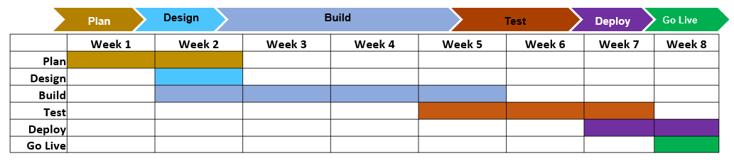

Plan  - Kick-off meeting  - Define project scope  - Document business rules  - Prepare project schedule, with milestones  - Confirm resources are in place  - Governance model in place  - Commitment from all parties | Design  - Supplier’s technical solution defined  - Development time lines defined  - Relationship established on SAP Ariba  - SAP Ariba network account configured  - Test scenario’s defined | Build  - Supplier develops mapping requirements  - Establish connectivity to the AN  - Submit sample documents for validation  - SIT testing
Test  - UAT testing with pre-defined test scripts  - Validation solution meets requirements  - Formal sign-off and acceptance | Deploy  - Migration to production  - Supplier migrates maps to production  - AN account is setup  - Change management in place | Go Live  - Confirm transactions in production  - SI post-production support (2 weeks)  - Project close

Project Schedule

Milestone | Start Date | End Date
Plan
Design
Build
Test
Deploy
Go Live | 9/15/2020

Contingency Plan
Discuss what the contingency plan will be if target dates are not achievable.
Document:
- Why dates were missed
- New target dates
- How supplier will transact in the meantime
  - Canadian Pacific Rail will accept PO Flip invoices if possible for supplier

ASSUMPTIONS & CONSTRAINTS

Assumptions
- There will be a single primary point of contact with each Trading Partner for Project Management activities.
- It is assumed that assigned resources have the correct skills and knowledge to complete all responsibilities.
  - Knowledge of business operations with customer
  - Experienced Developers

Constraints
Provide details of any challenges that would impact the scope and/or project time line.

- Competing Priorities
  - Are other integration/capital projects running at the same time?
  - Can this project start now or in the future?
- System Maintenance Schedule
  - Upgrades
  - System refresh
- Resource Constraints
  - Vacations
  - Holidays
  - Knowledge
- Processes
  - Updates/changes to code must be scheduled
  - Go live at certain points of the month
- 3rd Party Dependencies
  - Are changes scheduled or added as needed?
  - Are error notifications/failures communicated back?
  - Is there a dedicated resource to support the project?
  - Will they attend standing calls?

PROJECT SCOPE

Documents In-Scope  - Purchase Order  - Change Order  - Invoice  - Service Entry Sheet | Optional Documents  - Order Confirmation  - Advanced Ship Notification  - Service Entry Sheet Response  - Receipt Notification | Documents Out of Scope

Document Details and Supplier Transmission
Document | Document Detail | Yes/No/Optional | Delivery cXML/EDI/EDIFACT/Email/On-Line
Orders | Catalog | Yes
Orders | Non-Catalog | Yes
Orders | P-Card | No
Orders | Attachments | Optional
Orders | Blanket Order – with release | No
Orders | Blanket Order – without release | No
Orders | Service Order – sent as material | Yes
Orders | Service Order – sent as service | Yes
Orders | Change Order- catalog | Yes
Orders | Change Order – non-catalog | Yes
Orders | Change Order – P-Card | No
Orders | Precision Rounding | No
Orders | Advanced Pricing Detail | No
Order Confirmation | Header Level | Optional
Order Confirmation | Line Level | Optional
ASN | Advanced Shipping Notification | Optional
GRN | Receipt ( Goods Receipt Notification) | No
SES | Service Entry Sheet | Yes
SES | Service Entry Sheet Response | No
Invoice | Debit – Header Level | No
Invoice | Debit – Line Level | Yes
Invoice | Contract | Yes
Invoice | Blanket | No
Invoice | Non-PO | No
Invoice | Service | Yes
Invoice | Credit – Header Level | No
Invoice | Credit – Line Level | Yes
Invoice | Cancellations | Yes
Invoice | Attachments | Optional
Invoice | Precision Rounding | No
Invoice | Advanced Pricing Detail | No
Catalog | CIF | Yes
Catalog | Punchout – Level 1 | Yes
Catalog | Punchout – Level 2 | Yes
Cutover Documents | Orders – With Legacy Flag | No
Cutover Documents | Order – Without Legacy Flag | No
Cutover Documents | Invoices – With Legacy Flag | No
Cutover Documents | Invoices – Without Legacy Flag | No
Cutover Documents | Buyer provides report of ‘Old’ and ‘New’ order numbers – Y/N | No

Cutover Documents

- Document how cutover activities will be handled

- Any existing orders will continue to be handled in their old channel. After the go live date, all new orders will use Ariba Network.

DOCUMENT REQUIREMENTS

The following tables outline the requirements unique to your Buyer’s procurement environment, as detailed in the Excel Delta document. Not all required elements as outlined in the DTD are represented as this is meant to identify information that is important to your Buyer.

Orders
General
Change Orders | Yes | Allowed
Cancel Orders | Yes | Allowed
Header
Ship To | Yes | Ship To Address IDs Required. Ship To information can be sent at the header and/or line level. Address and ID needs to be captured and returned on the invoice. No ad-hoc Ship To’s will be used.
Bill To | Yes | Bill To Address IDs Required. Address and ID needs to be captured and returned on the invoice
Deliver To | Yes | Deliver To will be used
Payment Terms | Yes | Will be sent on all POs
Attachments |  | Allowed
Extrinsic Values | Optional | <Extrinsic name="CompanyCode">1000</Extrinsic>  <Extrinsic name="InvoicingConditions">Link to the Purchase Order Terms and Conditions site:  https://www.cpr.ca/en/about-cp/selling-to-cp/policies-and-guidelines</Extrinsic>
Line Level
Supplier Part ID |  | Supplier Product IDs will be sent when available
Buyer Part ID |  | May be sent on catalog POs if available
Manufacturer Part ID |  | May be sent on non-catalog POs if available
Unit of Measure |  | ISO UOM
Classification Code |  | UNSPSC
Service PO |  | Supplier Part ID may show as not available for a service order
 |  | Will include service Period Start and End Dates
Service Name Extrinsic may be provided:
<Extrinsic name="Name">SERVICE NAME TEXT</Extrinsic>
Extrinsic Values | Optional | <Extrinsic name="Req. Line No.">1</Extrinsic>  <Extrinsic name="Requester">Kate Zhuravleva</Extrinsic>  <Extrinsic name="PR No.">PR1823</Extrinsic>  <Extrinsic name="Name">Machine Parts</Extrinsic>  <Extrinsic name="incoTerm"/>  <Extrinsic name="incoTermLocation"/>  <Extrinsic name="QuoteReference"/>  <Extrinsic name="QuoteLineReference"/>  <Extrinsic name="Contract ID">C56</Extrinsic>  <Extrinsic name="ExpectedUnplanned">  <Money alternateCurrency="" alternateAmount="" currency="CAD" >2,000.00</Money></Extrinsic>  <Extrinsic name="shortname">Sharpie Oil-Based Paint Marker, Bold Point, ... </Extrinsic>

Order Confirmation

 | General
 | In Scope? |  | Yes |  | Optional
Header
Attachments |  |  |  | Allowed
Line Level
Estimated Delivery Date |  | Yes |  | Required
Estimated Shipment Date |  | Yes |  | Required
Line Item Descriptions |  |  |  | No changes allowed to line item descriptions
Rejection |  | Yes |  | Reason Required at Line Level for Rejected Orders or Backorders
Comments |  | Yes |  | Required at Line Level when there are any changes compared to PO

Advanced Shipping Notification (ASN)

 | General
 | In Scope? |  | Yes |  | Optional
Header
Shipping Date |  | Yes |  | Required
Delivery Date |  | Yes |  | Required
Attachments |  |  |  | Attachments Allowed
Delivery & Transport |  | Yes |  | Delivery and Transport information allowed such as Carrier Name or Tracking Number
Line Level
Multiple Delivery Dates |  | No |  | Not Allowed
Advanced Packaging |  |  |  | Allowed
Component Receipt |  |  |  | Component Receipt for multiple multi-tier notices allowed to be created

Invoice

 | General
 | Service Invoices |  | Yes | Auto-Generates Service Entry Sheet
 |  |  |  | Multiple Invoices allowed for amount-based service items
Header
Invoice Number |  |  |  | Invoice # Max Length is 16  No Special Characters are allowed  Suppliers can only reuse invoice number if it failed
Invoice Date |  | Yes |  | Backdating Allowed up to 1 day
Bill To |  | Required |  | Bill To ID and Address Required
Remit To |  | Required |  | Remit To ID and Address Required
 |  |  |  | Supplier Tax ID Required
Sold To |  | Required |  | Sold To Address is Required and Must Match Bill To Name and Country
Ship From |  | Required |  | Ship From Address is Required
Ship To |  | Required |  | Ship To ID and Address Required
From |  | Required |  | From Address Required
Payment Terms |  | Required |  | Payment Terms are Required
Contract Reference |  |  |  | Allowed
Attachments |  |  |  | Allowed
Service Invoice |  |  |  | Invoice Period Range Required for all Service Invoices
Line Level Credit Memo |  |  |  | Must reference another invoice
 |  |  |  | Requires a Reason
Extrinsic |  | Required |  | <Extrinsic name="invoiceSubmissionMethod">CXML</Extrinsic>
Extrinsics |  | Optional |  | <Extrinsic name="invoiceSourceDocument">PurchaseOrder</Extrinsic>  <Extrinsic name="paymentMethod">check</Extrinsic>  <Extrinsic name="ServiceDescription">charge ontario tax</Extrinsic>  <Extrinsic name="punchinContractInvoice">no</Extrinsic>  <Extrinsic name="CompanyCode">2600</Extrinsic>
Line Level
Quantity |  |  |  | Line Item Quantity must be greater than zero
Currency |  |  |  | Must match local currency sent in PO
Taxes |  | Yes |  | Taxes Required at Line Level
 |  |  |  | Tax Details Required: Category, Percentage Rate, Taxable Amount, Tax Amount, and Description
Service Invoice |  |  |  | Start and End Sates Required at line level
Extrinsics |  | Optional |  | <Extrinsic name="punchinItemFromCatalog">no</Extrinsic>  <Extrinsic name="GR Based Invoice">No</Extrinsic>  <Extrinsic name="receiptID"/>  <Extrinsic name="ReceiptLineNumber"/>  <Extrinsic name="AccountCategory">K</Extrinsic>  <Extrinsic name="parentPOLineNumber">00010</Extrinsic>
Summary Detail
Currency |  |  |  | Must match local currency sent in PO
Taxes |  | Yes |  | Taxes supported at Summary Level
 |  |  |  | Tax Details Required: Category, Percentage Rate, Taxable Amount, Tax Amount, and Description
Special Handing |  | No |  | No ad-hoc charges allowed
Shipping |  | No |  | No ad-hoc charges allowed

Tax Requirements

  - Tax is Required at the line level and is also supported at the summary level.

NOTE: Strict address validation is enforced. When this rule is enabled, the system will check if the following cXML elements are present and if it has a value:

  - Name
  - PostalAddress.Street
  - PostalAddress.City
  - PostalAddress.State
  - PostalAddress.PostalCode
  - PostalAddress.Country isoCountryCode attribute

Supporting Documentation
Have the buyer provide documentation for the following, if in scope:
- Ship To addresses & ID
- Bill To addresses & ID
- Remit To addresses & ID

Where to Find Buyer Transaction Rules

Rules configured by the Buyer that define how transactions will e validated on the Ariba Network from a technical and business process perspective. These rules define the technical requirements presented in the Ariba Integration Guide and are unique to each Buyer.

To view a Buyers transaction rules:

- Login at supplier.ariba.com
- Select Company Settings in the blue menu at the top of the page
- Select Customer Relationships
- Select the Customer to view their unique rules

CONNECTIVITY AND INFRASTRUCTURE

Buyer Profile

Identification | Test | Production
ANID | AN01469267434-T | AN01469267434
DUNS
DUNS+4

System Profile | Description
ERP | SAP ECC
Middleware
Buying Channels | B&I (Buying and Invoicing), Contracts, SLP
UoM Classification | ISO UOM
UNSPSC Classification | UNSPSC

Supplier Profile

Identification | Test | Production
ANID
DUNS
DUNS+4
ISA Qualifier

System Profile | Description
ERP | SAP R/3 v4.7  SAP ECC 5.0  SAP ECC 6.0  SAP S/4 HANA  Oracle 12c v11.2.0.4  Oracle 12c v12.1.0.2  Oracle 12c v12.2.0.1  PeopleSoft  In House
Middleware | webMethods  Mincom  BizTalk  In House
UoM Classification | UNUOM  ANSI  Custom
UNSPSC Classification | UNSPSC V11.2  UNSPSC V12.2  Custom

Supplier ERP Connection
Type | Description
Connection | Cloud Integration Gateway (CIG)
Authentication | - Certificate by a Trusted Authority. No self-signed certificates, base64 encoding  - Name & Password
VAN | Y/N
Third Party Provider | Provide company information

SUPPLIER ERROR HANDLING & BUSINESS PROCESS

Order Validation
Identify which fields from the Order and Change Order are validated in Supplier’s ERP:
- Part Number
- Unit Price
- UOM
- UNSPSC
- Delivery Date
- Service Date (start & end)

Invoice Processing
Identify how the invoices are sent to the AN.
- Real time (individually)
- Batched
- Scheduled run nightly
- Scheduled run next business day (check if there is any conflict with backdating rule. Would also apply to corrected invoices)

Error Handling

Discuss and document the process for the various cases below. Add in any other error handling cases.

- What happens when an order is transmitted to the supplier’s system, but is not processed?
  - Is there an error log that is monitored?
  - How often are the logs checked?
  - Who is notified?
  - How is this corrected?
  - What is the turn-around time to address failed orders?
- What happens when an order fails on data validation? Ie. Wrong part number, price, UOM…..
  - Who gets notified?
  - How is this corrected?
  - Does the supplier system automatically make substitutions?
  - What is the turn-around time to address failed orders?
- Is there any schema or data validation done on the invoice before it is sent to the AN?
- What is the process if an invoice fails against a business rule in the AN?
- What is the process if an invoice is rejected by the buyer?
- What is the process if duplicate invoice numbers are not allowed when an invoice has failed or been rejected?

Business Processes
Describe any out of the box/unique processes that will be put into place.

Example:
- How change orders will be handled if not supported electronically?
- If order confirmation is not in scope, how will changes be communicated back to buyer?

POST GO LIVE SUPPORT
Seller Integrators provide two weeks support post go live starting with the first transaction in Production. After the two-week period, a Service Request should be created for any assistance. See imbedded deck for details instructions.

SUPPLEMENTAL DOCUMENTATION

This document contains <BUYER> specific information regarding transaction requirements. Information in this document does NOT cover the complete technical aspects of integrating with the Ariba Network. Below are three sections for supplemental documentation to be used with this document for cXML, EDI or PIDX transaction formats. Only refer to the section that pertains to the format your organization with be sending/receiving.

cXML Section for Supplemental Documentation
New cXML supplier to Ariba Network must:
- Support a DTD (document type definition) validation tool internally and download the document type definitions (DTD’s) for all supported transactions.
- Support HTTPS protocol. Ariba supports HTTPS (not HTTP) only for cXML transactions.
- Review the cXML Solutions Guide and cXML User Guides.
cXML Document Type Definitions (DTD’s):
- http://cxml.org Download InvoiceDetail.zip for the InvoiceDetailRequest.dtd.
- http://cxml.org Download cXML.DTD for the OrderRequest
- http://cxml.org Download Fulfill.dtd for ConfirmationRequest/ShipNoticeRequest

EDI x12 Supplemental Documentation via SAP Ariba Cloud Integration Gateway
New Cloud Integration Gateway supplier to the Ariba Network
- Cloud Integration Portal Guide (aka. CIG “How to Guide”)

All EDI Supplier Guides
- SAP Ariba PO850 4010 Purchase Order
- SAP Ariba PC860 4010 Purchase Order Change
- SAP Ariba PR855 4010 PO Acknowledgment (Order Confirmation)
- SAP Ariba IN810 4010 Invoice
- SAP Ariba FA997 4010 Functional Acknowledgment (inbound)
- SAP Ariba FA997 4010 Functional Acknowledgment (outbound)

PIDX Supplemental Documentation via SAP Ariba Cloud Integration Gateway
New Cloud Integration Gateway supplier to the Ariba Network
- Cloud Integration Portal Guide (aka. CIG “How to Guide”)

All PIDX Supplier Guides
- SAP Ariba PIDX OrderCreate OrderChange 1.61 Outbound
- SAP Ariba PIDX OrderResponse 1.61 Inbound
- SAP Ariba PIDX Invoice 1.61 Inbound
- SAP Ariba PIDX InvoiceResponse
- SAP Ariba PIDX Receipt Outbound

If you do not yet have user access to CIG, the SAP Ariba Seller Integrator will forward these documents. Once user access is obtained, the current CIG documentation may be viewed in or downloaded from the CIG Resources section.

SAP ARIBA CUSTOMER SUPPORT FOR SUPPLIERS

How to utilize Help Center and access Customer Support
At SAP Ariba, our goal is to empower Suppliers with the information and tools they need to seamlessly navigate through Ariba Solutions. You can find the answers you need about Ariba products in the SAP Ariba Help Center. You can also contact SAP Ariba Support directly through the Help Center, when necessary.

Access the Help Center
Sign in to your account (supplier.ariba.com) and look to the right-hand side of your screen to view the Help Center panel. If the panel is collapsed and you can’t see any articles, click Help Center >> to expand.

Using the Help Center
The Help Center is the first place to start if you have questions about any Ariba Solution. You can search for answers to functional and navigational questions in our FAQs and Tutorials.
The following tutorials are helpful when you’re getting started:
  - Supplier Basics
  - Invoices

Still need more help? Contact Customer Support
If you don’t find your answer after searching, you can request direct support via email, chat, or phone (depending on the type of account you have).

To Request Support:
  - Click the icon in the bottom-right corner of the expanded Help Center. After clicking, you will see a new window titled Ariba Exchange User Community.
  - You will see the words I need help with next to a search bar. If you don’t see this, click Support in the upper-right corner of your screen.
  - Search for your issue in the I need help with search bar.
Based on your search, you may see Guided Assistance. Guided Assistance features a series Yes or No questions that will guide you either to support options or to relevant content to resolve your issue. If the guided content does not resolve the issue, the following direct support options are presented:

Email SAP Ariba Customer Support
- Send a written online request to SAP Ariba Customer Support via a short webform.
- Provide a Short Description, Details, and Attachment to ensure a fast and accurate response.

Get help by live chat
- Start a live chat with an SAP Ariba Customer Support specialist.

Click to call
- Avoid waiting on the phone. Fill in a short form to request a callback from the next available specialist.

APPENDIX A

Precision Rounding on Invoice

An invoice exception will occur in the Ariba Network if the monetary amount has a mathematical error. There are two general situations where this happens.

- Monetary values sent are not calculated correctly (net amount/gross amount)
- A rounding algorithm is being used where the rounding is different from the Ariba Buying & Invoicing solution (B&I)

Two Solutions
- Send the same monetary values as what was sent on the originating order
- In B&I, set the field “AmountRoundingForInvoiceExceptionCalculation” as follows

0 = No rounding: This is the default value. No rounding occurs when Ariba computes the amounts and then compares the amounts against the total invoiced.
1 = Round invoice line item amounts to currency precision: Ariba rounds all line amounts to currency precision, and then totals the line item amounts and compares that to the total invoiced amount.
2 = Round invoice total cost to currency precision: Ariba totals the line items amounts first and then rounds the total amount to currency precision before comparing it to the total invoiced amount.

Without Rounding (0) | With Rounding on Line Amount (1) | With Rounding on Invoice Total (2)
Line 1 2045.046 (price) * 9.94 (quantity) = 20, 327.757 | 20,327.76 (rounded) | 20,327.757
Line 2 121.511 (price) * 7.04 (quantity) = 855.43744 | 855.44 (rounded) | 855.43744
Total = 21, 183.19444 | Totals to 21,183.20 | Rounded to 21,183.19

APPENDIX B

Advanced Pricing / Price Basis Quantity (PBQ)

Check if the Buyer rules allow for changes to advanced pricing detail. You can find how to do this in “Buyer Transaction Rules” section.

If there is Advanced Pricing/PBQ, the detail section of Pricing details will be sent in the cXML

Usually, Subtotal = Unit Price * Quantity, which in this case will not be true, 60 ≠ 48 * 7.50. (48*7.50 = 360)

However, for PBQ, the formula used is
Subtotal = Quantity * (Unit Conversion/Price Unit Quantity) * Unit Price
60 = 48 * (1/6) * 7.50

Easier way to remember is buyer is selling “item” in pack of 6. So, price 7.50 is price of 6.
Quantity is 48 (6*8). Even though quantity says 48, actually it is 8 packs of 6. So the subtotal price is 8 *7.50 = 60.

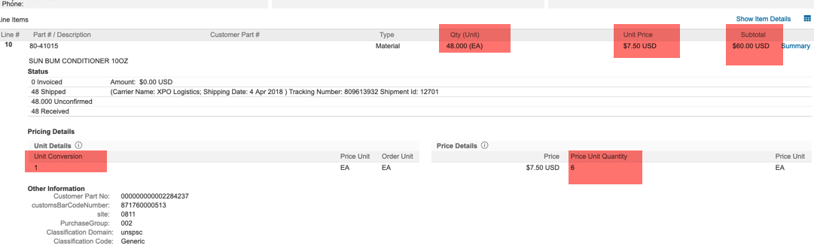

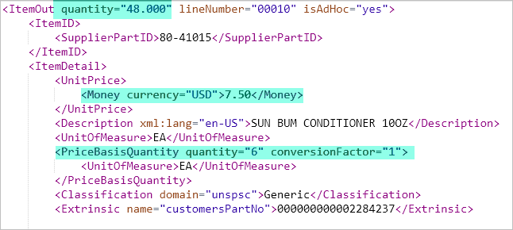

EDI Suppliers must ad CTP segment as is from the PO for Advanced pricing.

PO1*00010*48*EA*7.5**VP*80-41015*****C3*Generic~
CUR*BY*USD~
CTP*WS***6*EA*CSD*1~

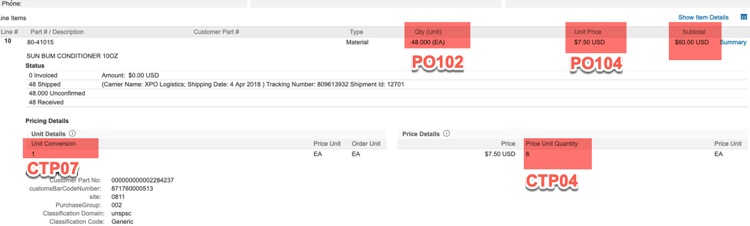

© 2020 SAP SE or an SAP affiliate company. All rights reserved.
No part of this publication may be reproduced or transmitted in any form or for any purpose without the express permission of SAP SE or an SAP affiliate company.

The information contained herein may be changed without prior notice. Some software products marketed by SAP SE and its distributors contain proprietary software components of other software vendors. National product specifications may vary.

These materials are provided by SAP SE or an SAP affiliate company for informational purposes only, without representation or warranty of any kind, and SAP or its affiliated companies shall not be liable for errors or omissions with respect to the materials. The only warranties for SAP or SAP affiliate company products and services are those that are set forth in the express warranty statements accompanying such products and services, if any. Nothing herein should be construed as constituting an additional warranty.

In particular, SAP SE or its affiliated companies have no obligation to pursue any course of business outlined in this document or any related presentation, or to develop or release any functionality mentioned therein. This document, or any related presentation, and SAP SE’s or its affiliated companies’ strategy and possible future developments, products, and/or platform directions and functionality are all subject to change and may be changed by SAP SE or its affiliated companies at any time for any reason without notice. The information in this document is not a commitment, promise, or legal obligation to deliver any material, code, or functionality. All forward-looking statements are subject to various risks and uncertainties that could cause actual results to differ materially from expectations. Readers are cautioned not to place undue reliance on these forward-looking statements, and they should not be relied upon in making purchasing decisions.

SAP and other SAP products and services mentioned herein as well as their respective logos are trademarks or registered trademarks of SAP SE (or an SAP affiliate company) in Germany and other countries. All other product and service names mentioned are the trademarks of their respective companies. See www.sap.com/copyright for additional trademark information and notices.

