CI-9 SP2 Transport Import Failure - Type ARBACL_ADAPTER_FRMWRK is unknown:
Issue
Issue Description:
Customer is facing issues in CI-9 SP2 Transport Import Errors in SAP ECC (STMS_IMPORT)
Customer tried to do the transport A74K900542 (Ariba Transport for Network Adapter Objects) after they imported the EC9K900823 (Ariba Transport for Common Objects).
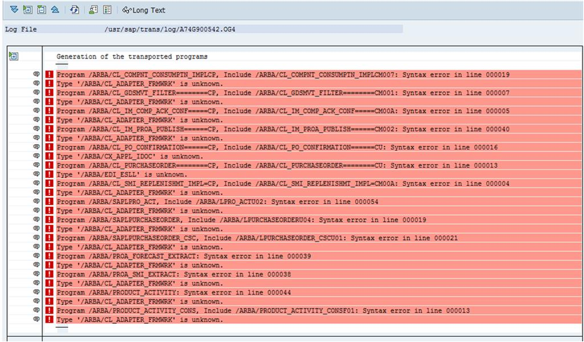
Defect Behaviour:
We follow the instruction in the readme.txt (attached) and got this issue. There is no workaround.
Cause
A Dependent Object or Class is missing and hence the below error was thrown:
"Type /ARBA/CL_ADAPTER_FRMWRK is unknown"
There are 2 common objects that need to be imported before we import the adapter object. Customers only imported one. Later they imported the highlighted one and the issue is fixed

1.Cloud Integration 9 SP2: New Installation
============================================
The following transport must be installed if this is the first time. Ariba transports are being installed on your SAP system.
You must specify the client when importing the transports as they contain both client dependent and independent objects.
Note: The below transports should be imported in the same order.

Ariba Common Objects
====================
EC9K900823 Ariba Transport for Common Objects

Adapter-Sourcing Common Objects
===============================
A74K900521 Adapter Sourcing Common Objects
Network Adapter Objects
============================================================================================
Note: For all hotfixes import the corresponding consolidated TR’s mentioned below.
============================================================================================
A74K900542 Ariba Transport for Network Adapter Objects
A74K900536 Payment batch cXML Integration
EC9K900953 Buyer Catalog Export

Solution
We have checked the error log and we could see the class /ARBA/CL_ADAPTER_FRMWRK is used in many programs delivered by transport A74K900542.
As this does not exist in the system prior A74K900542 Ariba Transport for Network Adapter Objects this transport implementation is failing.
So, the /ARBA/CL_ADAPTER_FRMWRK is found in the A74K900521 Adapter Sourcing Common Objects transport.
As a workaround, we suggested the Customers to implement the A74K900521 Adapter Sourcing Common Objects before implementing the A74K900542 Ariba Transport for Network Adapter Objects.
This has resolved this issue.

